**Musculoskeletal Development Notes**

**I.** Limb elements arise from **paraxial** (**somitic**) and **lateral plate** mesoderm

From **paraxial mesoderm** (i.e. somites):

* **Dermatome** gives rise to connective tissue of the dermis
* **Myotome** gives rise to limb muscles

From **lateral plate mesoderm:**

* Bones of arm, forearm, hand, thigh, leg and foot
* Blood vessels
* Connective tissue (except for that of the dermis)

(**Peripheral nerve elements**, of course, are derived from **neural crest**)

**II. Development of limb bones** is via **endochondral ossification**

1. Mesenchyme begins to condense into chondrocytes
2. Chondrocytes form a model of the prospective bone
3. Blood vessels invade the center of the model, where osteoblasts localize, and proliferation is restricted to the ends (epiphyses)
4. Chondrocytes toward the shaft (diaphysis) undergo hypertrophy and apoptosis as they mineralize the surrounding matrix.
5. Growth of the long bones continues into early adulthood and is **maintained by FGF-dependent proliferation of chondrocytes** in the growth plates (long bones have two growth plates, in smaller bones (phalanges), there is only one at the tip).

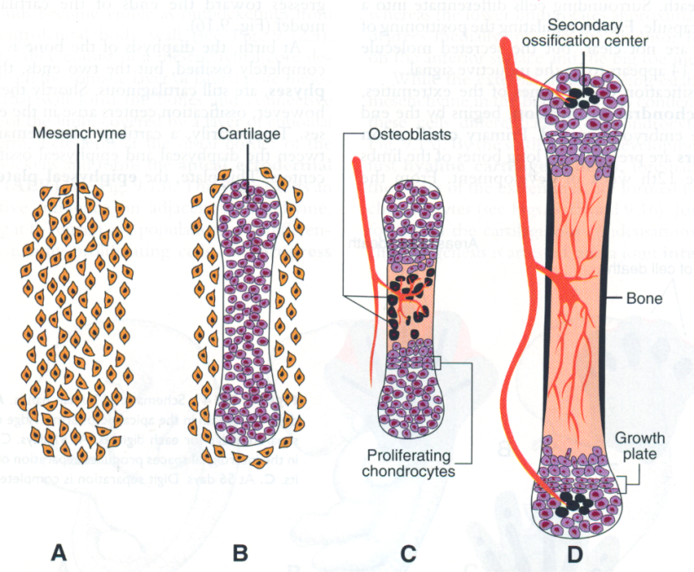--**Achondroplastic dwarfism** occurs when there are defects in FGF signaling or anything related to chondrocyte proliferation and results in **shortened limb bones** due to premature closure of epiphyseal growth plates

**III. Limb growth and patterning**

**A.** Much of the initial growth and patterning of the limbs occurs during weeks 4 – 8. Limb buds **appear at about 4 weeks** and much of the **basic structures of the limbs** (bones and muscle groups) are established by **8 weeks**. After 8 weeks, the limb elements then just increase in size.

**B.** Disruption of growth and/or patterning can result in many possible defects:

* **Amelia**: absence of an entire limb (e.g. early loss of Fgf signaling)
* **Meromelia:** absence of part of a limb (e.g. later or partial loss of Fgf signaling)
* **Phocomelia**: short, poorly formed limb (e.g. partial loss of Fgf; or Hox disruption)
* **Adactyly**: absence of digits (e.g. even later loss of Fgf)
* **Ectrodactyly**: “Lobster-Claw” deformity (variant of adactyly –middle digit is lost)
* **Polydactyly:** extra digits (disruption –usually **upregulation**– of Shh pathway)
* **Syndactyly**: fusion of digits (BMP or Shh disruption)

**C.** Patterning, growth, and maturation of the limbs occurs along **proximal-distal**, **anterior (rostral)-posterior (caudal)**, and **dorsal-ventral** axes. Because of all of the complexity, limb defects are among the **most common of all birth defects** with an overall incidence of **1:200 of all live births**.

**D.** **Proximo-distal growth and patterning:**

* Limb outgrowth initiated by the **apical ectodermal ridge** (AER) at the tip of the limb buds and proceeds from **proximal** (i.e. shoulder or hip) to **distal** (i.e. hand or foot); i.e. proximal elements (humerus/femur) are formed prior to distal elements (ulna/tibia).
* This process is absolutely dependent on FGF signaling from the AER ***–anything that disrupts FGF signaling and/or formation and maintenance of the AER will result in arrested limb development***.
* 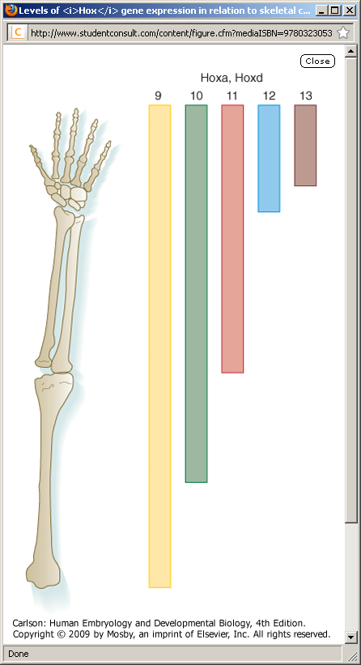Proximo-distal patterning of the limb elements is also dependent on HOX genes to specify each of the elements (e.g. HOX11A,D specifies radius and ulna whereas HOX12A,D specifies carpals). Disruption of HOX genes (via mutation or teratogens such as retinoic acid or ethanol) will therefore result in the loss of specific limb elements.

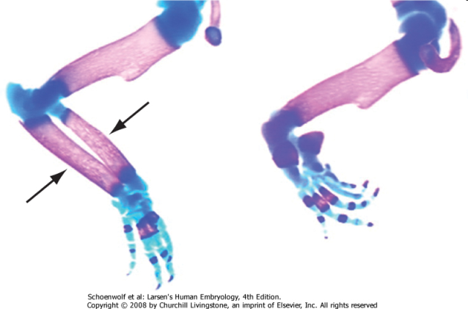

Loss of HOX11A

and/or HOX11D

**E.** **Dorso-ventral patterning:**

* Specifies the dorsal surface (e.g. extensors) vs. ventral surface (flexors, palm/sole) of the limbs
* Ventral (BMPs and Engrailed-1) and dorsal (Wnt7) signaling factors are antagonistic and this is what sets up the AER specifically at the tip of the limb bud, so disruption of D-V signals will not only affect D-V patterning, but can also affect proximo-distal growth as well.

**F.** **Anterior-posterior patterning:**

* Anterior-posterior here is in the **embryological sense** where “anterior” means toward the head. Holding the arms straight out with the thumbs up, the thumb and radius are therefore “anterior” whereas the little finger and ulna are “posterior.”
* A-P patterning is established by the **Zone of Polarizing Activity** (ZPA) on the **posterior** side of the limb (i.e. the little finger side). Shh signaling from the ZPA specifically signals the formation of posterior elements.
  + ***Loss of the ZPA therefore results in loss of posterior elements***
  + ***Upregulation of ZPA signals results in additional posterior elements (e.g. polydactyly on hypothenar side of hand)***
  + ***Duplication of the ZPA results in duplication of posterior elements (e.g. little fingers on both sides of the thumb)***

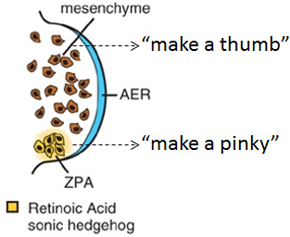

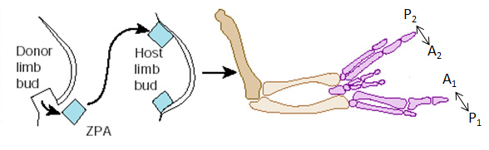

* Signaling from the ZPA also essential for maintaining the AER, so disruption of the ZPA often results in dysregulation of limb growth (too long if ZPA signals are upregulated; too short if ZPA signaling is lost).
* 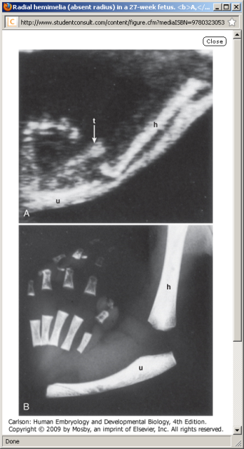Development proceeds such that **posterior elements** (e.g. little finger/ulna) are formed **prior** to **anterior elements** (e.g. radius/thumb). ***Therefore, disruption of A-P patterning and growth can also result in the loss of anterior elements (e.g. loss of the radius and/or thumb).***

**IV. Separation of digit rays**

* The digits are initially interconnected by tissue which then regresses via apoptosis to produce separate digits
* Apoptosis of interdigital tissue is dependent on BMP signaling within the interdigital tissue under the influence of Shh from the ZPA. ***Disruption of this process can therefore result in syndactyly, and, not surprisingly, most often affects digits 3, 4, and/or 5.***

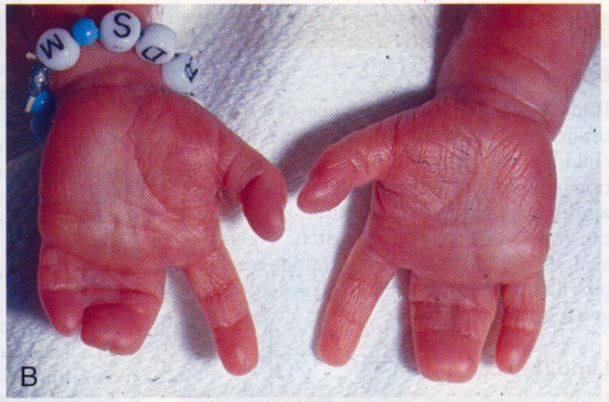

**V. Development of body musculature**

**A.** Derived from paraxial mesoderm (somitomeres in head, somites in neck and trunk)

**B.** Somite gives rise to **sclerotome**, which develops into vertebral and rib bones; **myotome**, which develops into muscle, and **dermatome**, which develops into dermal connective tissue.

**C.** Myotome is further divided into **primaxial myotome** and **abaxial myotome** subpopulations**:**

* **Primaxial myotome:** population of myoblasts adjacent to neural tube (i.e. closer to the “axis,” hence the term “primaxial”) and affected by signaling factors from the neural tube to generate muscle precursors with limited migratory potential. These less migratory cells give rise to **epaxial muscles** of the back as well as **proximal hypaxial muscles** of the body wall (prevetebrals, intercostals), “strap muscles” (scalenes and geniohyoid) and proximal limb girdle (rhomboids, levator scapulae, and latissimus dorsi).

*Recall that “epaxial” and “hypaxial” refers to the INNERVATION of muscles (epaxial innervated by DORSAL rami, hypaxial by VENTRAL rami).*

* 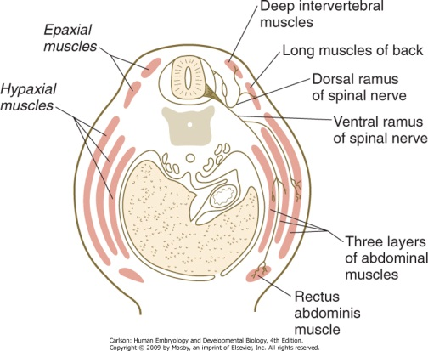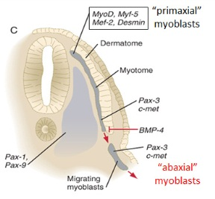**Abaxial myotome:** ventrolateral myoblasts that are farther away from the neural tube and respond instead to signals from the adjacent lateral plate mesoderm and ectoderm to give rise to a migratory population of muscle precursors that stream out into the body wall and limbs.