**Gut Development Learning Objectives:**

1. Understand the contributions of endoderm and mesoderm to the gastrointestinal tract and associated glands.

2. Understand the vascular basis of the division of the gastrointestinal tract into foregut, midgut, and hindgut.

3. Understand the developmental basis by which the gastrointestinal tract is suspended within the body cavity by mesenteries and which gastrointestinal organs have both dorsal and ventral mesenteries versus those which have only dorsal mesenteries.

4. Understand the **general** process of cranial-caudal and radial patterning of the gut tube occurs.

5. Understand the general processes by which each region of the gastrointestinal tract develops and developmental anomalies that can occur with errors in this process:

1. esophagus (especially atresia, tracheoesophageal fistulae, and/or stenosis)
2. stomach (especially pyloric stenosis)
3. liver and pancreas (especially the etiology and complications of an annular pancreas)
4. midgut and proximal colon (particularly herniation and rotation and associated complications)
5. hindgut (particularly division of the alimentary and urogenital tracts).

6. Understand what is meant by the designation of an organ as intraperitoneal vs. retroperitoneal vs. secondarily retroperitoneal and to which regions of the GI tract these specific terms apply.

7. Understand the general process by which the enteric nervous system develops and defects that might occur due to errors in this process.

**Gut Development Notes**

**I. Overview**

**A. Formation of the primitive gut tube**

* The gut tube is formed from endoderm lining the yolk sac which is enveloped by the developing coelom as the result of cranial and caudal folding.
* During folding, **somatic mesoderm** is applied to the body wall to give rise to the **parietal peritoneum. Visceral (or splanchnic) mesoderm** is wraps around the gut tube to form the **mesenteries** that suspend the gut tube within the body cavity. The mesoderm immediately associated with the endodermal tube also contributes to most of the wall of the gut tube. **Nerves** and **neurons** found in the wall are derived from **neural crest.**
* Summary of germ layer contributions:
  + endoderm: **mucosal epithelium, mucosal glands, and submucosal glands** of the GI tract.
  + mesoderm: **lamina propria, muscularis mucosae, submucosal connective tissue** and **blood vessels, muscularis externa**, and **adventitia/serosa**
  + neural crest: **neurons** and **nerves** of the submucosal and myenteric plexes

**B. Basic subdivisions of the gut tube**

* Cranio-caudal and lateral folding cause the opening of the gut tube to the yolk sac to draw closed (like a pursestring) forming a pocket toward the head end of the embryo called the "anterior (or cranial) intestinal portal" and a "posterior (or caudal) intestinal portal" toward the tail of the embryo. These are the future foregut and hindgut, respectively. The midgut remains open to the yolk sac.

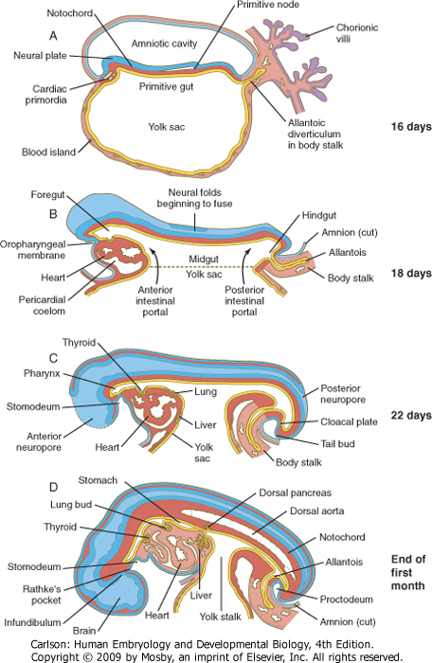

* Further folding and growth of the embryo causes the communication of the gut with the yolk sac to continue to get smaller and the regions of the gut (foregut, midgut, and hindgut) to become further refined:



* **The derivatives of the gut regions are as follows:**

**FOREGUT MIDGUT HINDGUT**

Trachea & respiratory tract Lower duodenum** Distal 1/3 of transverse colon

Lungs Jejunum Descending colon

Esophagus Ileum Sigmoid colon

Stomach Cecum Rectum

Liver Appendix Upper anal canal

Gallbladder & bile ducts Ascending colon Urogenital sinus

Pancreas (dorsal & ventral) Proximal 2/3 of transverse colon

Upper duodenum*

*portion served by ant. and post. **portion served by ant. and post.

**superior** pancreaticoduodenal **inferior** pancreaticoduodenal

arteries arteries

**C. Definitive subdivisions of the gut tube**

* Within the abdominal cavity, the gut is definitively divided into **foregut, midgut,** and **hindgut BASED ON THE ARTERIAL SUPPLY:**
  + **Foregut derivatives in the abdomen** are supplied by branches of the **celiac artery**
  + **Midgut derivatives** are supplied by branches of the **superior mesenteric artery**
  + **Hindgut derivatives** are supplied by branches of the **inferior mesenteric artery**

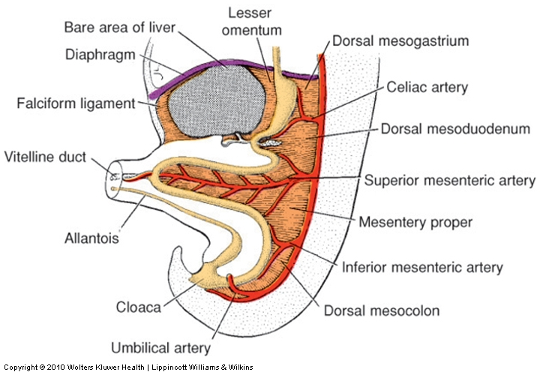

**D. Cranio-caudal patterning of the gut tube**

* specific regions of the gut tube (i.e. that which will become lung vs. that which become esophagus vs. stomach, etc.) and important junctions (e.g. gastro-esophageal junction) are established by a cranial to caudal pattern of segmental, combinatorial "codes" of HOX gene expression in the endoderm and mesoderm of the early embryo.

**E. Radial patterning of the gut tube**

* concentric layering of the gut tube is accomplished largely via expression of Sonic Hedgehog (SHH) in the endoderm which inhibits smooth muscle and neuronal differentiation close to the endoderm. Farther away from the endoderm, the SHH concentration is lower, thus permitting smooth muscle and neuronal differentiation in the muscularis externa. Later in development, the SHH expression goes away, allowing development of smooth muscle in the muscularis mucosae and neurons of the submucosal plexus.
* As the gut tube tube develops, the endoderm proliferates rapidly and actually temporarily OCCLUDES the lumen of the tube around the 5th week. Growth and expansion of mesoderm components in the wall coupled with apoptosis of some of the endoderm at around the 7th week causes re-canalization of the tube such that by the 9th week, the lumen is open again.

***This occlusion and re-canalization process occurs THROUGHOUT the tube (esophagus to anus) and errors in this process can occur in anywhere along the tube resulting in stenosis (narrowing of the lumen or even outright occlusion) in that region.***

**F. Mesenteries of the gut tube (refer to the figure on the previous page)**

* the thoracic esophagus and anus are anchored within the body wall and are therefore **retroperitoneal**
* the stomach and liver are suspended in a mesentery that is attached to the dorsal AND ventral body walls:
  + the **dorsal mesentery of the stomach** becomes the **greater omentum**
  + the **ventral mesentery of the liver** becomes the **falciform ligament**
  + the **mesentery between the stomach and liver** becomes the **lesser omentum**
* the rest of the GI tract is suspended by a dorsal mesentery, named according to the organ to which it is attached (mesoduodenum, mesoappendix, mesocolon, etc.)
* some portions of the GI tract remain **intraperitoneal** in the adult and are therefore suspended by a mesentery.
* some portions of the GI tract, however, are applied against the body wall during development and the dorsal mesentery becomes incorporated into the body wall, making the organ **secondarily retroperitoneal**.

A summary of what is retroperitoneal, intraperitoneal, or secondarily retroperitoneal in the adult:

**Retroperitoneal Intraperitoneal Secondarily retroperitoneal**

thoracic esophagus abdominal esophagus duodenum

rectum spleen pancreas

anus stomach ascending colon

liver & gallbladder descending colon

jejunum & ileum

cecum & appendix

sigmoid colon

**II. Derivatives of the foregut:**

**A. Esophagus**

* The region of the foregut just caudal to the pharynx develops two longitudinal ridges called the **tracheoesophageal folds** that divide the tube **ventrally** into the **trachea** (and subsequent lung buds), and **dorsally** into the **esophagus**.
* As with the rest of the gut tube, the lumen of the esophagus becomes temporarily OCCLUDED around the 5th week of development and recanalizes by around the 9th week.
* The esophagus is initially short and must grow in length to "keep up" with the overall growth in length of the embryo.

**Clinical considerations**

1. **Esophageal atresia**
   * occurs when the tracheoesophageal ridges deviate too far dorsally causing the upper esophagus to end as a closed tube.
   * usually is accompanied by a tracheoesophageal fistula, in which case gut contents can be aspirated into the lungs after birth causing inflammation (pneumonitis) or even infection (pneumonia).
   * typically associated with polyhydramnios prenatally (the fetus cannot swallow amniotic fluid and it accumulates in the amniotic cavity). Postnatally, the child will regurgitate IMMEDIATELY upon feeding and, if a tracheoesophageal fistula is present, there will be congestion in the lungs.
2. **Esophageal stenosis**
   * occurs when the esophagus fails to recanalize
   * also typically associated with polyhydramnios prenatally. Postnatally, the child will regurgitate IMMEDIATELY upon feeding. However, there is usually NOT a tracheoesophageal fistula, so the lungs will usually NOT be congested.
3. **Congenital hiatal hernia**
   * occurs when the esophagus fails to grow adequately in length. As a result, the esophagus is too short and therefore pulls the cardiac stomach into the esophageal hiatus in the diaphragm. The resulting compromised structure of the hiatus can allow other gut contents (usually loops of small bowel) to herniate up into the thoracic cavity.

**B. Stomach**

* appears first as a fusiform dilation of the foregut endoderm which undergoes a 90° rotation such that the **left side** moves **ventrally** and the **right side** moves **dorsally** (the vagus nerves follow this rotation which is how the **left vagus** becomes **anterior** and the **right vagus** becomes **posterior**).
* differential growth on the left and right sides establishes the greater and lesser curvatures, respectively; cranio-caudal rotation tips the pylorus superiorly
* dorsal AND ventral mesenteries of the stomach are retained to become the greater and lesser omenta, respectively
* proliferation of mesoderm-derived smooth muscle in the caudal end of the stomach forms the pyloric sphincter (dependent on a variety of genetic factors)

***Clinical Considerations Related to Stomach Development***

***Hypertrophic pyloric stenosis***

* + *occurs due to oveproliferation (hypertrophy) of the smooth muscle of the pyloric sphincter*
  + *rather common (0.5% to 0.1% of infants), more so in males than females; also tends to run in families*
  + *is associated clinically with* ***forceful*** *or "****projectile,****"* ***non-bilious vomiting*** *shortly after feeding (usually ~1 hour) because the hypertrophic sphincter prevents gastric emptying into the duodenum. The vomit is usually non-bilious because the blockage is UPSTREAM of the duodenal papilla where bile is added to the gut tube. The hypertrophied sphincter can sometimes be palpated as a* ***small knot at the right costal margin in the epigastric region*** *–sometimes, contractions of the sphincter can even be seen or felt under the skin.*

**C. Liver**

* arises out of ventral foregut endoderm adjacent to the septum transversum (the mesoderm of the septum transversum and developing heart send out signals that induce this region of endoderm to become liver).
* the parenchyma of the liver (cords of hepatocytes and branched tubules of bile ducts) intercalates within the tissue of the septum transversum and the plexus of vitelline vessels, accounting for the overall architecture observed in the adult (plates of hepatocytes, which are endoderm derived, surrounded by vascular sinusoids, which are mesoderm derived).

**D. Pancreas**

* the endodermal lining of the foregut forms TWO outgrowths caudal to the forming liver: the **ventral pancreatic bud** and the **dorsal pancreatic bud.**
* within each bud, the endoderm develops into branched tubules attached to secretory acini (the exocinre pancreas). The endocrine pancreas (islets of Langerhans) arise from stem cells at the duct branch points that then develop into discrete islands of vascularized endocrine tissue within the parenchyma of the exocrine glandular tissue.
* Primary rotation of the gut tube (discussed later), causes the ventral and dorsal buds to merge together into what is usually a SINGLE organ in the adult:
  + the **uncinate process** of the **head** of the pancreas is derived from the **ventral pancreatic bud**
  + the **remaining portion of the head**, **body, and tail** of the pancreas is derived from the **dorsal pancreatic bud**

*Errors in the fusion process can result in an* ***annular pancreas*** *that wraps around the duodenum, which can cause obstruction –the symptoms of which would be similar to pyloric stenosis except that the vomit may be bilious and there would NOT be a palpable knot in the epigastric region.*

**E. Proximal or upper duodenum**

* arises from the caudalmost part of the foregut and is served by anterior and posterior branches of the superior pancreaticoduodenal artery, which is a branch of the celiac artery.
* with rotation of the gut tube, the duodenum and pancreas are pushed up against the body wall and become **secondarily retroperitoneal**.

**III. Derviatives of the midgut**

**A. Distal or lower duodenum**

* arises from the cranialmost portion of the midgut and is served by anterior and posterior branches of the inferior pancreaticoduodenal artery, which is a branch of the superior mesentery artery.
* as with the rest of the duodenum, becomes **secondarily retroperitoneal**
* as with the rest of the entire GI tract, the lumen is obliterated transiently during development and then re-canalizes.

*Failure to recanalize the duodenum can result in stenosis (narrowing) or atresia (complete blockage), the symptoms of which would be bilious projectile vomiting an hour or so after feeding.*

**B. Jejunum, ileum, cecum, appendix, ascending colon, and proximal 2/3 of transverse colon**

* elongates rapidly beyond the capacity of the embronic abdominal cavity and thus forms a U-shaped loop that herniates into the umbilicus and is oriented parallel to axis of the embryo such that there is an upper, or cranial, loop and a lower, or caudal, loop.
* the upper loop contains what will be jejunum and upper part of the ileum.

* the lower, or caudal loop, contains what will be the lower ileum, cecum, appendix, ascending colon and proximal 2/3 of the transverse colon. The appendix can be seen as a diverticulum that is initially pointed downward or toward the tail.
* the midpoint of the loop (which is future ileum) is attached to an elongated remnant of the yolk sac called the vitelline duct that normally becomes obliterated.

*Failure to obliterate the vitelline duct can result in diverticula (out pouching of the gut tube) called Meckel's diverticula,vitelline cysts or vitelline fistulas (a connection of the small intestine to the skin). These will often be attached at one end to the umbilicus and at the other end to the ileum.*

* the gut tube undergoes a PRIMARY rotation of 90 degrees counterclockwise (if you were looking at the embryo) such that the lower loop (which has the appendix) is on the embryo's left side.
* as the embryo grows the abdominal cavity expands thus drawing the gut tube back into the abdomen, during which time the gut tube further rotates another 180 degrees such that the appendix ends up in the upper right quadrant.
* growth of colon pushes the appendix down to its final location in the lower right quadrant.

*Failure to pull all of the gut contents back into the abdominal cavity or to completely close off the ventral body wall at the umbilicus can result in an oomphalocoele, where the gut contents herniate out of the body wall.*

*Defects and variations in rotation can cause a variety of aberrant anatomical positions of the viscera that are often asymptomatic, but important to appreciate when trying to diagnose and/or treat gastrointestinal problems (e.g. abnormal positioning of the appendix due to malrotation should be considered when trying to diagnose appendicitis). Malrotation can also cause twisting or volvulus of the gut tube resulting in stenosis and/or ischemia. Alternatively, blood supply to a portion of the mid- or hindgut may become compromised during rotation or herniation leading to ischemia and loss, fibrosis, septation, or narrowing of that portion.*

**III. Derivatives of the hindgut**

* include the distal 1/3 of the transverse colon, descending colon, sigmoid colon, rectum, and upper anal canal.
* terminal end of the hindgut ends in an endoderm-lined pouch called the cloaca, which is in common with the developing lower urogenital tract.
* the formation of a urorectal septum divides the cloaca ventrally into urogenital sinus and dorsally into the rectoanal canal:
  + urogenital sinus contributes to the lower urogenital tract:
    - bladder (except trigone), urethra, and vagina in the female
    - bladder (except trigone), prostate gland, and prostatic and membranous urethras in the male
  + rectoanal canal: forms the rectum and upper anal canal
  + urorectal septum: develops into the perineal body
* The portion of the cloaca where the hindgut endoderm is up against the ectoderm of the skin breaks down to allow the formation of the anus.

*Failure of the cloacal membrane to break down (due to TOO MUCH mesoderm) can result in an* ***imperforate anus****.*

*Failure to generate enough mesoderm during gastrulation can result in* ***anal atresia*** *in which there is insufficient development of the wall (namely the smooth muscle and connective tissue) of the rectoanal canal*

*Failures in the division of the cloaca (usually accompanied by anal atresia) can lead to a variety of aberrant connections of the rectal canal to portions of the urogenital tract.*

* innervation of the hindgut is achieved via the migration of vagal and sacral neural crest cells into the wall of the hindgut followed by their differentiation into neurons of the submucosal and myenteric plexuses (the same is true for the midgut and foregut except that they receive only vagal neural crest).

*Failure of neural crest cells to migrate and/or differentiate into neurons in a portion of gut will result in an* ***aganglionic segment*** *(missing submucosal and myenteric ganglia). The main function of these ganglia is to allow local relaxation in the wall of the gut tube, so the aganglionic segment is tonically contracted, leading to obstruction. For a variety of reasons, the distal portions of the colon are most susceptible to this problem, leading to a condition known as* ***Hirschsprung disease*** *or* ***congenital megacolon****. This condition occurs in about 1:5000 births (2-4x more in males than females) and the affected individuals often present with a* ***very distended abdomen*** *due to the presence of an aganglionic segment of colon (usually in the sigmoid colon) that causes a blockage and then backup of feces (and massive enlargement) in the descending colon. Not surprisingly, these individuals often have other neural crest-related defects (hypopigmentation, outflow tract defects, pharyngeal arch defects, etc.).*