**DEVELOPMENT OF THE KIDNEYS**

**I. Overview**

* The urogenital system arises from **intermediate mesoderm** which forms a **urogenital ridge** on either side of the aorta.
* The urogenital ridge develops into three sets of tubular nephric structures (from head to tail): the **pronephros**, the **mesonephros**, and the **metanephros.**

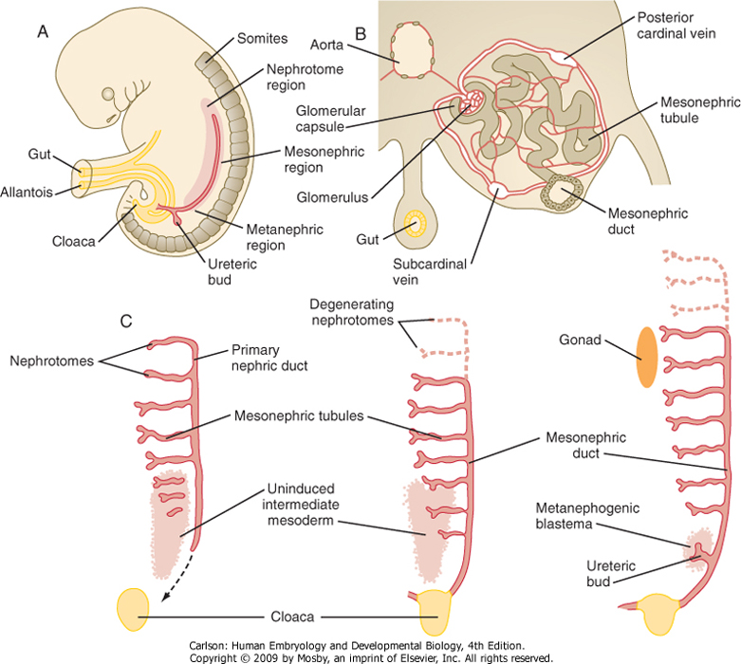

**A. The Pronephros**

* Is the cranialmost set of tubes, which mostly regress

**B. The mesonephros**

* Is located along the midsection of the embryo and develops into **mesonephric tubules** and the **mesonephric duct** (Wolffian duct).
* These tubules carry out some kidney function at first, but then many of the tubules regress. **However, the mesonephric duct persists and opens to the cloaca at the tail of the embryo.**

**C. The metanephros**

* Gives rise to the definitive adult kidney.
* Develops from an outgrowth of the caudal mesonephric duct, the **ureteric bud**, and from a condensation of nearby renogenic intermediate mesoderm, the **metanephric blastema**.

**II. Steps in renogenesis**

* Involves a process of **reciprocal induction**, which is **retinoic acid dependent**
* Cranial-caudal patterning establishes a “renogenic” region within the intermediate mesoderm in the tail of the embryo –this renogenic mesoderm is the **METANEPHRIC BLASTEMA**
* The METANEPHRIC BLASTEMA secretes growth factors that induce growth of the **URETERIC BUD** from the caudal portion of the mesonephric duct.
* The URETERIC BUD proliferates and responds by secreting growth factors that stimulates proliferation and then differentiation of the metanephric blastema into glomeruli and kidney tubules (i.e. induces the blastema to undergo **mesenchymal-to-epithelial transition** ).
* Perturbations in **any aspect** of these inductive events (e.g. mutations of either metanephric or ureteric factors or disruption of retinoic acid signaling) may cause inhibition of ureteric bud growth and **renal hypoplasia** or **agenesis**. Conversely, **duplication** or **overproliferation** of structures can occur if there is a gain of function of the inductive factors.

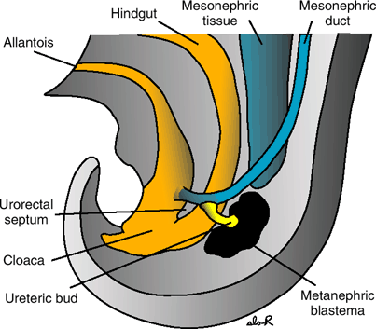

**III. Derivatives of the ureteric bud and metanephric blastema in the adult kidney**

**A. Derivatives of the metanephric blastema:**

* Podocytes covering glomerular capillaries
* 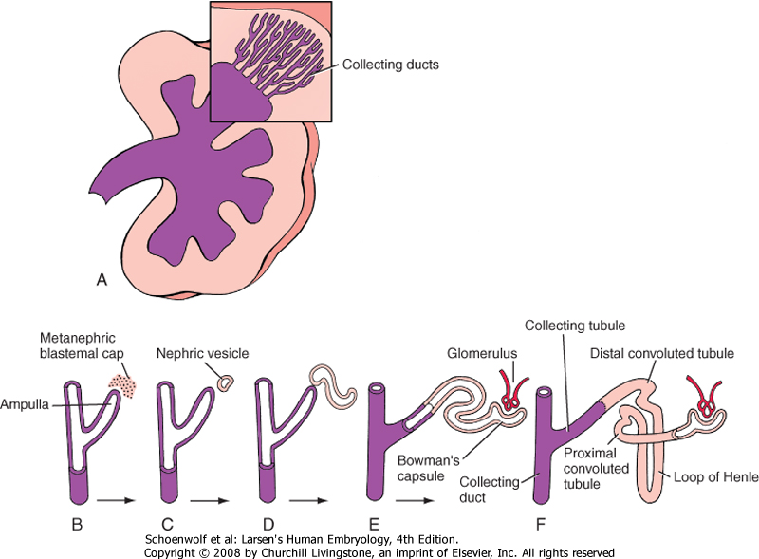Epithelial cells lining Bowman’s capsule
* Proximal convoluted tubules
* Descending thick limbs of the loops of Henle
* Thin limbs of the loops of Henle
* Ascending thick limbs of the loop of Henle
* Distal convoluted tubules

**B. Derivatives of the ureteric bud:**

* Collecting tubules and ducts
* Minor and major calyces
* Ureters

**IV. Examples of perturbations in induction or differentiation of kidney tissue**

**A. Duplication of the urinary tract**

* Occurs when the ureteric bud prematurely divides before penetrating the metanephric blastema
* Results in either a double kidney and/or a duplicated ureter and renal pelvis

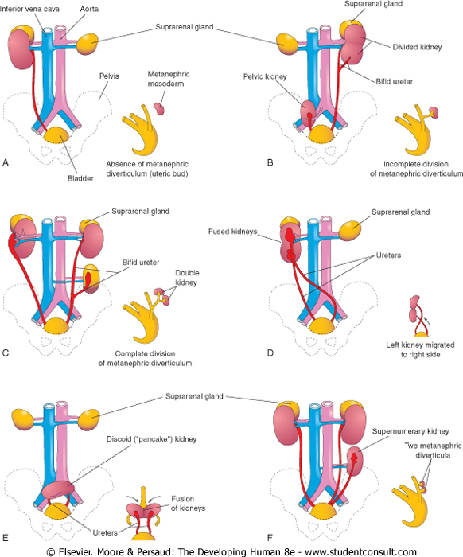

**B. Renal-Coloboma syndrome**

* The Pax2 gene essential for metanephric mesenchyme to differentiate into epithelial tubules in response to inductive signals from ureteric bud, so mutations (even if HETEROZYGOUS) can produce renal defects. Patients typically exhibit the following symptoms:
  + Renal hypoplasia - due to reduced proliferation of the mesenchyme derived epithelia during development.
  + Vesicouretral Reflux - most likely due to improper connection of the ureter to the bladder or possibly due to inherent defects in epithelial cells of the mature ureter.
  + Colobomas (ventral fissures in iris, retina, and/or optic nerve) - due to failure of the optic fissure to fuse (expression of Pax2 is observed in ventral part of the optic cup and optic stalk).

**C. Nephroblastoma (Wilms Tumor)**

* found in infants from 0-24 months of age
* consists of blastemal, epithelial, and stromal cell types
* associated with mutations in genes related to kidney development (PAX2, WT1, etc.)
* essentially due to **incomplete mesenchymal-to-epithelial transformation** (i.e. the cells fail to fully differentiate and transform into cancerous cells).

**D. Polycystic kidney disease**

* can arise due to a variety of factors:
  + loss of polarity: aberrant differentiation of tubule cells results in inappropriate location of Na/K channels to the apical (rather than basal) domain of the cells. Na+ is pumped apically, water follows resulting in dilation of tubule lumens.
  + Overproliferation: excessive growth of tubule epithelium can occlude the lumen causing blockage.

*A hallmark of renal agenesis, hypoplasia, or dysfunction in utero is* ***oligohydramnios*** *(low amniotic fluid volume) since the amniotic fluid is produced by the kidneys. Reduced amniotic fluid volume causes increased pressure on the developing fetus, resulting in a* ***sloped forehead****,* ***“parrot beak” nose****,* ***shortened fingers****, and* ***hypoplasia of internal organs****, particularly the* ***gut*** *and* ***lungs****. Collectively, this sequence of anomalies is known as the* ***Potter sequence.***

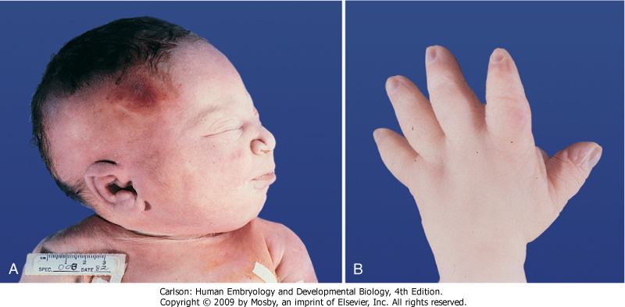

**V. Ascent of the kidneys**

* The kidneys initially form near the tail of the embryo.
* Vascular buds from the kidneys grow toward and invade the common iliac arteries.
* Growth of the embryo in length causes the kidneys to “ascend” to their final position in the lumbar region.
* Rather than “drag” their blood supply with them as they ascend, the kidneys send out new and slightly more cranial branches and then induce the regression of the more caudal branches.

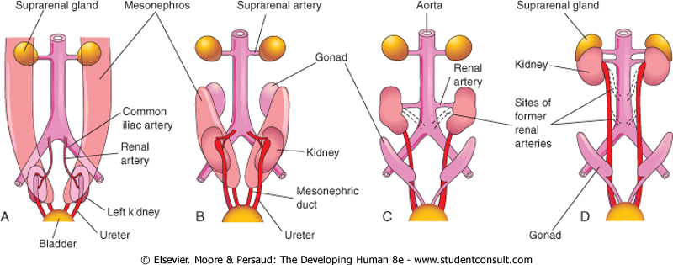

**VI. Malformations related to the ascent of the kidneys**

* **Pelvic kidney (A):** one or both kidneys stays in the pelvis rather than ascending
* **Horseshoe kidney (B):** the two developing kidneys fuse ventrally into a single, horseshoe shape that gets trapped in the abdomen by the inferior mesenteric artery.
* **Supernumerary arteries (C):** can often have more than one renal artery per kidney, which is often asymptomatic but can sometimes compress the ureter causing a backup of fluid into the renal pelvis and kidney tubules (hydronephrosis)

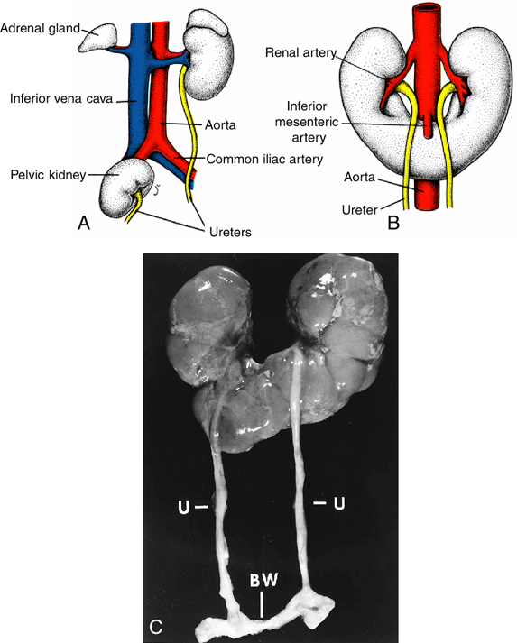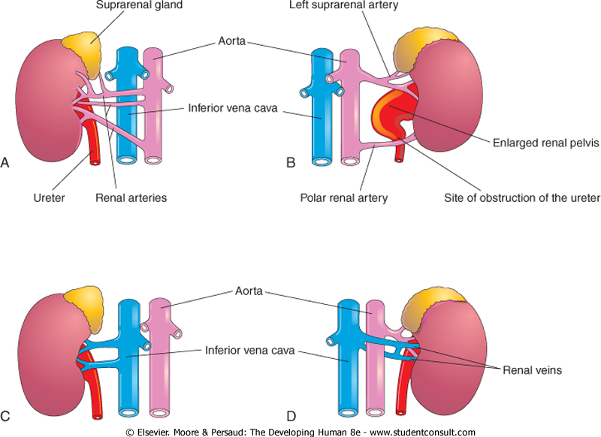

**C**

**VII. Development of the bladder**

* The terminal part of the hindgut ends in the CLOACA, which is an endoderm-lined chamber that contacts the surface ectoderm at the cloacal membrane and communicates with the allantois, which is a membranous sac that extends into the umbilicus alongside the vitelline duct.
* The cloaca is then divided by the URORECTAL SEPTUM
  + the DORSAL (inferior) portion develops into the RECTUM and ANAL CANAL
  + 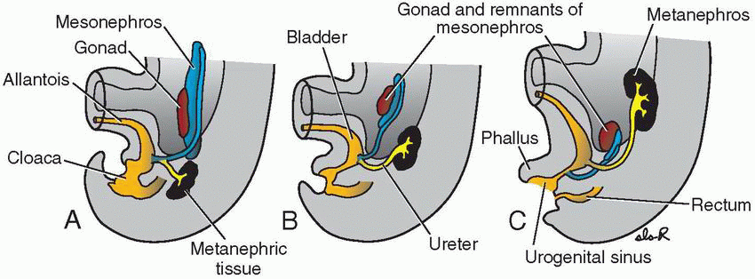the VENTRAL (superior) portion develops into the UROGENITAL SINUS which will give rise to the **bladder** and **lower urogenital tracts** (prostatic and penile urethrae in males; urethra and lower vagina in females).
* 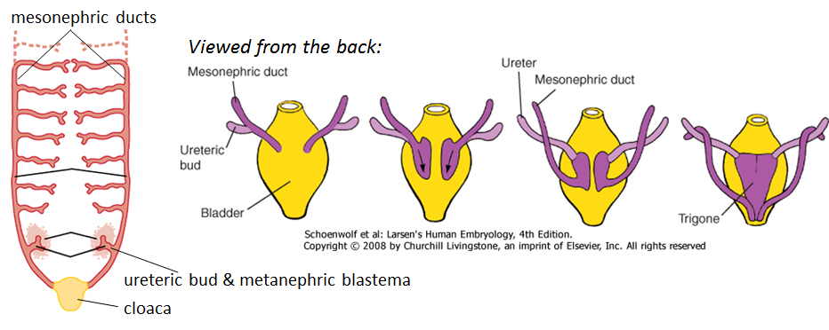As the bladder grows and expands, the distal ends of the mesonephric ducts are absorbed into the wall of the bladder as the **TRIGONE**.

**VIII. Malformations related to the development of the bladder**

* **Trigonitis:** As a MESONEPHRIC DUCT derivative, the trigone is sensitive to sex hormones and can undergo hormone-induced epithelial metaplasia (usually transformation from a transitional type to squamous type epithelium which can overproliferate and lead to urinary blockages).
* **Abnormal attachment of the ureters**: the ureters can sometimes be attached to either to the urethra or parts of the reproductive tracts.
* **Urachal fistulas, sinuses, and cysts**: occur when a **remnant of the allantois persists** and are found in the midline along the path from the umbilicus to the apex of the bladder (i.e. along the median umbilical ligament).

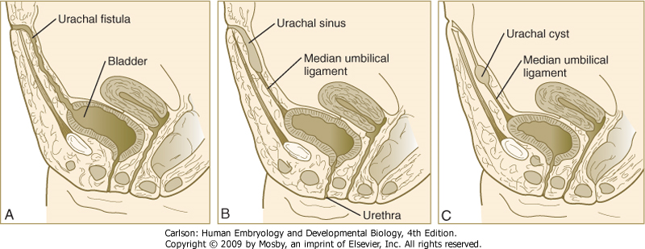

**DEVELOPMENT OF THE SUPRARENAL GLANDS**

**I. Development of the adrenal cortex**

* Arises mostly from **intermediate mesoderm** in the lumbar region of the embryo.

**II. Development of the adrenal medulla**

* Trunk **neural crest cells** migrate into the center of the adrenal glands and develop into the chromaffin cells of the adrenal medulla. These cells are essentially postganglionic sympathetic neurons that release epinephrine or norepinephrine directly into the bloodstream as opposed to innervating a target organ.

**DEVELOPMENT OF THE REPRODUCTIVE SYSTEMS**

**I. Overview**

* The **gonads** arise from intermediate mesoderm within the urogenital ridges of the embryo
* The **genital ducts** arise from paired **mesonephric** and **paramesonephric ducts**
  + **The mesonephric ducts** give rise to **MALE genital ducts**
  + **The paramesonephric ducts** give rise to **FEMALE genital ducts**

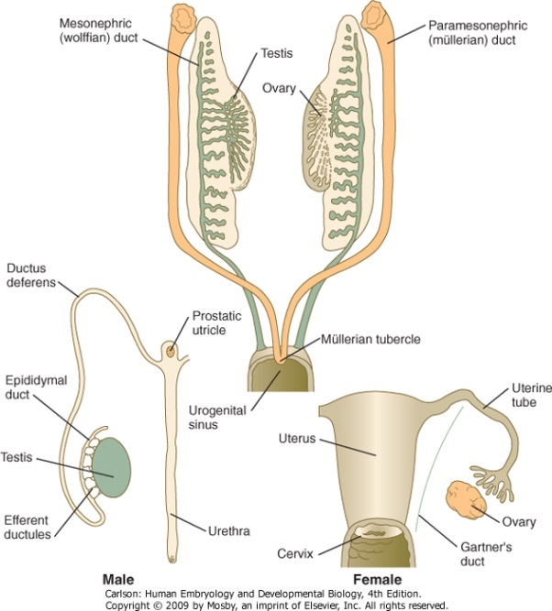

* The gonads and reproductive tracts are indifferent up until 7 weeks of development; differentiation is influenced largely by the presence or absence or SRY (on the Y chromosome)
  + If SRY+, then development proceeds along the male path
  + If SRY-, then development proceeds along the female path

**II. Development of the MALE reproductive tract**

* Under the influence of SRY, the gonad develops into a TESTIS containing spermatogonia, Leydig cells, and Sertoli cells.
* **Leydig cells** produce **TESTOSTERONE**, which support growth of the **mesonephric ducts**. ***NOTE: without testosterone, the mesonephric ducts will REGRESS.***
* Some testosterone is converted into **Dihyroxytestosterone** (DHT), which supports development of the prostate gland, penis, and scrotum.
* **Sertoli cells** produce **ANTI-MÜLLERIAN HORMONE** (aka Müllerian Inhibiting Substance, or MIS), which induces **regression of the paramesonephric ducts. *NOTE: in the absence of MIS, the paramesonephric ducts will PERSIST.***

**III. Descent of the testes**

* The testes arise in the lumbar region but then descend into pelvic cavity and through the inguinal canal to end up in the scrotum
* Descent of the testis is due to tethering of the testes to the anterior body wall by the gubernaculum. With growth and elongation of the embryo coupled with shortening of the gubernaculum, the testes are pulled into the scrotum.

**IV. Summary of male urogenital tract derivatives**

* Ureteric bud: ureter
* Mesonephric ducts: rete testis, efferent ducts, epididymis, vas deferens, seminal vesicle, trigone of bladder
* Urogenital sinus: bladder (except trigone), prostate gland, bulbourethral gland, urethra

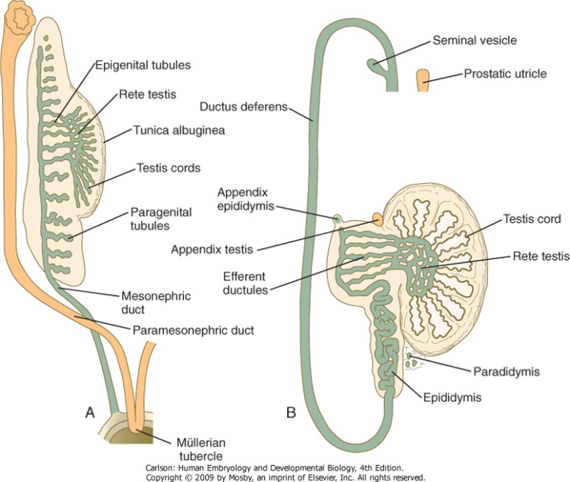

**V. Development of the female reproductive tract**

* In the absence of SRY, the gonad develops into an ovary with oogonia and stromal cells.
* Since **no testosterone** is produced, the **mesonephric ducts regress**.
* Since there is also **no MIS,** the **paramesonephric ducts persist** to give rise to the oviducts, uterus, and upper vagina

**VI. Summary of female urogenital tract derivatives**

* Ureteric bud: ureter
* Mesonephric ducts: trigone of bladder
* Paramesonephric ducts: oviduct, uterus, upper 1/3 of vagina
* 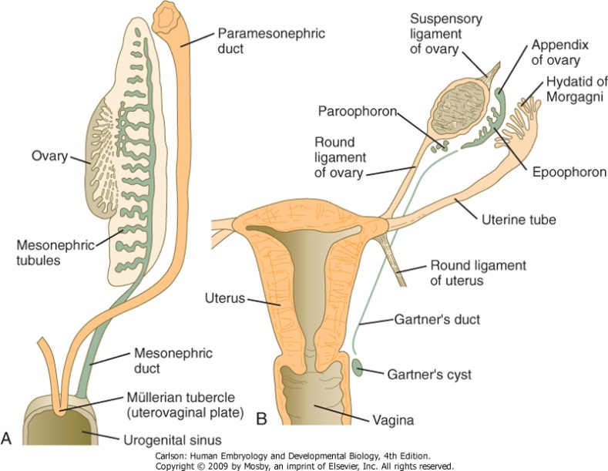Urogenital sinus: bladder (except trigone), bulbourethral gland, urethra, lower 2/3 of vagina

**VII. Formation of the external genitalia**

* Proliferation of mesoderm and ectoderm around the cloacal membrane produces primordial tissues of the external genitalia in both sexes: the genital tubercle, genital folds, and genital swellings. The primordia are indistinguishable up until about **week 12**.
* In the **MALE**, the primordia differentiate as follows:

|  |  |  |
| --- | --- | --- |
| **Genital Tubercle** | **Genital Folds** | **Genital Swellings** |
| Body and glans of penis | Ventral aspect of penis | Scrotum |
| Corpora cavernosum & spongiosum | Penile raphe | Scrotal raphe |

* In the **FEMALE**, the primordia differentiate as follows:

|  |  |  |
| --- | --- | --- |
| **Genital Tubercle** | **Genital Folds** | **Genital Swellings** |
| Body and glans of clitoris | Labia minora | Labia majora |
|  |  | Mons pubis |

**VIII. Anomalous sexual differentiation**

**A. Persistent Müllerian Duct syndrome**

* + Occurs in **genetic males** with **mutations in MIS** or the **MIS receptor**
  + Because of testosterone and DHT production, there are **normal male external genitalia** and **male genital ducts**
  + Because there is effectively **NO Mullerian inhibition**, the **paramesonephric ducts PERSIST**; i.e. there is a small uterus and paired fallopian tubes
  + The testes may lay either in what would be the normal position for ovaries (i.e. within the broad ligament) or one or both testes may descend into the scrotum.

**B. Androgen Insensitivity (aka “Testicular Feminization”) Syndrome**

* + Occurs in **genetic males** with **mutations in the androgen receptor (AR)**
  + Lack of virilization of due to inability of AR to bind testosterone or DHT
  + XY sex reversal with **relatively normal female external genitalia** but **undescended testes**
  + **Mesonephric ducts are rudimentary or lacking** due to loss of testosterone signaling
  + Normal production of MIS from Leydig cells causes **Müllerian duct regression**, so no oviducts, uterus, or upper 1/3 of vagina

**C. Female pseudointersexuality due to congenital adrenal hyperplasia**

* + Occurs in **genetic females** often due to defects in 21-hydroxylase essential for cortisol synthesis –lack of feedback to pituitary causes overproduction of ACTH and overactivity of the adrenal gland
  + Increased production of weak androgenic hormones from the adrenal gland (can’t make cortisol but can make androgens such as androstenedione) results in **weak virilization of external genitalia**:
    - Enlarged clitoris
    - Partial or complete fusion of labia majora
  + **Internal genitalia** are **FEMALE**
    - Testes **absent** (no SRY)
    - No mesonephric (male) ducts (**no testosterone** to support their development)
    - NO MIS, so the Müllerian (female) duct structures (uterus and oviduct) are **intact**.