**Craniofacial and Pharyngeal Arch Development Notes**

**Matthew Velkey, Ph.D.**

[**matt.velkey@duke.edu**](mailto:matt.velkey@duke.edu)

**I. Pharyngeal apparatus**

* paired structures associated with the pharynx that contribute greatly to the formation of the face, jaw, ear, and neck
* the 1st pharyngeal arch appears at about the beginning of the 4th week and others are added more caudally later such that there are ultimately 5 arches by the end of the 4th week; the 5th arch fails to form, so the arches are numbered 1, 2, 3, 4, and 6.
* the entire apparatus consists of paired **pharyngeal arches, pharyngeal pouches, pharyngeal clefts** (or **grooves**), and **pharyngeal membranes** (see diagram).
  + each pharyngeal arch consists of a core of **somatic mesoderm** and **neural crest mesenchyme**
    - **somatic mesoderm** contributes to the **arch artery** (i.e. aortic arches 1-6) as well as **skeletal muscle tissue** in each arch
    - **neural crest mesenchyme** develops into **bone**, **cartilage**, and/or **connective tissue** in each arch.
  + each pharyngeal arch has a cranial nerve associated with it:
    - arch 1: CN V (trigeminal)
    - arch 2: CN VII (facial)
    - arch 3: CN IX (glossopharyngeal)
    - arch 4: CN X (superior laryngeal branch of the vagus)
    - arch 6: CN X (recurrent laryngeal branch of the vagus)
  + the **inside** of the pharyngeal apparatus is lined by **endoderm** that forms infoldings or **pouches** between the arches; since there are 5 pharyngeal arches, there are **4 pharyngeal pouches**, the fates of which are discussed below.
  + the **outside** of the pharyngeal apparatus is covered by **ectodermal** that forms outer **pharyngeal clefts** (or grooves); as with the pouches, there are initially 4 pharyngeal clefts, the fates of which are discussed below

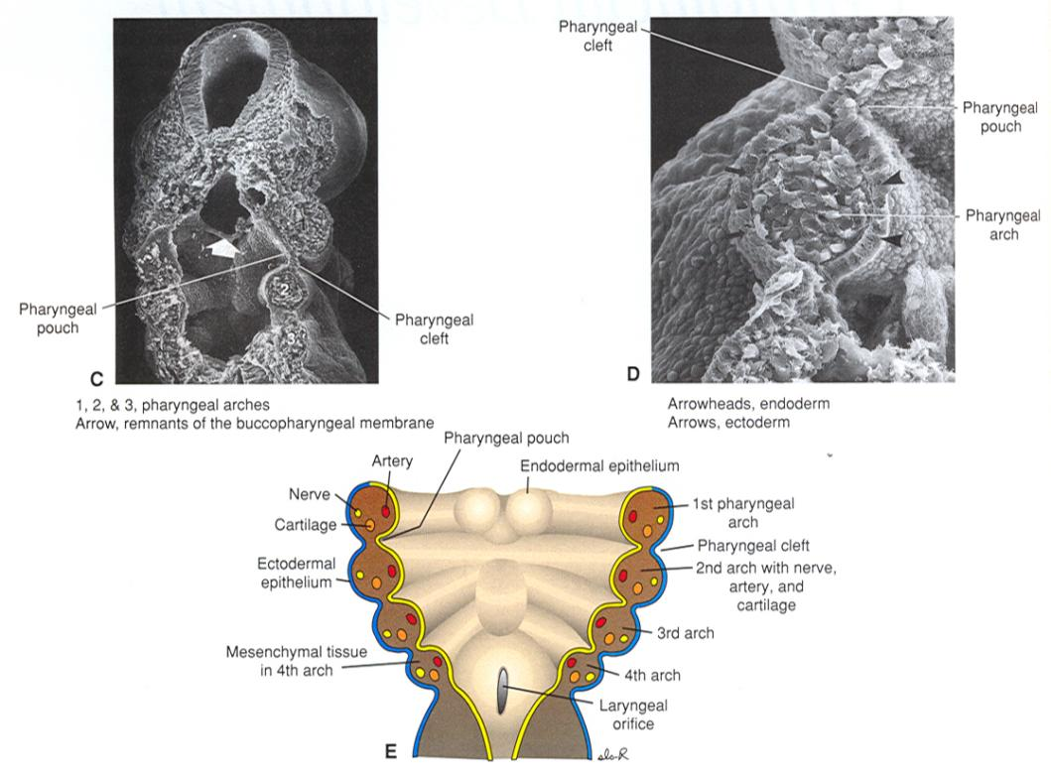

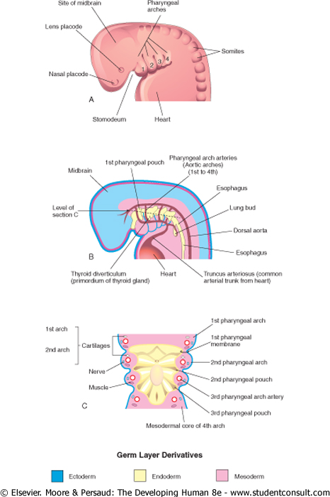

plane of section for figure below

**A. Fates of pharyngeal clefts**

**1.** **pharyngeal cleft 1**: develops into the **external auditory meatus** (the corresponding 1st pharyngeal pouch develops into the auditory (or Eustacian) tube, and the intervening membrane develops into the tympanic membrane).

*Defects in the development of pharyngeal cleft 1 can result in* ***preauricular*** *(i.e. in front of the pinna of the ear)* ***cysts*** *and/or* ***fistulas.***

**2.** **pharyngeal clefts 2, 3, and 4** are overgrown by expansion of the 2nd pharyngeal arch and usually **obliterated**.

*Remnants of pharyngeal clefts 2-4 can appear in the form of* ***cervical cysts*** *or* ***fistulas*** *found along the* ***anterior border of the sternocleidomastoid muscle****.*

**B. Fates of pharyngeal arches**

**1. Pharyngeal Arch 1 (mandibular arch)**

* associated with the 1st aortic arch, which develops into part of the **maxillary artery**
* innervated by **CN V (trigeminal nerve)**
* splits into an upper **maxillary prominence** and a lower **mandibular prominence**
* derivatives of the 1st arch are:



**2. Pharyngeal Arch 2 (hyoid arch)**

* associated with the 2nd aortic arch, which develops into the **stapedial artery**
* innervated by **CN VII (facial nerve)**
* derivatives of the 2nd arch are:



**3. Pharyngeal Arch 3**

* associated with aortic arch 3, which contributes to the **common carotid artery** and **proximal segment** of the **internal carotid artery**
* innervated by **CN IX (glossopharyngeal nerve)**
* derivatives of the 3rd arch are:



**4. Pharyngeal Arch 4**

* associated with aortic arch 4, which contributes to the **proximal segment** of the **right subclavian artery** and the **arch of the aorta**
* innervated by **CN X (superior laryngeal branch of the vagus nerve)**
* derivatives of the 4th arch are:



**5. Pharyngeal Arch 6**

* associated with aortic arch 6, which contributes to the **proximal segments** of the **pulmonary arteries** and **ductus arteriosus** (which becomes the **ligamentum arteriosum** in the adult)
* innervated by **CN X (recurrent laryngeal branch of the vagus nerve)**
* derivatives of the 6th arch are:



**C. Fates of pharyngeal pouches (see figure below)**

**1. Pharyngeal Pouch 1** –develops into the **auditory tube** and **middle ear cavity**

**2. Pharyngeal Pouch 2** –forms numerous infoldings that become the **crypts of the palatine tonsil**; later, lymphocytes (from the thymus and bone marrow) infiltrate the underlying lamina propria to establish the definitive **palatine tonsil**.

**3. Pharyngeal Pouch 3** –divides into an anterior/superior (or dorsal) and a posterior/inferior (or ventral) portion:

**dorsal portion of pouch 3**: forms the **inferior parathyroid glands** –the chief (or principal) and oxyphil cells are derived from the endodermal lining of the pouch

**ventral portion of pouch 3**: forms the **thymus** –the epithelial reticular cells (including those that comprise the thymic or Hassall's corpuscles) are derived from the endodermal lining of the pouch. T-cell progenitors from the bone marrow infiltrate the cortex to establish the definitive thymus.

**4. Pharyngeal Pouch 4 –**also divides into an anterior/superior (or dorsal) and a posterior/inferior (or ventral) portion:

**dorsal portion of pouch 4:** forms the **superior parathyroid glands** –the chief (or principal) and oxyphil cells are derived from the endodermal lining of the pouch

**ventral portion of pouch 4:** forms a diverticulum called the **ultimobranchial body**, which gives rise to **parafollicular (C) cells of the thyroid gland**.

*Anomalous development of the derivatives of pouches 3 and/or 4 can result in ectopic or absent parathyroid, thymic, or parafollicular thyroid tissue. The most common disorder in which this occurs is* ***DiGeorge syndrome****, caused by a deletion in the long (or "q") arm of chromosome 22, leading to a* ***hypoplasia of 3rd arch derivatives.*** *Symptoms and signs of DiGeorge include:*

* + *thymic hypoplasia (immunodeficiency)*
  + *hypoparathyroidism (missing or hypoplastic inferior parathyroid glands)*
  + 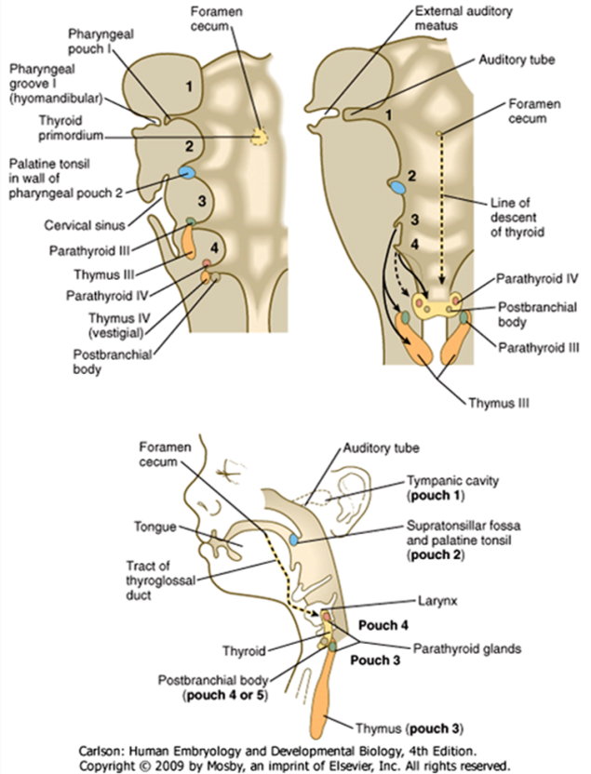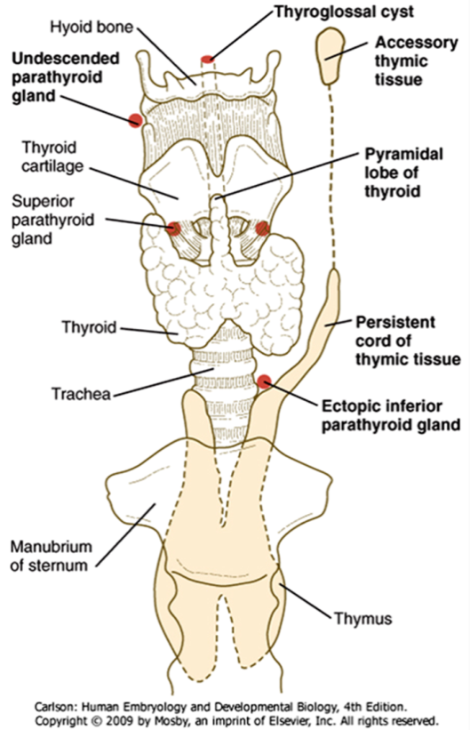*outflow tract defects (neural crest in this area also contributes to conotruncal cushions of the outflow tract)*

**II. Development of the tongue**

**A. Anterior 2/3 of the tongue:**

**1. Formation:** the anterior 2/3 of the tongue is derived from median and lateral tongue buds that arise from the floor of the **1st pharyngeal arch** and then grow rostrally. The tongue buds are then invaded by occipital myoblasts that form the intrinsic muscles of the tongue.

**2. Innervation of the anterior 2/3 of the tongue:**

* + **sensory innervation** **of the mucosa** is via the **lingual branch of the trigeminal nerve**
  + **taste innervation** is via the **chorda tympani branch of the facial nerve**, except for the taste buds in any circumvallate papilla that may be present in the posteriormost part of the anterior 2/3 of the tongue –these are innervated by the glossopharyngeal nerve.
  + **motor innervation of the intrinsic skeletal muscles** is via the **hypoglossal nerve**

**B. Posterior 1/3 of the tongue:**

**1. Formation:** swellings from the floor of the 3rd and 4th pharyngeal arches overgrow the 2nd arch and fuse with the anterior 2/3 of the tongue. Thus, the **posterior 1/3 of the tongue is derived from the 3rd and 4th arches** and there is NO contribution of the 2nd pharyngeal arch in the adult tongue. Intrinsic musculature is also derived from occipital myoblasts. The line of fusion of the anterior 2/3 and posterior 1/3 of the tongue is indicated by the **terminal sulcus**.

**2. Innervation of the posterior 1/3 of the tongue:**

* + **sensory innervation** **of the mucosa** is mostly via the **glossopharyngeal nerve** (and some vagus)
  + **taste innervation** is mostly via the **glossopharyngeal nerve** (and some vagus)
  + **motor innervation of the intrinsic skeletal muscles** is via the **hypoglossal nerve**

**III. Development of the thyroid gland**

* is NOT derived from any of the pharyngeal pouches
* arises from a **midline thyroid diverticulum** that forms from the **endoderm** in the floor of the pharynx just caudal to the 1st pharyngeal arch; these endoderm cells differentiate into the **follicular cells of the thyroid gland**.
* with differential growth of the embryo, the diverticulum elongates, but remains connected to the forming tongue by a **thyroglossal duct** that later is obliterated; the site of the opening of the thyroglossal duct is the **foramen cecum** found in the midline at the terminal sulcus of the tongue.

*Anomalies in thyroid development can result in* ***ectopic thyroid tissue*** *and/or* ***cysts*** *present along the course of the thyroglossal duct, which is a midline structure (as opposed to cervical cysts, which are remnants of pharyngeal clefts 2-4 and are found* ***lateral*** *to the sternocleidomastoid muscles).*

**IV. Muscles of the Head and Neck**

* **Some arise from unsegmented paraxial mesoderm that migrates into arches 1-3:**
  + **Arch 1**: muscles of mastication, tensor tympani, tensor veli palantini, anterior belly of digastric (**CN-V**)
  + **Arch 2**: muscles of facial expression, stapedius, stylohyoid, posterior belly of digastric (**CN-VII**)
  + **Arch 3**: stylopharyngeus (**CN-IX**)
* **Some are from segmented (somitic) paraxial mesoderm that migrates into arches 4 and 6:**
  + **Arch 4**: pharyngeal constrictors, levator veli palatini (**superior laryngeal branch of CN-X**)
  + **Arch 6**: intrinsic laryngeal muscles (**recurrent laryngeal branch of CN-X**)
* **Some are from unsegmented paraxial mesoderm that do NOT migrate into arches:**
  + Extraocular muscles (**CN-III**, **-IV**, **-VI**)
* **Some are from somitic paraxial mesoderm that migrates into the tongue after its formation:**
  + Intrinsic and extrinsic muscles of the tongue (**CN-XII**)
* **Some are from occipital LATERAL PLATE MESODERM* adjacent to somites 1-3 ([Theis](http://dev.biologists.org.proxy.lib.duke.edu/content/137/17/2961.short)** [**et al. Development 2010 137: 2961-2971):**](http://dev.biologists.org.proxy.lib.duke.edu/content/137/17/2961.short) 
  + Trapezius and sternocleidomastoid (**CN-XI**

**IV. Development of the skull**

* anterior portions (viscerocranium) are derived primarily from neural crest mesenchyme that develop into bones via membranous ossification
* bones in the floors of the cranial fossae (cribriform plate, sphenoid, petrous temporal and clivus of the occipital) are derived from somitic tissue that develop bone via endochondral ossification
* flat bones of the cranial vault (e.g. frontal, squamous temporal, parietal, and posterior occipital) are derived from somitic mesoderm that develops into bone via membranous ossification
* the bones of the skull do not fuse together until after birth (to allow crowning of the head during delivery and growth of the brain postnatally), leaving **sutures** and **fontanelles** that typically close at various times postnatally:
  + the **confluence of the lambdoid and sagittal sutures** at the back of the skull marks the site of the **posterior fontanelle**, which typically closes at around 3-6 months postnatally
  + the **confluence of the sagittal, coronal, and frontal sutures** at the top, front of the skull marks the site of the **anterior fontanelle**, which typically closes by 1.5-2 years postnatally.

*Because the brain continues to grow in size up until 6-7 years of age, premature fusion of the sutures or fontanelles will result in abnormal shaping of the head as the brain will cause displacement of the bones that remain unfused.*

**V. Development of the face (see figures below)**

* initially formed by 5 mesenchymal swellings (aka processes or prominences):
  + **2 mandibular prominences** (right and left, from 1st arch neural crest mesenchyme)
  + 2 **maxillary prominences** (right and left, from 1st arch neural crest mesenchyme)
  + **frontonasal prominence** (midline structure, from cranial neural crest mesenchyme)
* two nasal pits develop in the ventrolateral aspects of the frontonasal prominences, thereby forming 2 **lateral and medial nasal prominences**
* development of the face occurs via the growth and fusion of these prominences:
  + the mandibular prominences grow together to form a single mandible
  + the maxillary prominences grow toward the midline and fuse with the lateral nasal prominences. A deep groove called the **nasolacrimal groove** forms between the maxillary and lateral nasal prominences on either side of the developing nose. Most of the groove is obliterated with fusion of the maxillary and lateral nasal prominences, but a small portion persists as the **nasolacrimal duct** and **lacrimal sac**.
  + continued inward growth of the maxillary prominences also pushes the two medial nasal prominences together such they fuse to form the midline of the nose and **philtrum** of the upper lip –the superior portion of the frontonasal prominence grows and extends to form the forehead whereas the inferior portion does not grow very much, thus allowing the medial nasal processes to fuse in the midline.

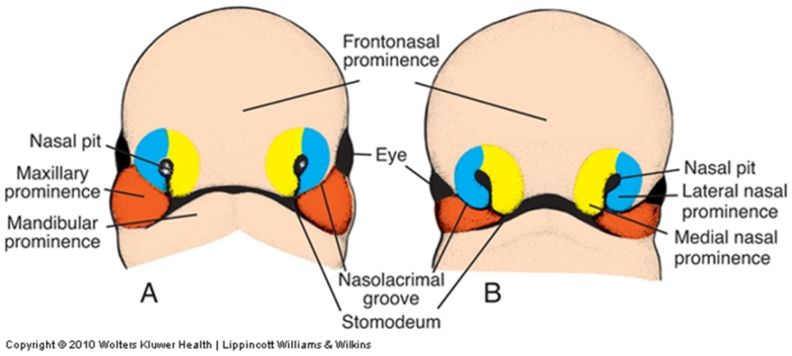

6 weeks

5 weeks

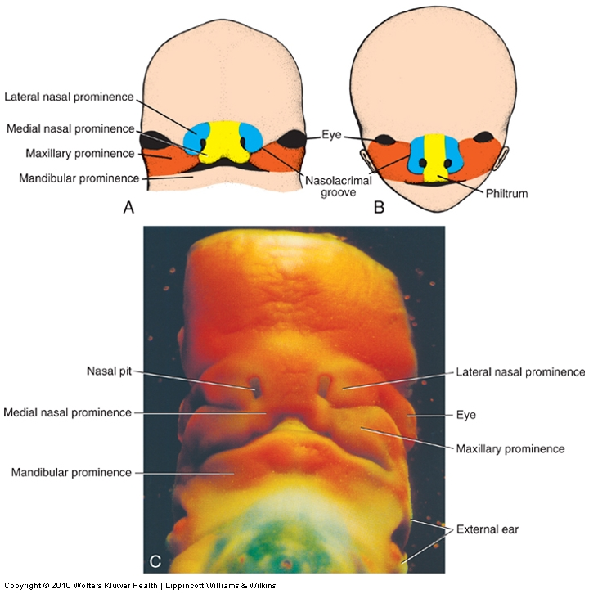

10 weeks

7 weeks

* **below is a summary of the contributions of the prominences to the adult face:**



*Disruption of the development of any of the facial prominences can result in a variety of facial anomalies, such as (from left to right in figures below):*

* *hare lip (bilateral failure of maxillary and lateral nasal prominences to fuse)*
* *oblique facial cleft (unilateral failure of maxillary and lateral nasal prominences to fuse)*
* *macrostoma (incomplete lateral merging of maxillary and mandibular processes)*
* *median cleft lip (incomplete fusion of medial nasal prominences)*
* *frontonasal dysplasia (hyperplasia of inferior frontonasal prominence, thus preventing fusion of the medial nasal prominences)*

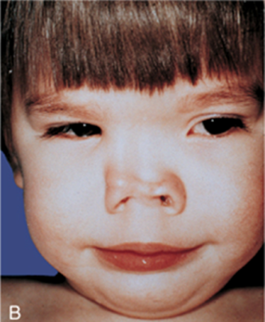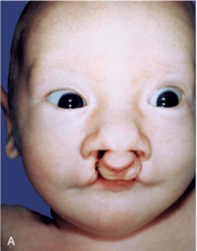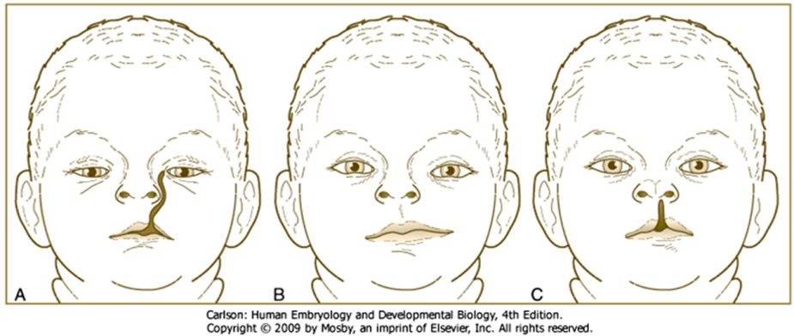

**VI. Development of the palate (see figures below)**

**A. Primary palate**

* forms via the fusion of the two medial nasal prominences in the midline (of course, this midline fusion is driven via growth of the maxillary prominences which pushes the nasal prominences toward to the middle)
* consists of the premaxillary segment of the maxilla, which contains the four incisors and the incisive canal

**B. Secondary palate**

* forms via outgrowths of the maxillary prominences called the **palatine shelves**
* initially, the palatine shelves project on either side of the tongue. With growth and expansion of the mandible the tongue moves down, allowing the palatine shelves to grow toward the midline and fuse to form the secondary palate, which consists of the palatine segment of the maxilla and palatine bone. *Disruption of growth of the tongue and/or mandible can therefore secondarily cause a cleft secondary palate.*

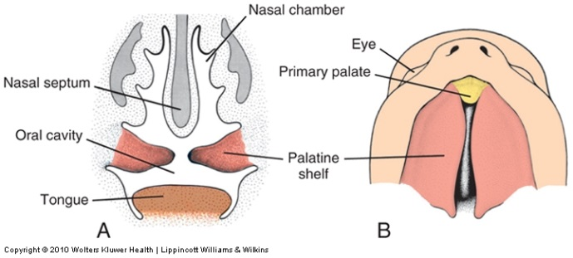

~7 weeks

*Complete fusion of the primary and secondary palate is a complex process involving growth of the component tissues, epithelial to mesenchymal transformation, cell migration, and programmed cell death at fusion sites –disruption of any part of this process can result in cleft palate. Given the involvement of the maxillary and nasal prominences, cleft palate is often (but NOT always) accompanied by cleft lip.*

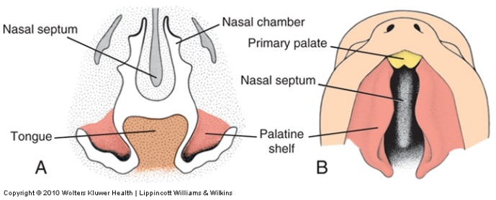

~8 weeks

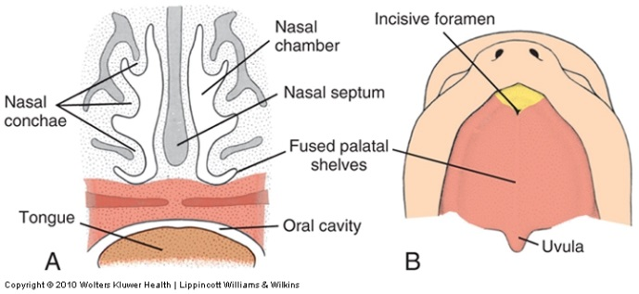

~10 weeks