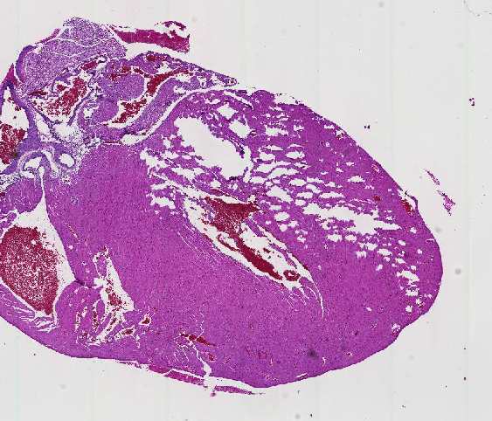
1. Identify the organ in the link below
http://vmw-aperioimg04.duhs.duke.edu/PATHOL_725_Histology/0093_S Mouse Tissues.svs/view.apml?X=0.13413665533511&Y=-0.357276893223585&zoom=2.0931123542524

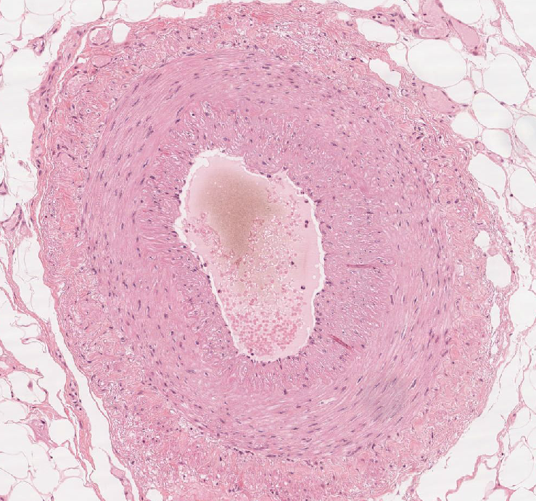
2. Identify the structure in the link below
http://vmw-aperioimg01.duhs.duke.edu/DukeHistology/NB_Review/umich-029.svs/view.apml?X=-0.401803058687009&Y=-0.181032615826229&zoom=18.6624
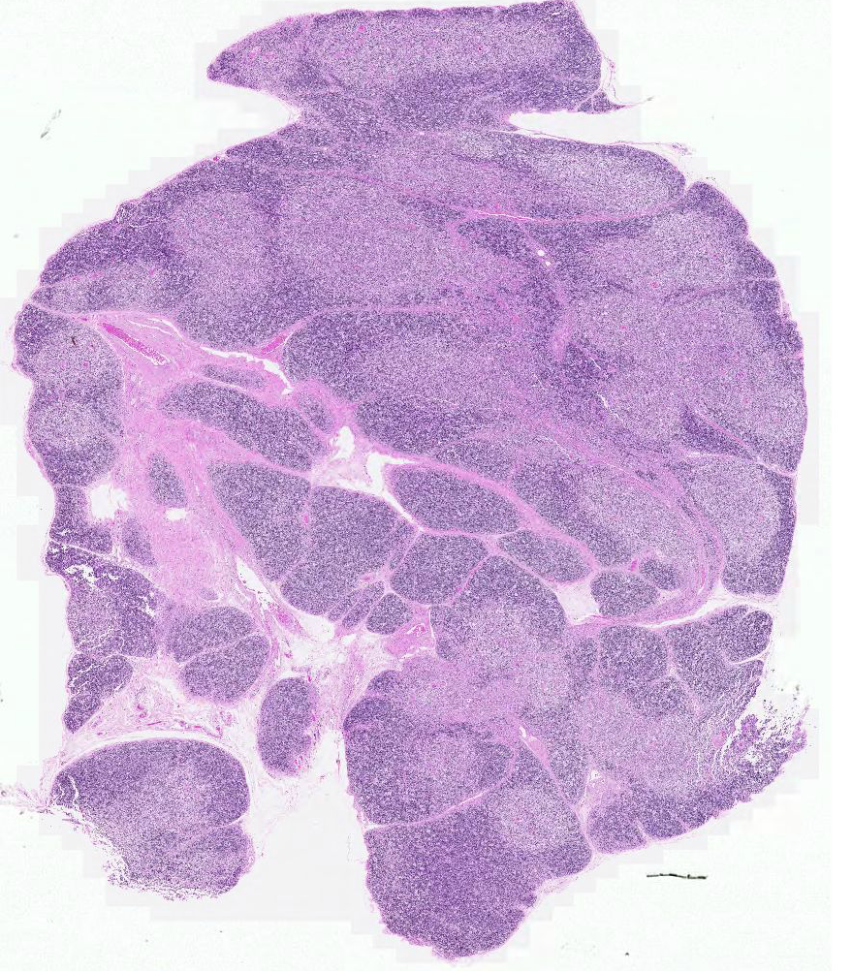
3. Identify the organ in the link below
http://vmw-aperioimg01.duhs.duke.edu/DukeHistology/NB_Review/path225-0040_S.svs/view.apml?X=0&Y=0&zoom=1.84888414055081

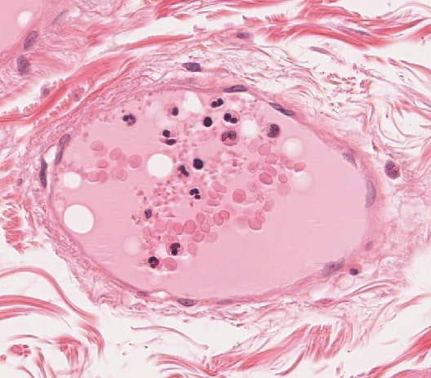
4. Identify the structure in the link below
http://vmw-aperioimg01.duhs.duke.edu/DukeHistology/NB_Review/umich-029.svs/view.apml?X=0.157611298696132&Y=0.296150787731071&zoom=92.876046336

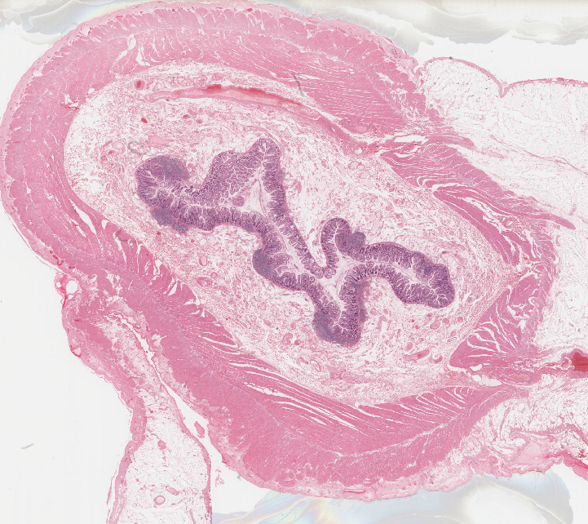
5. One special cell type that unambiguously identifies this organ. Name and draw that cell type.
http://vmw-aperioimg01.duhs.duke.edu/DukeHistology/NB_Review/umich-029.svs/view.apml?X=0.132918679561311&Y=0.0496641804897522&zoom=0.812119962898073

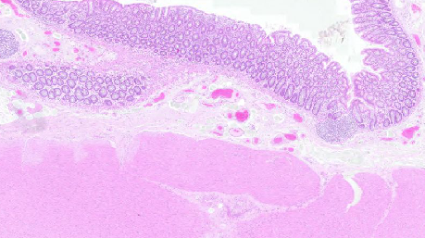
6. Does this organ have submucosal glands?
http://vmw-aperioimg01.duhs.duke.edu/DukeHistology/NB_Review/path200-0027_R.svs/view.apml?X=0.145196992824331&Y=0.135418178619969&zoom=5.59872

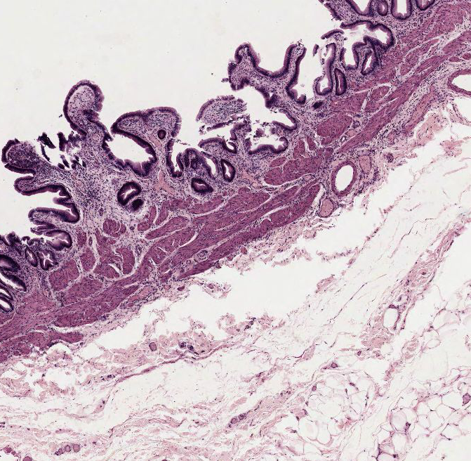
7. Describe the layering of this organ
http://vmw-aperioimg01.duhs.duke.edu/DukeHistology/NB_Review/drexel-MCP69.svs/view.apml?X=-0.007107781131774&Y=0.0621958131214068&zoom=12.4572822639668

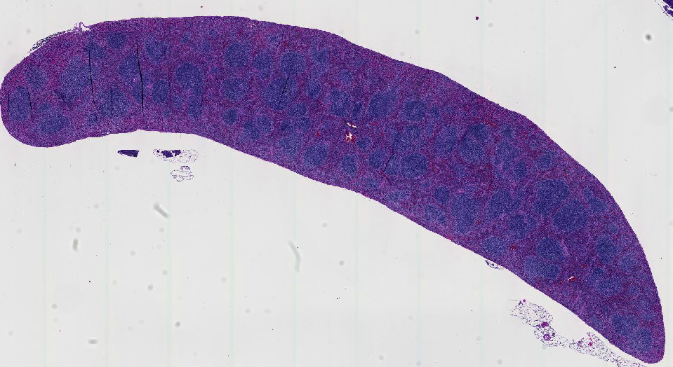
8. Identify the organ in the link below, justify your answer
http://vmw-aperioimg04.duhs.duke.edu/PATHOL_725_Histology/0090_S Mouse Tissues.svs/view.apml?X=0.0270738232205834&Y=-0.33630110083815&zoom=2.17013888888889

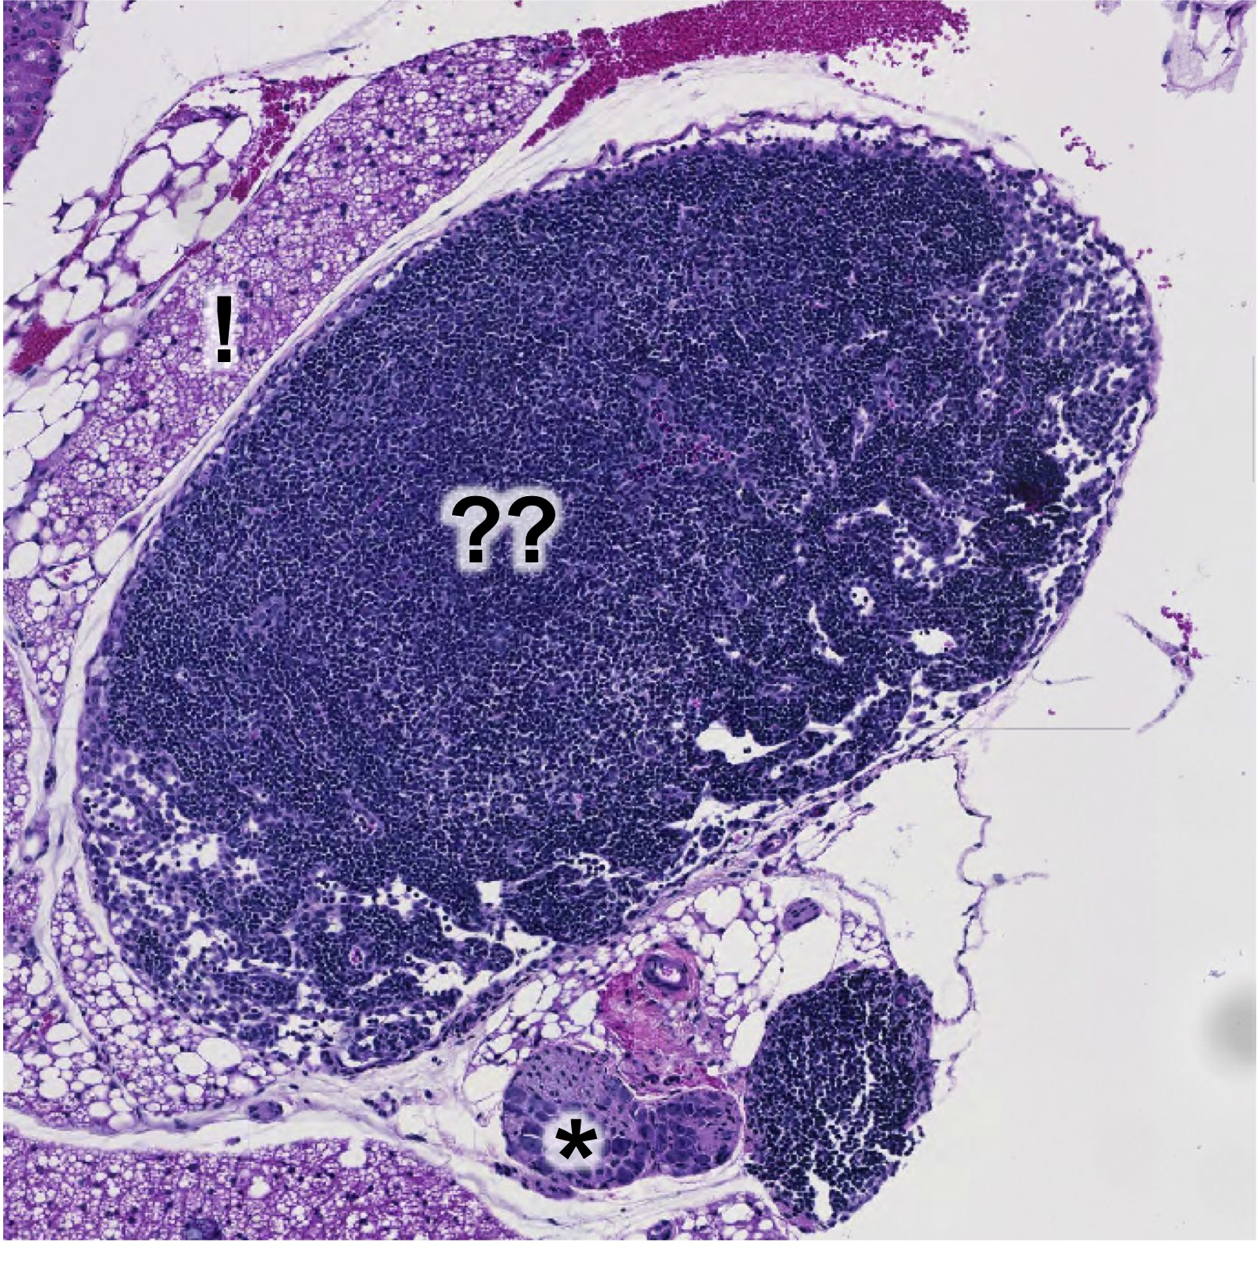
9. Identify the organ (??), justify your anwer.
http://vmw-aperioimg04.duhs.duke.edu/PATHOL_725_Histology/0090_S Mouse Tissues.svs/view.apml?X=-0.110416162399546&Y=0.0461065572271853&zoom=13.4587985741538

Bonus points
a. Identify the surrounding tissue marked with (!).
b. Identify the structure (*) below the organ, at ~6:00

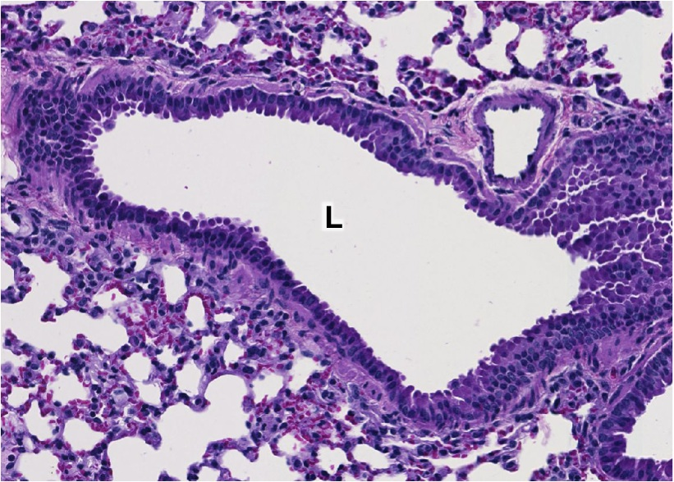
10. Identify the structure with the lumen marked L.
http://vmw-aperioimg04.duhs.duke.edu/PATHOL_725_Histology/0093_S Mouse Tissues.svs/view.apml?X=0.0111886493011656&Y=0.139434956594276&zoom=57.8703703703704
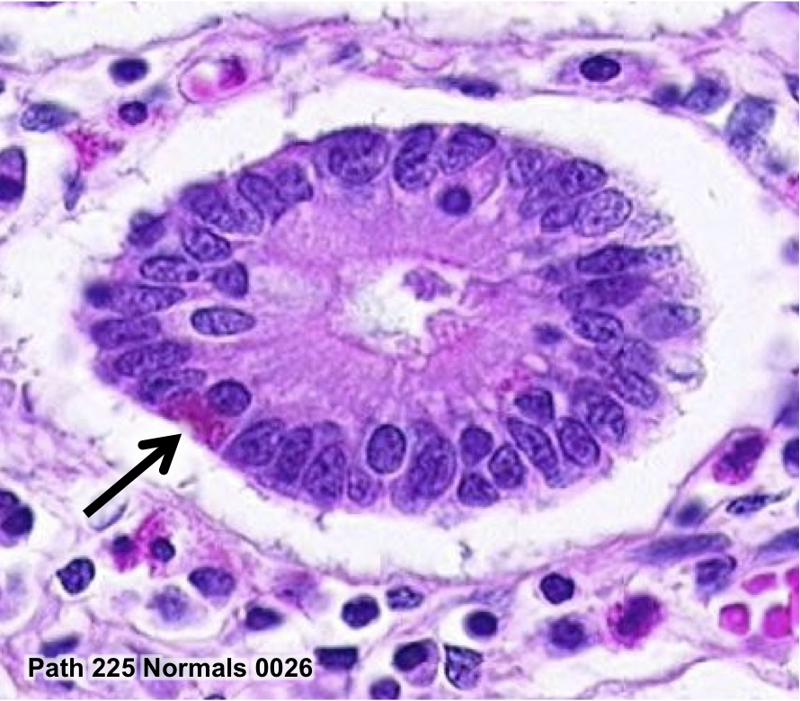
11. Identify the cell type marked with an arrow.
http://vmw-aperioimg04.duhs.duke.edu/PATHOL_725_Histology/0026_S.svs/view.apml?X=-0.219742597720577&Y=0.329919501015242&zoom=100
12. Identify the organ, give two key identifying features
13. Name 4 cell types found in the epithelium of this organ

