Respiratory Epithelium = pseudostratified ciliated columnar epithelium with goblet cells
- Transitions: Stratified Sq → Str. Col. → pseudostratified → Simple Col. → S. Cub. → S. Sq.
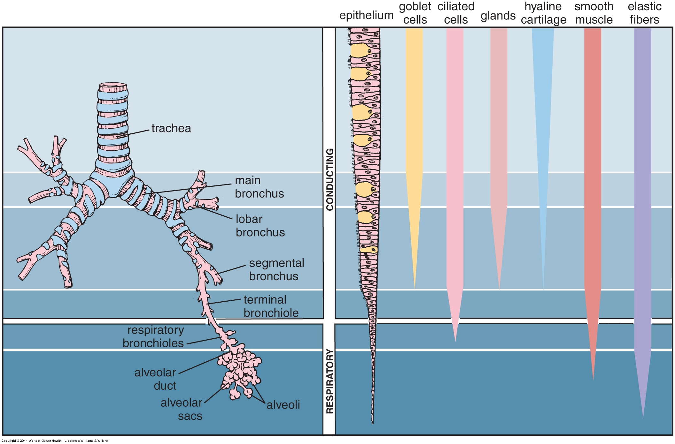
- Variable: regions of stratified squamous, e.g. vocal cords or regions of chronic irritation
Seromucous glands: Mix of serous and mucous acini, with serous demilunes
Nose/Mouth/Pharynx: Not covered. (Whew!)
Larynx
- Epiglottis: Epithelium, lamina propria, seromucous glands, elastic cartilage
- Vestibular fold: Epithelium, lamina propria, seromucous glands, adipose, thyroid cartilage
- Laryngeal ventricle: space between vestibular and vocal folds
- Vocal fold (cord): Stratified squamous, elastic CT, Vocalis muscle (Sk), thyroid cartilage
- Cricoid cartilage
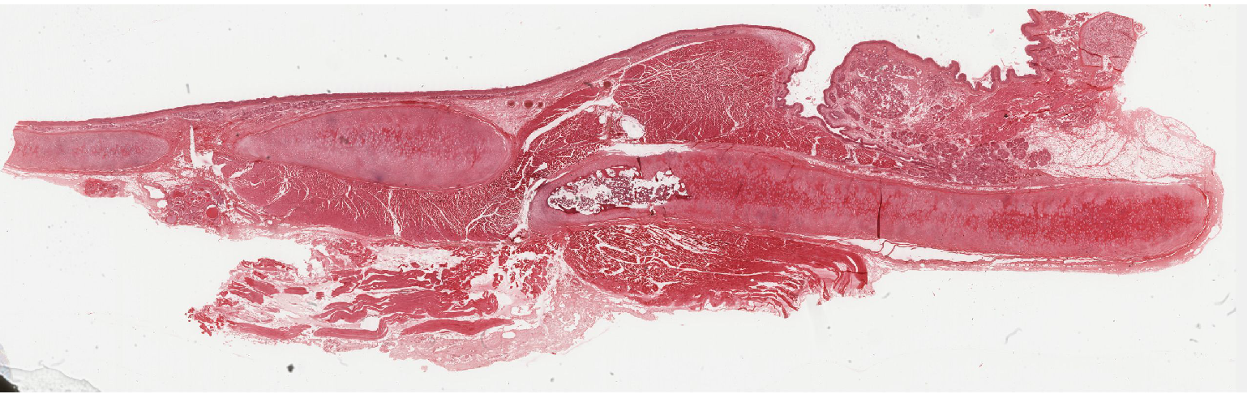
Trachea
- Mucosa
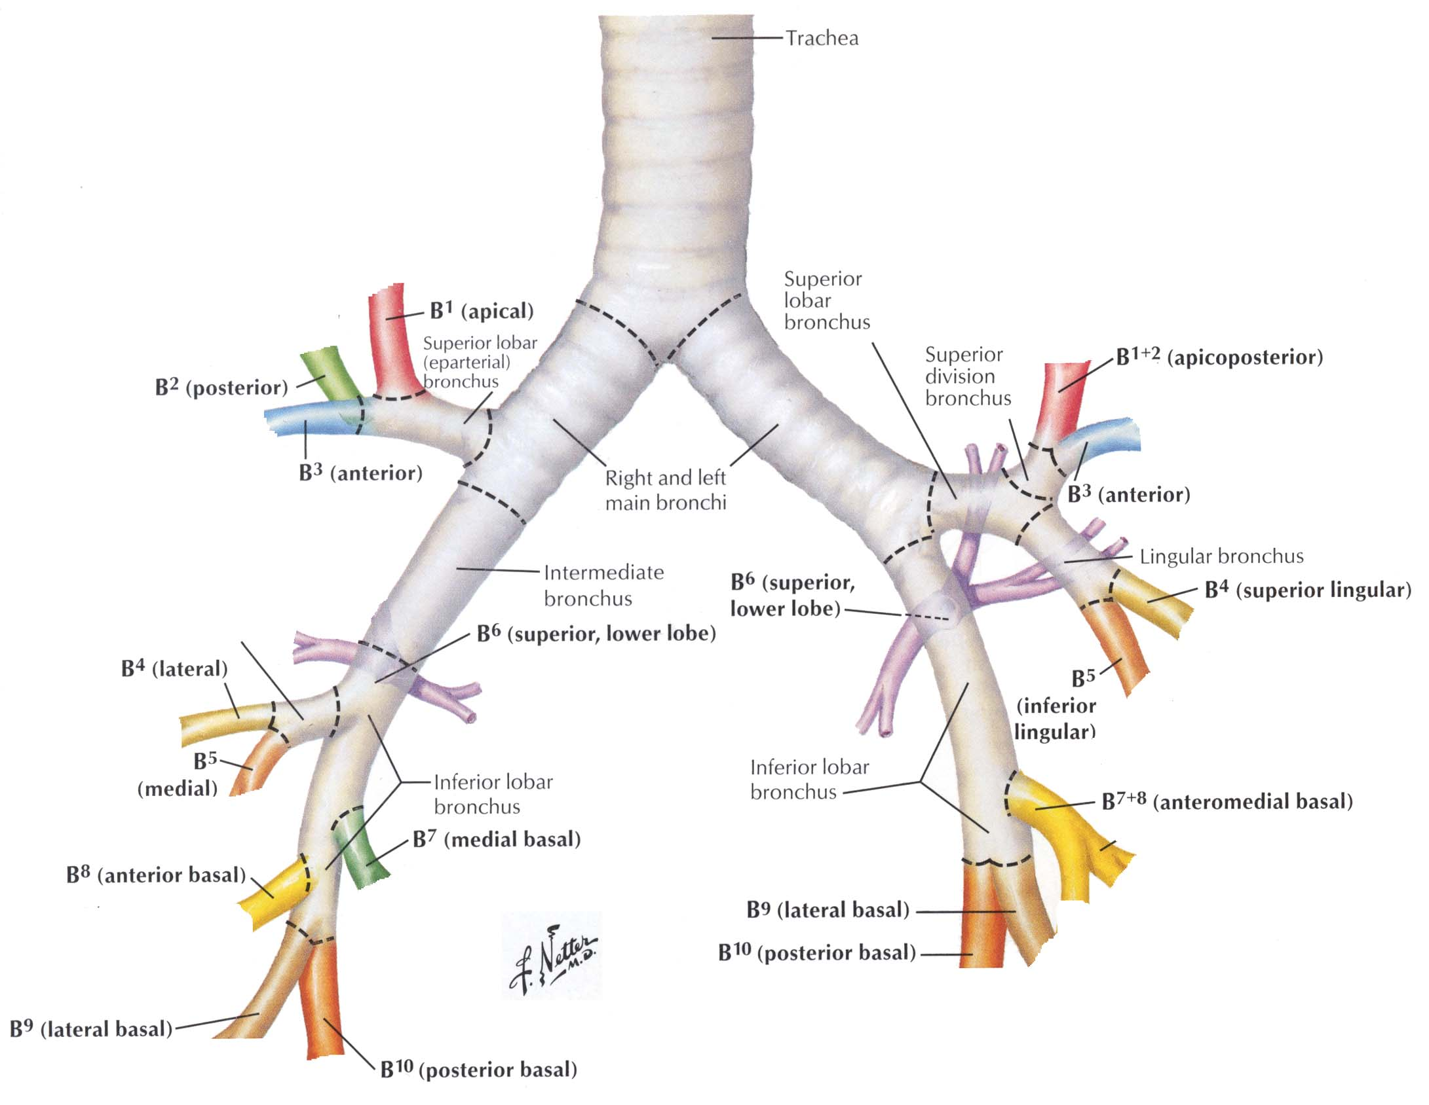
  - Respiratory epithelium
  - Thick basal lamina = basement membrane
  - Lamina Propria
  - Seromucous glands
- Submucosa
  - Dense irregular CT
  - C-shaped rings of hyaline cartilage
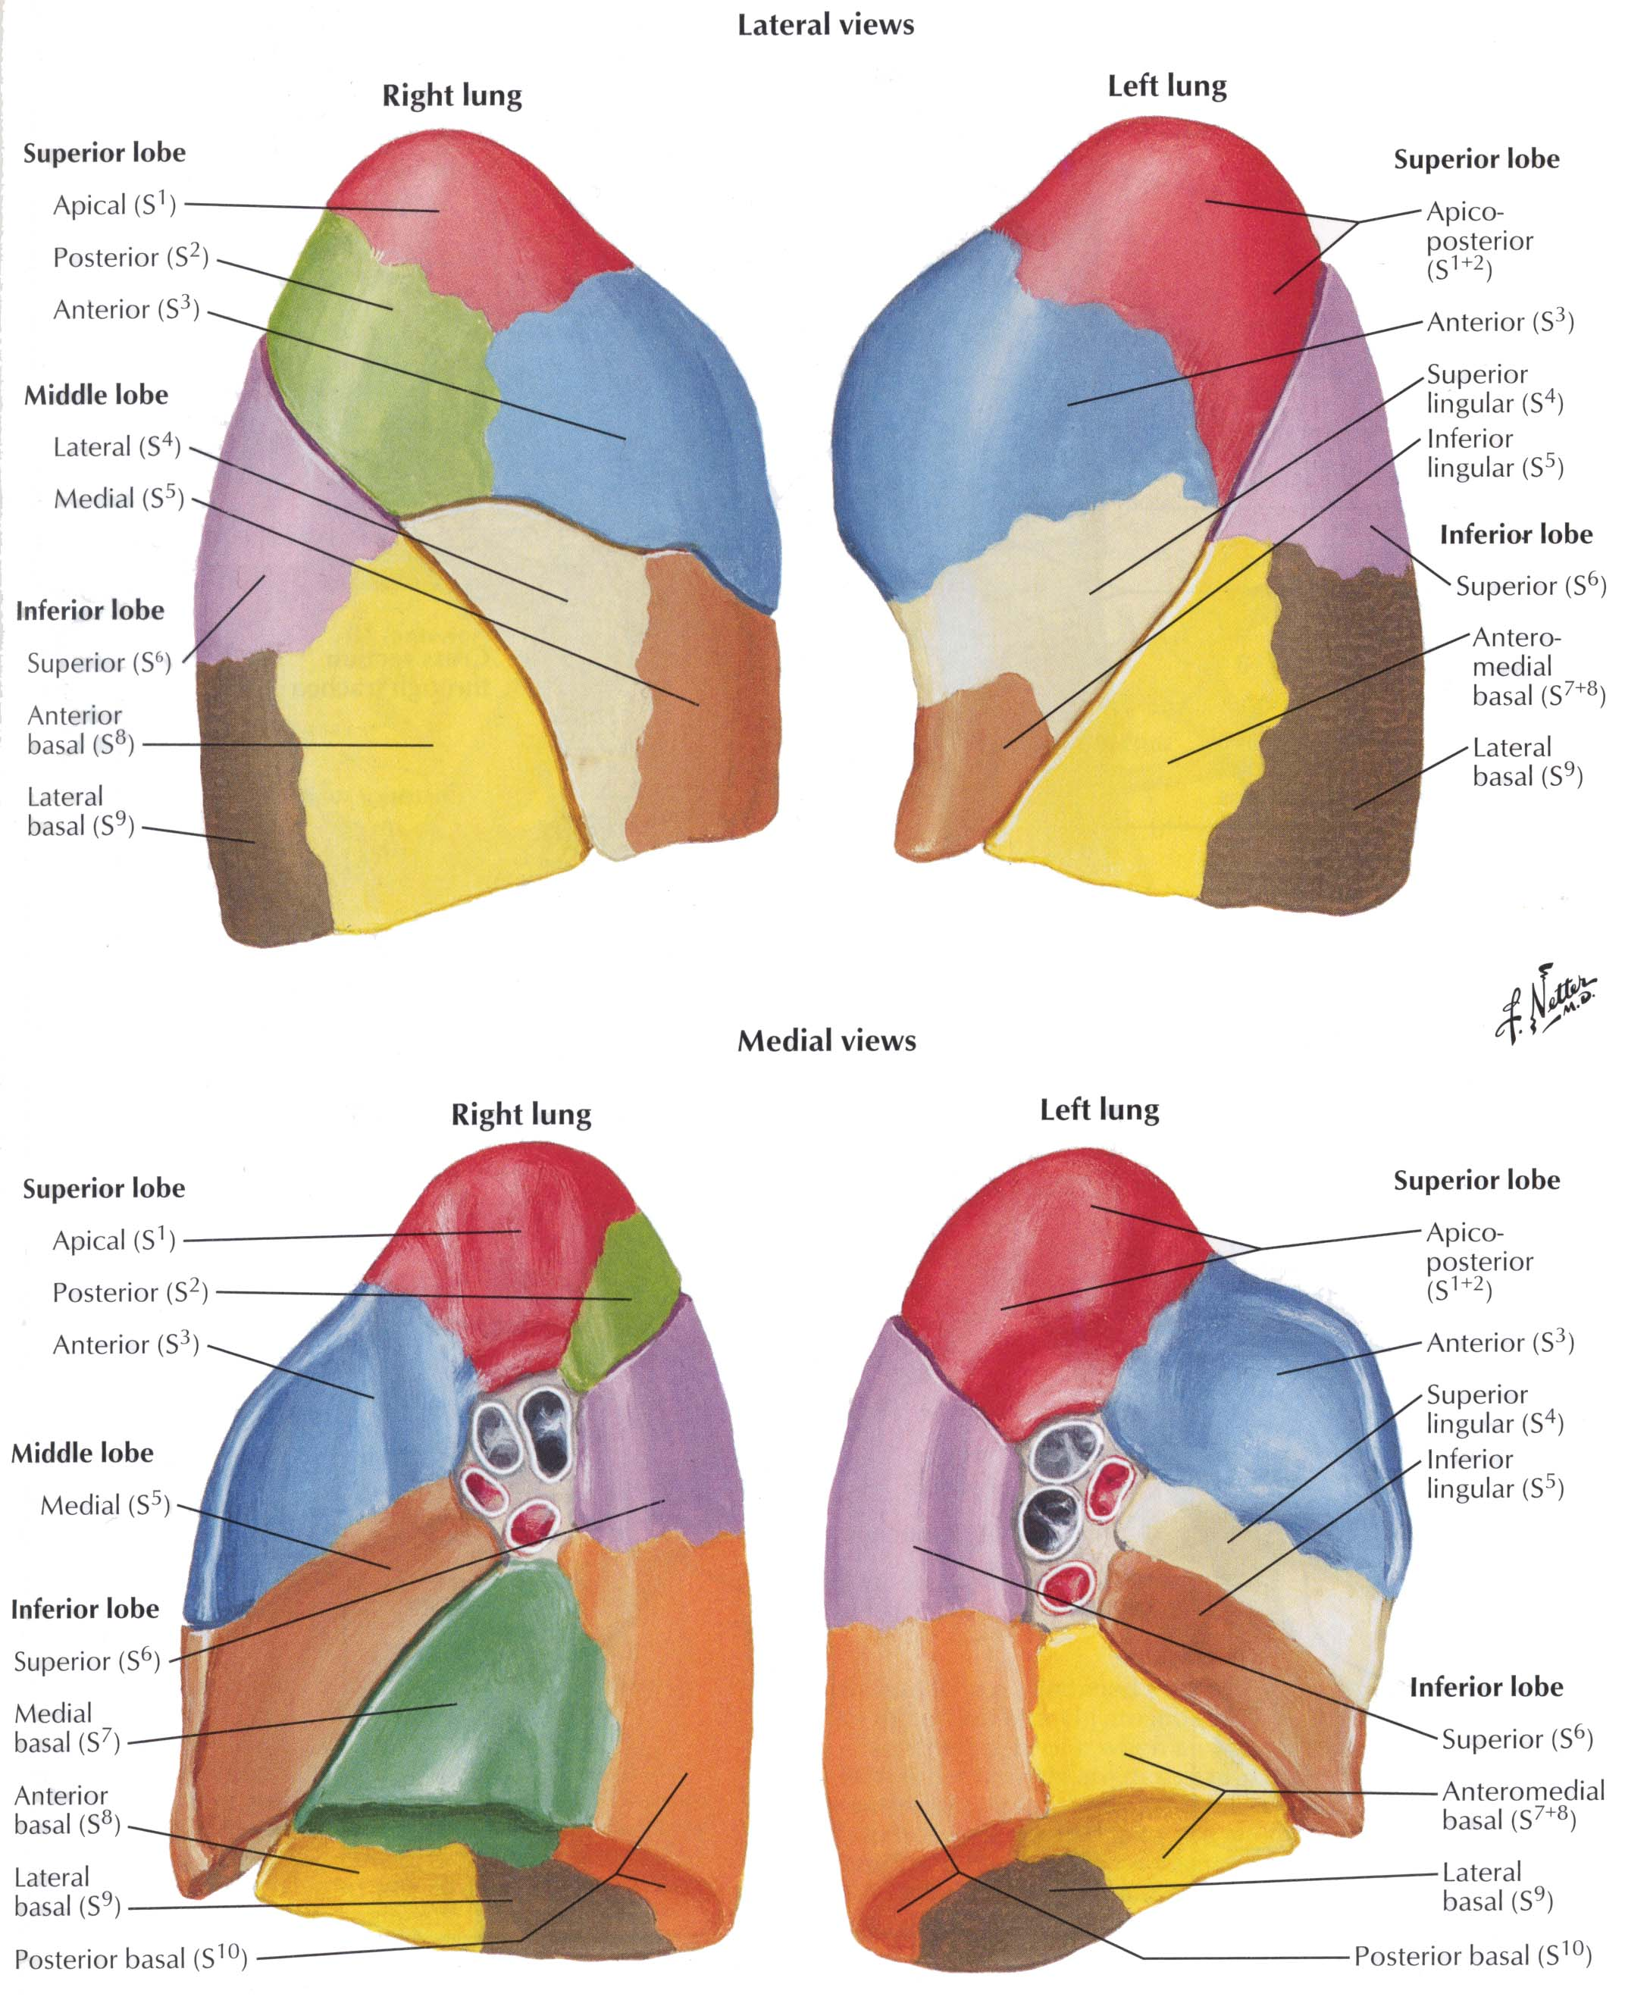
  - Trachealis (SmM) across C
- Adventitia: dense irregular CT
- Adjacent to esophagus
Bronchi
- 1°: = main, outside lungs, short
- 2°: = lobar, embedded in lungs
- 3°: = segmental
- Layers
  - Mucosa: Respiratory epithelium
  - Muscularis: Smooth muscle, circular
  - Submucosa: loose CT, seromucous glands
  - Plates of hyaline cartilage
  - Adventitia

Bronchioles
- No cartilage, no glands, no goblet cells
- Large bronchiole → terminal bronchiole → respiratory bronchiole
- Epithelium changes from pseudostratified ciliated columnar to simple cuboidal
- Club cells = cuboidal cells, secretory
Alveoli
- Alveolar ducts → alveoli
- Type I cells, squamous
- Type II cells, secretory
- Capillaries
- Alveolar macrophages
- (Brush Cells) not visible in our slides

