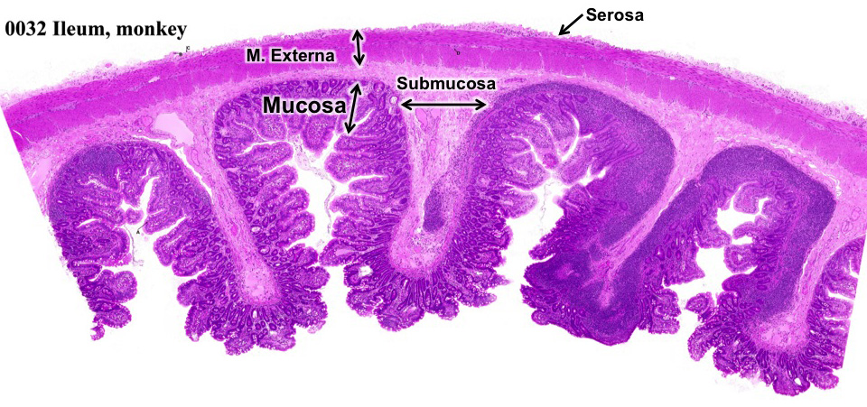
GI Layering: Start with Slide 32!
Figure 1. GI layering, our slide 32

Mucosa:
- Epithelium
- Lamina Propria: loose CT
- Muscularis Mucosae

Submucosa: dense irregular CT
- Meissner’s plexus: ENS
- Submucosal glands

Muscularis Externa:
- Skeletal m. at start and end
- smooth muscle in most of GI
- Inner circular layer, Outer longitudinal layer
- Auerbach’s plexus between layers: ENS
Serosa (DICT + mesothelium) or Adventitia (dense to fatty CT)

Esophagus:
- Tube with GI Layering: Mucosa, Submucosa, Muscularis externa, Adventitia
- Mucosa =
- Stratified squamous non-keratinized epithelium
- Lamina propria = thin layer of loose, cellular CT
- Muscularis mucosae = longitudinal smooth muscle, thick in proximal esophagus
- Submucosa = dense irregular CT with
- seromucous glands, ducts with stratified cuboidal to squamous epithelium
- (Meissner’s plexus)
- Muscularis externa
- 2 well-defined layers, inner circular, outer longitudinal
- Define orientation of section with respect to tube
- Muscle type varies: skeletal→mix→smooth muscle
- Define region: upper, middle or lower third
- Auerbach’s plexus between layers
- Adventitia = loose, fatty CT. May be lost in prep. (Serosa after diaphragm)
- Longitudinal folds, slightly collapsed lumen
- Look for neighbors (trachea, aorta, stomach)

Stomach:
- Tube with GI Layering: Mucosa, Submucosa, Muscularis externa, Serosa
- Mucosa =
- Wide-bore pits and narrow, coiled, tubular glands
- Surface epithelium = simple columnar mucous surface cells with mucous cup
- Glands define region of stomach:
      - Corpus/fundus
- Chief cells = wedge-shaped, dark cells, secretory granules, basal nuclei
- Parietal cells = round/triangular, ~20 µm, pale round nucleus, with nucleolus
- Mucous neck cells
      - Pyloric = some parietal cells, mostly mucous cells, look for duodenum
      - Cardiac = no chief, no parietal, all mucous cells, look for esophagus
    - Enteroendocrine cells with secretory granules facing lamina propria, part of ENS
- Submucosa: dense, irregular CT, blood vessels, nerves, (Meissner’s plexus)
- Muscularis externa:
- 3 layers, difficult to distinguish
- Inner oblique, middle circular, outer longitudinal
- Auerbach’s plexus
- Serosa
- Folds = rugae, distensible

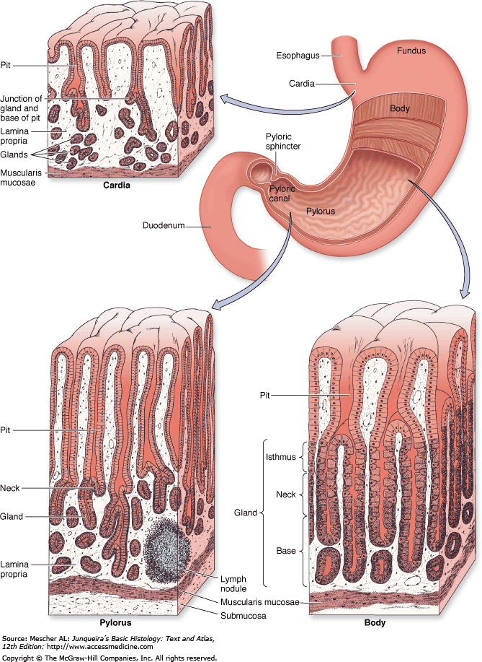
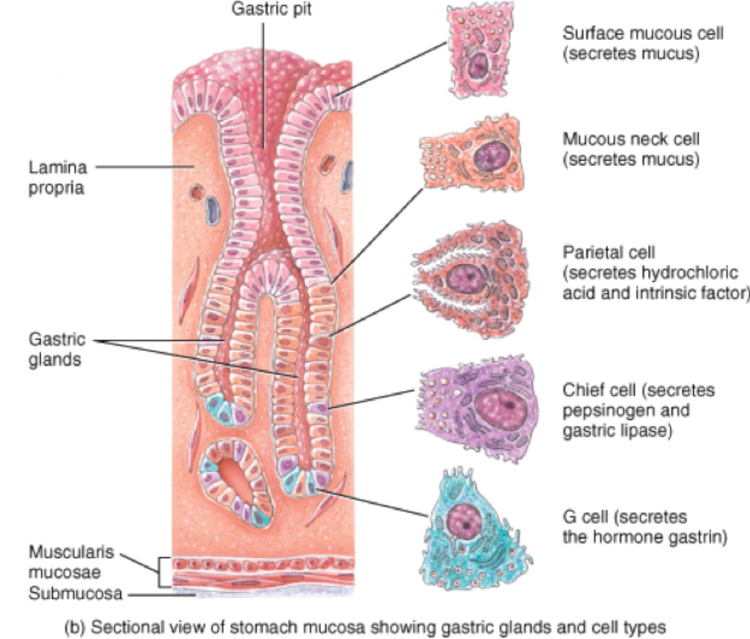

Small Intestine
- Tube with GI Layering: Mucosa, Submucosa, Muscularis externa, Serosa
- Mucosa =
- Villi & Crypts of Lieberkühn (glands)
- Epithelium =
- Enterocytes = simple columnar cells with brush border and
- Goblet cells
- Paneth cells with eosinophilic secretory granules in crypts
  - Enteroendocrine cells with secretory granules facing lamina propria, part of ENS
    - Rich lamina propria, may see occasional lymph nodules
    - Many nodules = Peyer’s patches (only in ileum!)
    - Thin muscularis mucosae, may see 2 layers
- Submucosa:
- dense, irregular CT, blood vessels, nerves,
- Meissner’s plexus
- Submucosal glands = Brunner’s glands (only in duodenum!)
- Muscularis externa:
- 2 clear layers
- Inner circular, outer longitudinal
- Auerbach’s plexus
- Serosa
- Folds = plicae circulares
- Identify region:
  - Many lymph nodules = Peyer’s patches ⇒ ileum
  - Brunner’s glands ⇒ duodenum
  - No Brunner’s glands, no Peyer’s patches ⇒ jejunum or ileum away from Peyer’s patches

Large Intestine:
- Mucosa
  - Straight-bore crypts
  - Epithelium
    - Enterocytes
    - Goblet cells
    - Enteroendocrine cells with secretory granules facing lamina propria, part of ENS
  - Rich lamina propria
  - Muscularis mucosae (may see 2 layers)
- Submucosa: dense, irregular CT, blood vessels, nerves, (Meissner’s plexus)
- Muscularis externa
  - May see teniae coli = thickening of outer, longitudinal layer into 3 distinct bands
- Serosa

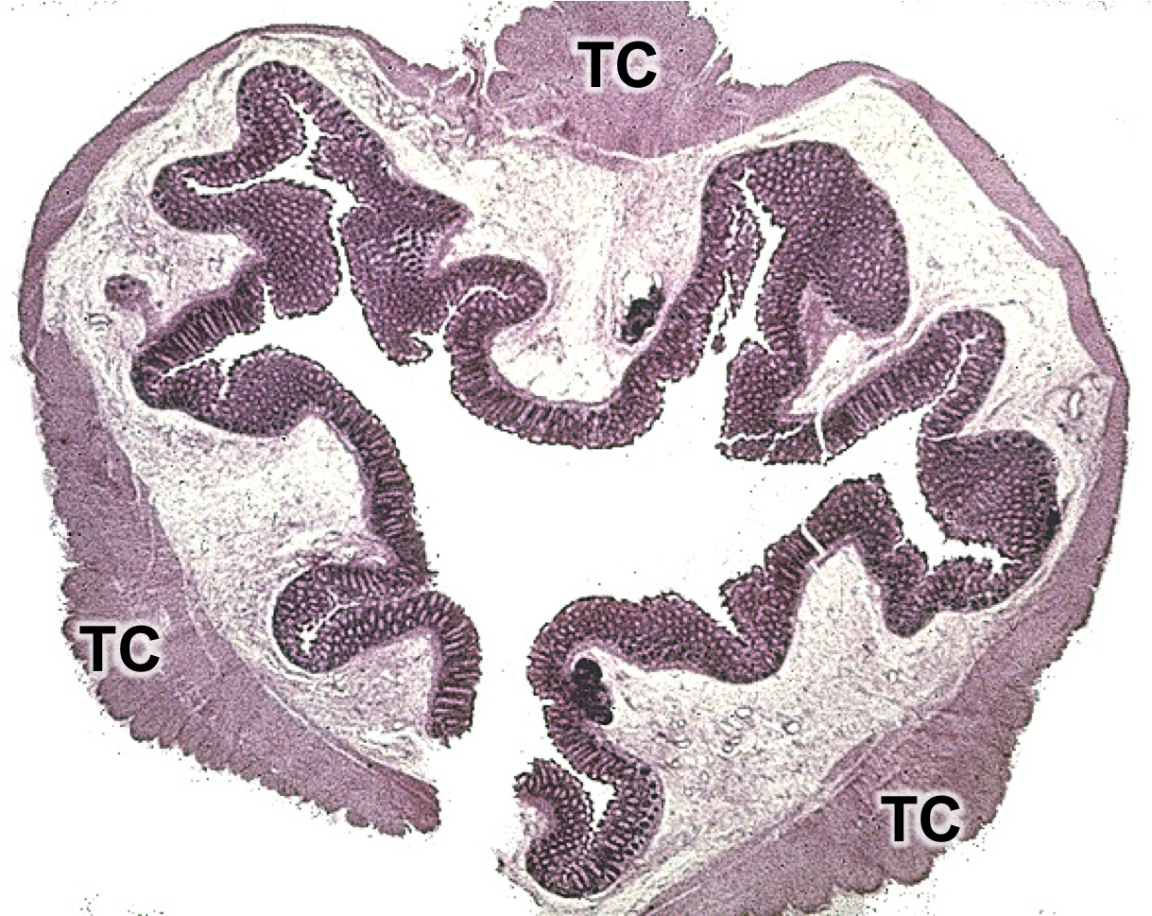
Ano-rectal junction:
Teniae Coli (TC) in the large intestine.
- See transition from simple columnar to stratified squamous
- Lose muscularis mucosae
- Eccrine and apocrine sweat glands in submucosa
- Serosa becomes adventitia
- Muscularis externa gains skeletal muscle
- Hair follicles

