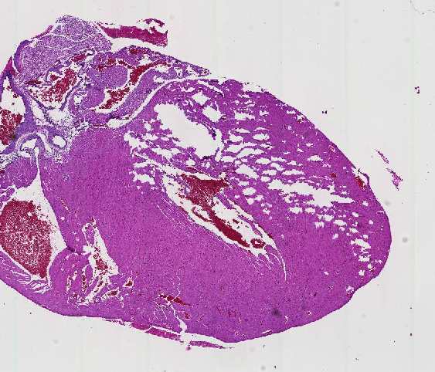 | 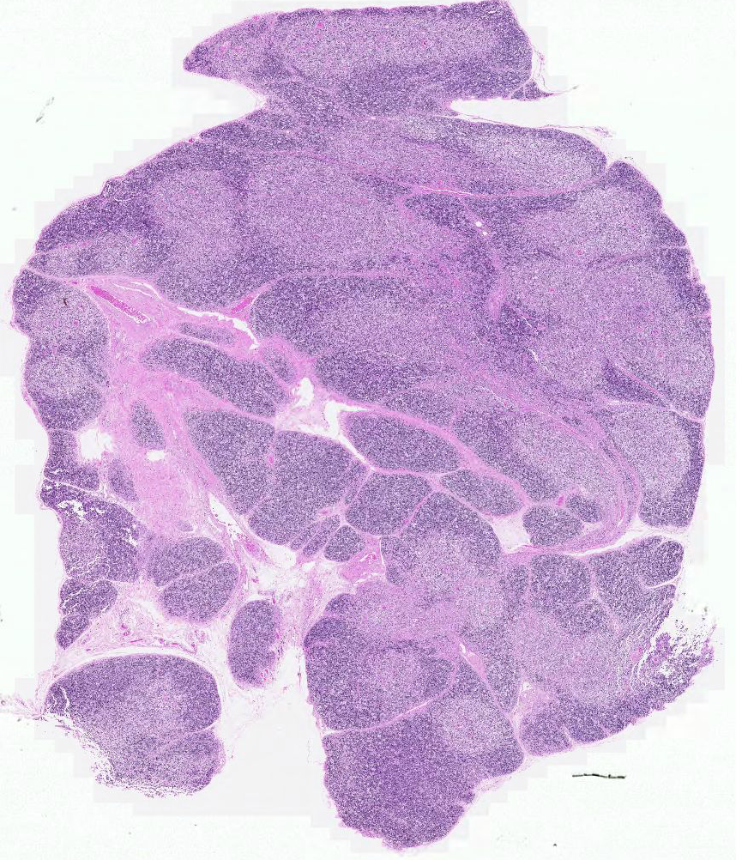
1. Identify the organ in the link below  http://vmw-aperioimg04.duhs.duke.edu/PATHOL_725_Histology/0093_S Mouse Tissues.svs/view.apml?X=0.13413665533511&Y=-0.357276893223585&zoom=2.0931123542524 | 3. Identify the organ in the link below  http://vmw-aperioimg01.duhs.duke.edu/DukeHistology/NB_Review/path225-0040_S.svs/view.apml?X=0&Y=0&zoom=1.84888414055081
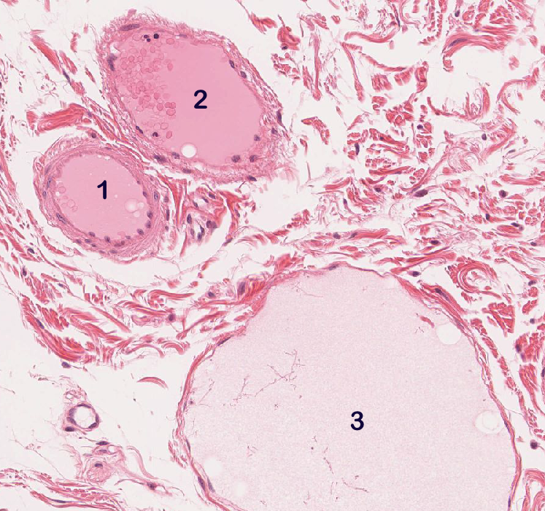 | 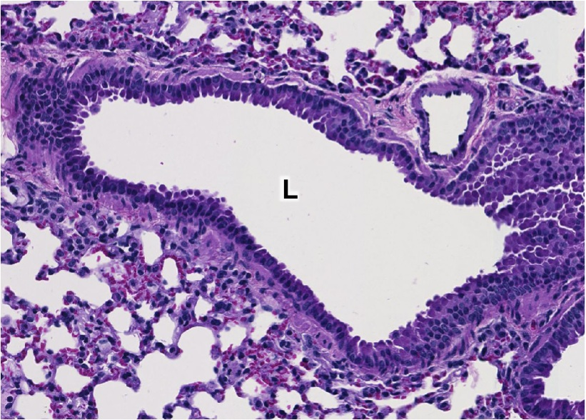
2. Identify the structures enclosing the three lumens in the link below  http://vmw-aperioimg01.duhs.duke.edu/DukeHistology/NB_Review/umich-029.svs/view.apml?X=0.181178974709096&Y=0.306510437499277&zoom=41.6666666666667 | 4. Identify the structure with the lumen marked L.  http://vmw-aperioimg04.duhs.duke.edu/PATHOL_725_Histology/0093_S Mouse Tissues.svs/view.apml?X=0.0111886493011656&Y=0.139434956594276&zoom=57.8703703703704
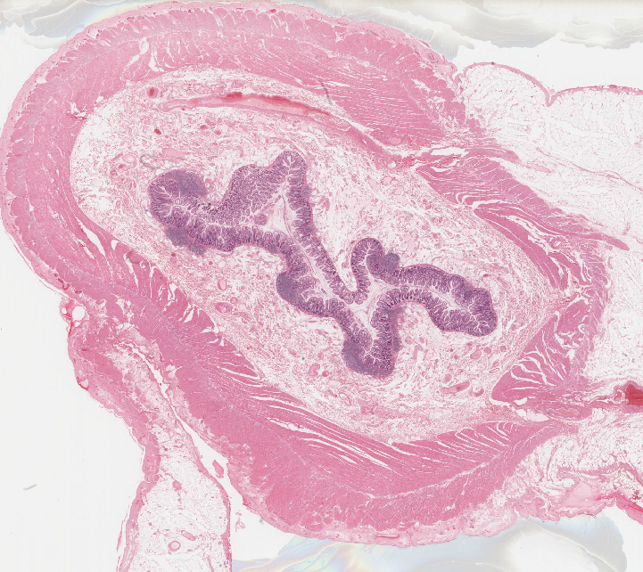 | 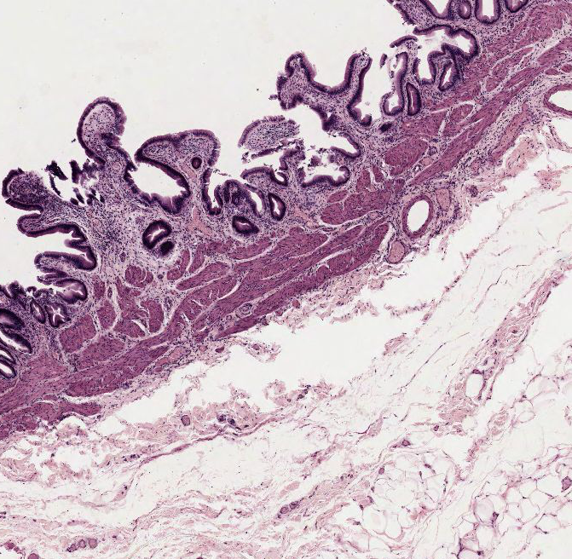
5. One special cell type unambiguously identifies this organ. Name and draw that cell type.  http://vmw-aperioimg01.duhs.duke.edu/DukeHistology/NB_Review/umich-029.svs/view.apml?X=0.132918679561311&Y=0.0496641804897522&zoom=0.812119962898073 | 7. Describe the layering of this organ  http://vmw-aperioimg01.duhs.duke.edu/DukeHistology/NB_Review/drexel-MCP69.svs/view.apml?X=-0.007107781131774&Y=0.0621958131214068&zoom=12.4572822639668
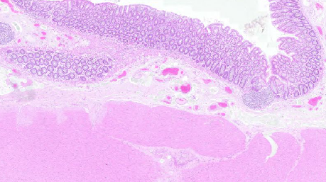 | 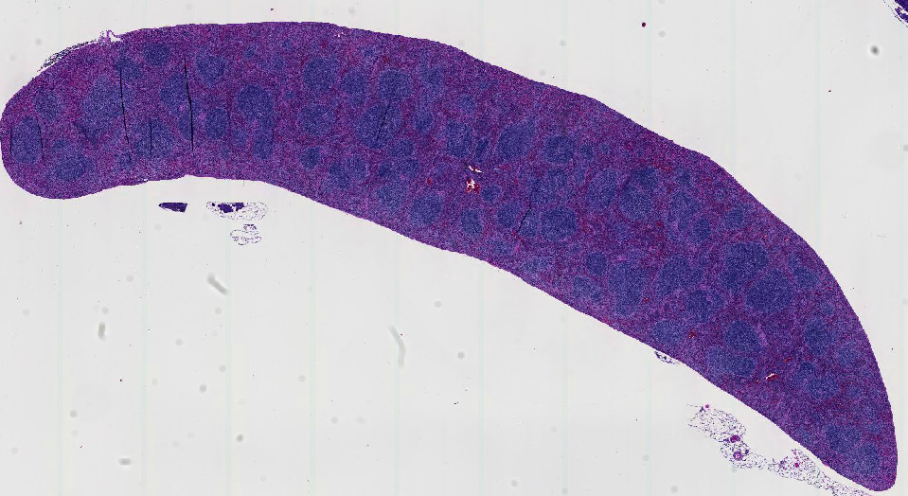
6. Does this organ have submucosal glands?  http://vmw-aperioimg01.duhs.duke.edu/DukeHistology/NB_Review/path200-0027_R.svs/view.apml?X=0.145196992824331&Y=0.135418178619969&zoom=5.59872 | 8. Identify the long narrow organ in the link below, justify your answer  http://vmw-aperioimg04.duhs.duke.edu/PATHOL_725_Histology/0090_S Mouse Tissues.svs/view.apml?X=0.0270738232205834&Y=-0.33630110083815&zoom=2.17013888888889

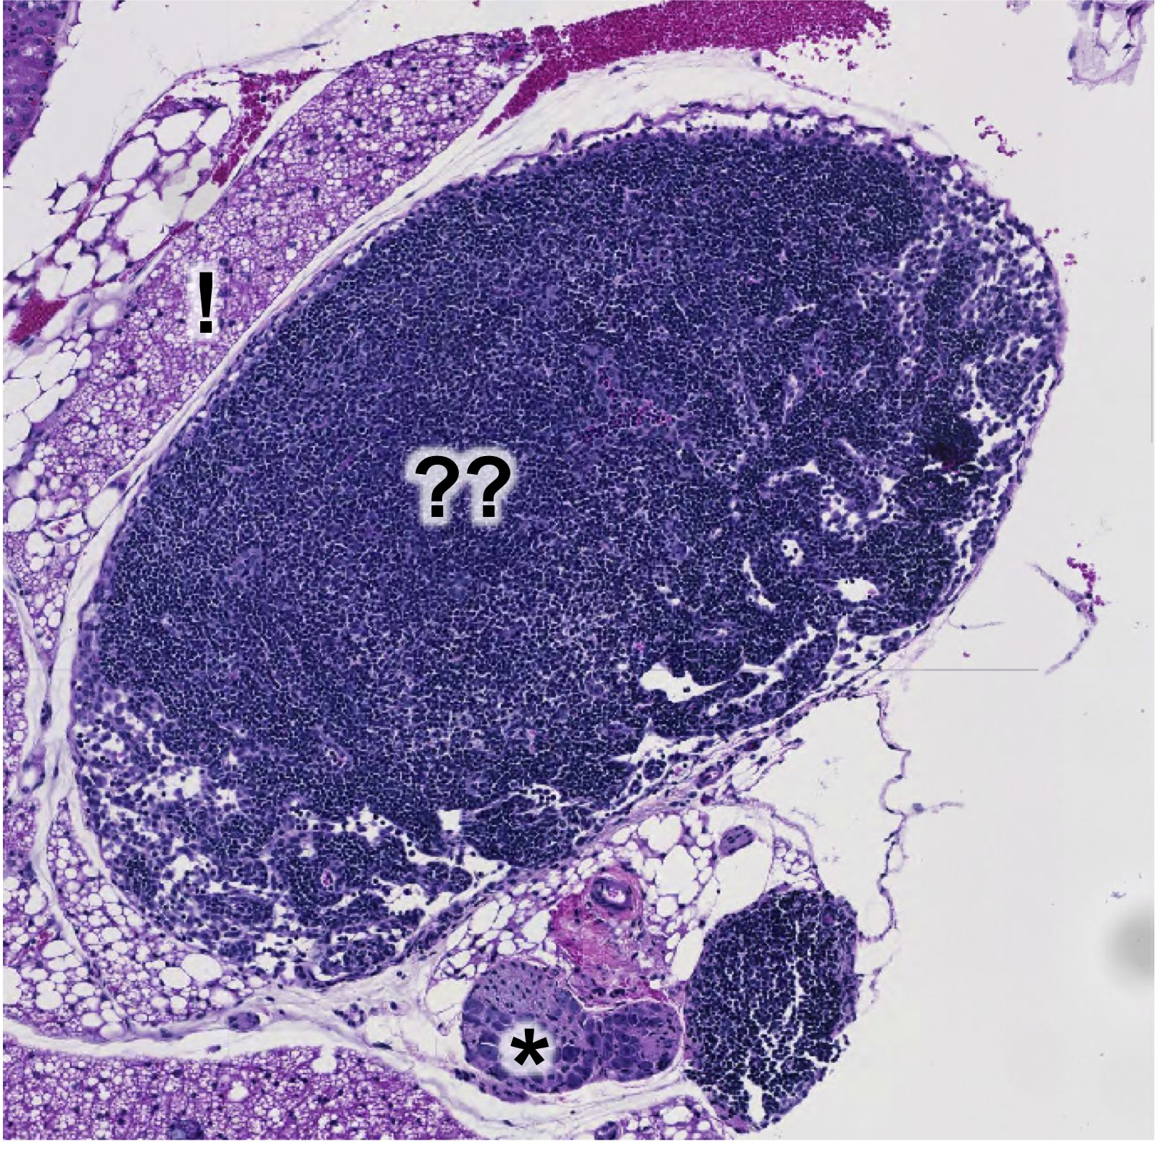 | 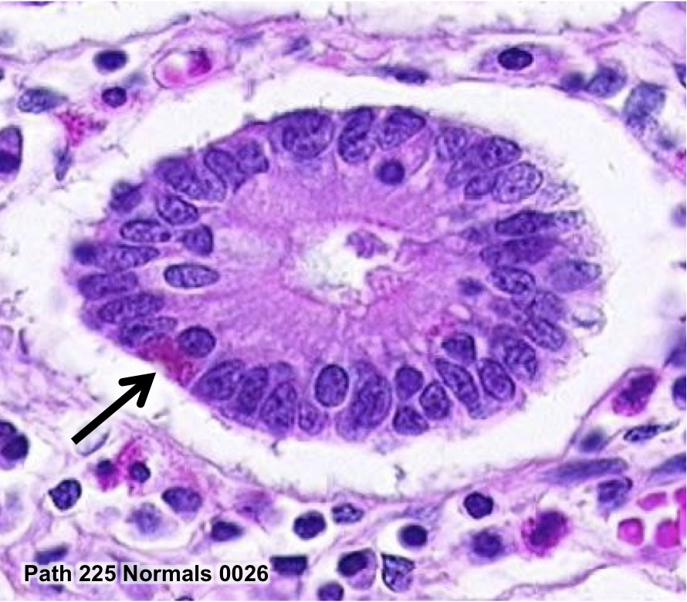
9. Identify the organ (??), justify your anwer.  http://vmw-aperioimg04.duhs.duke.edu/PATHOL_725_Histology/0090_S Mouse Tissues.svs/view.apml?X=-0.110416162399546&Y=0.0461065572271853&zoom=13.4587985741538  Bonus points  a. Identify the surrounding tissue (!).  b. Identify the structure (*) below the organ, at ~6:00 | 10. Identify the cell type marked with an arrow.  http://vmw-aperioimg04.duhs.duke.edu/PATHOL_725_Histology/0026_S.svs/view.apml?X=-0.219742597720577&Y=0.329919501015242&zoom=100  11. Identify the organ, give two key identifying features  12. Name 4 cell types found in the epithelium of this organ
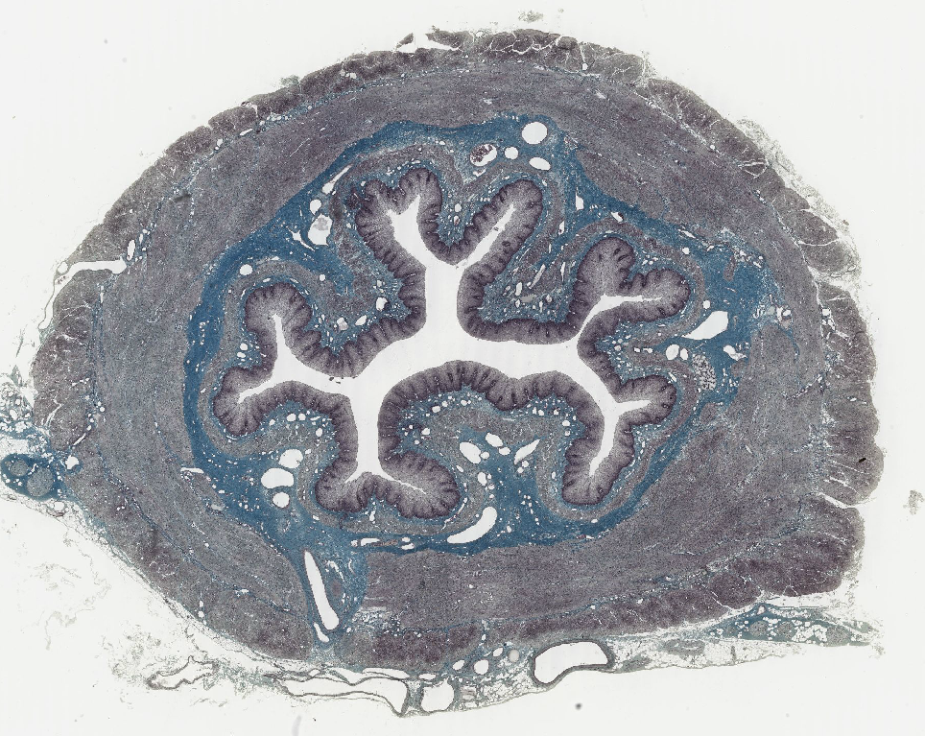 | 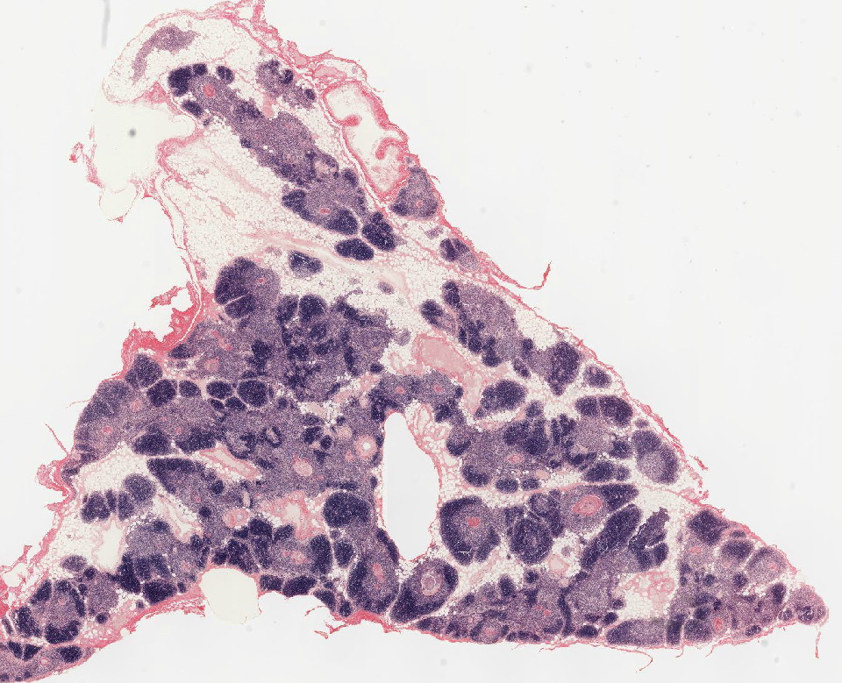
13. Justify why this is not the vagina  http://141.214.65.171/UCSF Histology/UCSF224_40X.svs/view.apml | 14. What’s the key identifying feature of this organ?  http://141.214.65.171/UCSF Histology/UCSF033_20X.svs/view.apml?

