Lymphatic system
- Key Feature: Parenchyma = lymphocytes
Mucosa-Associated Lymphoid Tissue (MALT):
- Diffuse lymphoid tissue, anywhere you have an epithelium.
- May or may not show nodules (follicles).
  - 1° = small, immature lymphocytes
  - 2° (germinal centers): B-cells → plasma cells → IgA → epithelium → lumen
- Beware! Distinguish between Nodule (tissue, ~0.2 mm) –vs– Node (organ ~1-10 mm)
Organ Diagnostic Tree:
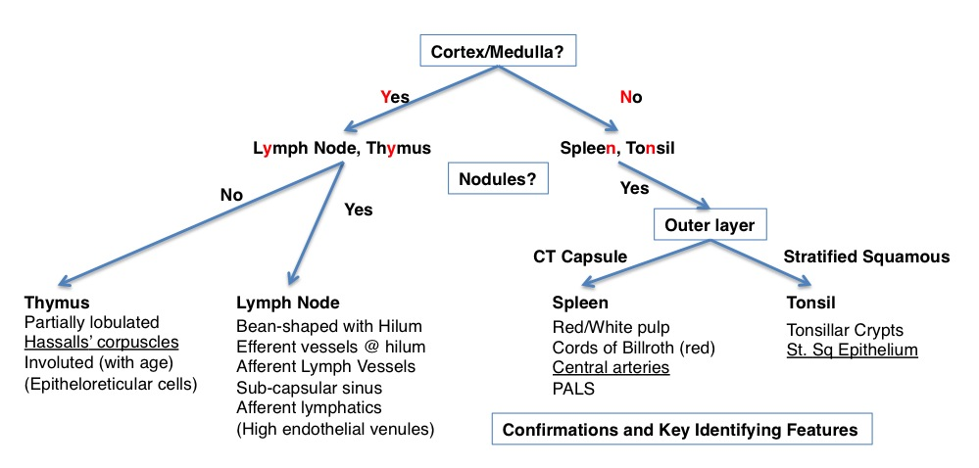
Lymph Node: A solid, encapsulated, bean-shaped organ with hilum, cortex/medulla organization
- CT capsule, with trabeculae that project into organ.
  - Capsule penetrated by lymphatic vessels = Afferent Lymphatic vessels
  - Sub-capsular sinuses
- Stroma = Reticular meshwork. Mostly small, thin cells ⇒ hard to see without silver stain
  - Reticular cells (fibroblasts), Dendritic cells (APCs), Macrophages (phagocytic and APC)
- Cortex
  - Lymph nodules (B-cells),
  - Paracortex (T-cells): beneath and between nodules
  - High Endothelial Venules (cuboidal endothelium)
Ohtani & Ohtani (2008) Arch. Histol. Cytol. 71(2):69-76.
    - In deep cortex, can be hard to see, site of diapedesis.
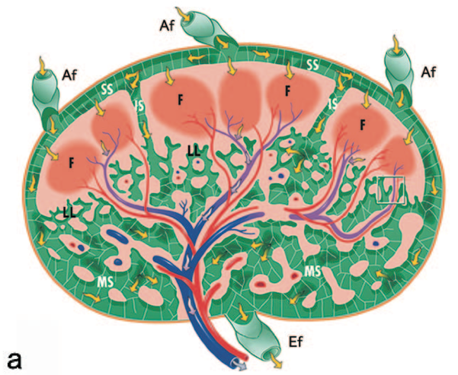
- Medulla
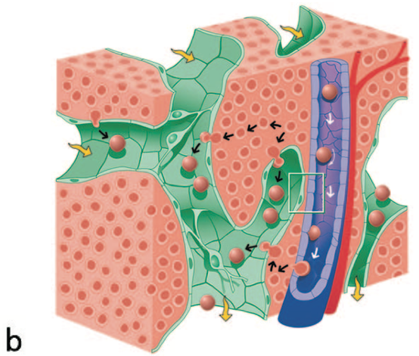
  - Medullary cords: lymphocytes, plasma cells, macrophages
  - Medullary sinuses
  - CT trabeculae
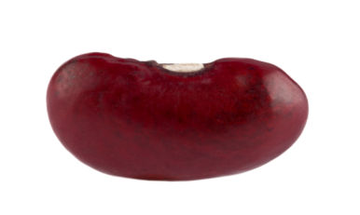
Bean
Thymus: solid, lobulated organ with cortex/medulla organization
- Beware! cortex/medulla (extended) NOT germinal centers (follicles).
- Think cauliflower.
- Thin CT capsule & trabeculae
  - Partially lobulated
  - Medulla is actually continuous ⇒ not true lobules
- Parenchyma = T-lympocytes: 98% culled by apoptosis!
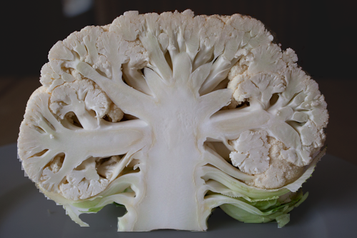
- Stroma = epithelioreticular cells
  - Six different types (indistinguishable by LM)
  - Large pale nuclei, pale cytoplasm
  - Blood-Thymus barrier in cortex (Type I)
  - Cortex-Medulla barrier (Type III and IV)
    - T-cells educated in cortex (+ selection)
    - Pass to medulla (- selection)

    - Exit medulla via fenestrated venules
  - Hassall’s corpuscles = concentric lamellar structure (Type VI), found in medulla
- Organ involutes (inactive, replaced with adipose) starting at puberty, but can revert if needed.
Spleen: Tongue-shaped organ, with thick CT capsule, no cortex/medulla, and lymph nodules throughout.
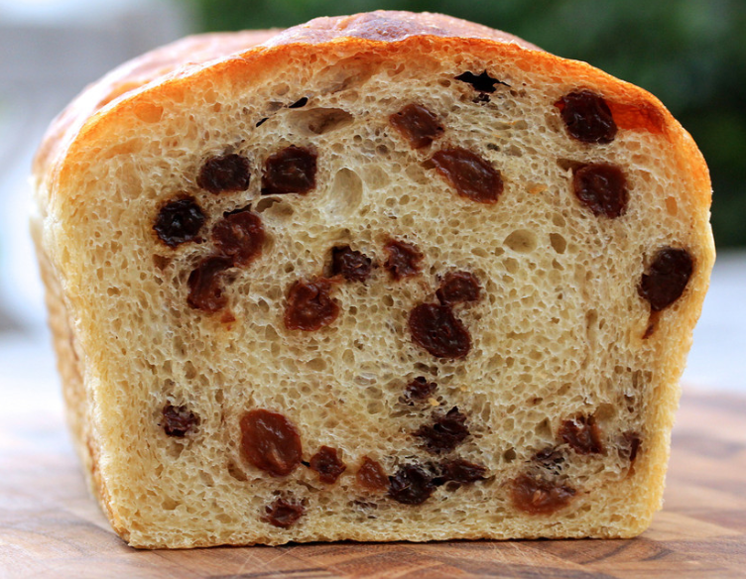
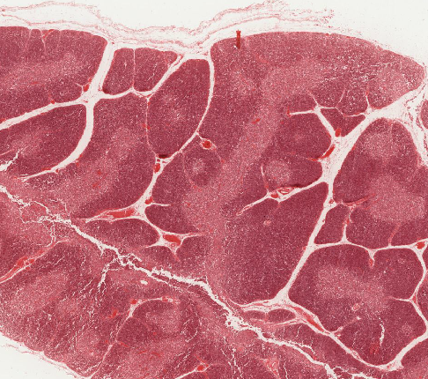
- Think raisin bread.
- Dense CT capsule with trabeculae and myofibroblasts.
- White pulp (blue in slides)
  - Central artery (key identifying feature)
  - PALS = Periarterial Lymphatic Sheath (T-Cells)
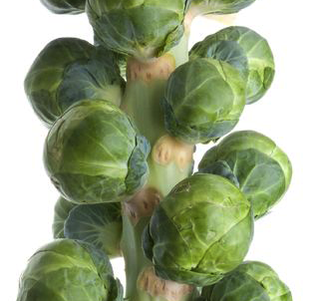
  - Nodules (B-cells) ⇒ central artery is actually at the side, not centered.
  - Think Brussels sprouts
- Red pulp
  - Open circulation: central arteries→
  - Sheathed arterioles (macrophages)→
  - Splenic cords (of Billroth)→
  - Splenic sinuses (discontinuous endothelium = littoral cells)
Tonsil:
- Partial capsule and adventitia
- Aggregates of lymph nodules
- Oral epithelium (stratified squamous)
- Tonsillar crypts (stratified → simple squamous)

Some unknowns to test yourself on:
http://141.214.65.171/UCSF%20Histology/UCSF027_20X.svs/view.apml?
http://141.214.65.171/UCSF%20Histology/UCSF019_40X.svs/view.apml?
http://141.214.65.171/UCSF%20Histology/UCSF037_20X.svs/view.apml?
http://141.214.65.171/UCSF%20Histology/UCSF033_40X.svs/view.apml?
http://141.214.65.171/UIowa_Virtual_Slides/b/b13.svs/view.apml?
http://141.214.65.171/LSUslides/A-44.svs/view.apml?

