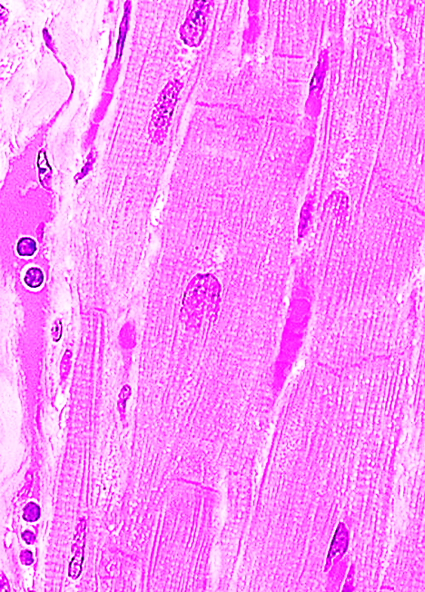
CARDIOVASCULAR LAB NOTES
CARDIAC MUSCLE:

Striations- A-I Banding
Central nuclei- one or two per fiber
Diameter = 10-25 um

Branching fibers
Shape = rectangular with blunt ends

Intercalated disc = dark band perpendicular to fiber length = fascia adherens & desmosomes

HEART:
Epicardium: s.sq mesothelium,
elastin, CT and fat
large blood vessels and nerves

Myocardium: cardiac myocytes – see description for cardiac muscle above

Endocardium: s.sq. endothelium
Subendothelium: CT and smooth muscle
Subendocardium: contains conducting fibers = Purkinje (2-3X contracting fiber in size), few myofibrils; central nuclei are often binucleate; pale staining due to glycogen; mitochondria around nuclei

BLOOD VESSELS
Arteries Arterioles Venules Veins

t. intima: IEL IEL (not in smallest) No IEL IEL in large

t. media: thick, sm musc 2-5 layer sm muscle thin, 1-2 sm musc thin sm musc
around lumen >t. adventitia <t. adventitia around lumen
EEL highest ratio sm m to thin wall to lumen No EEL
lumen diameter size

t.adventitia: thin CT not always seen thickest layer thickest layer
< or = t. media > t. media
No sm muscle sm muscle along tube axis
Vaso vasorum

