FEMALE REPRODUCTIVE SYSTEM

OVARY
Encapsulated organ (s. cuboidal epithelium = mesothelium, tunica albuginea =c.t.)
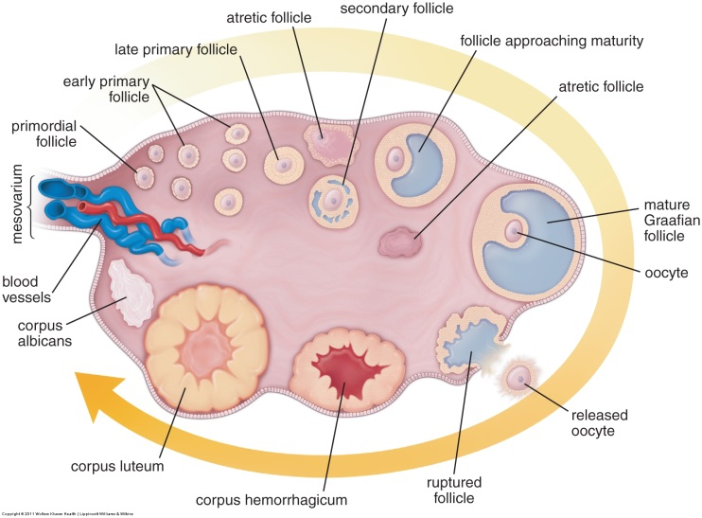
Hilus – entry/exit of blood vessels
Stages of ovarian follicles. Fig 23.2, Ross & Pawlina, 6th ed.
Cortex and medulla
Cortex – mesenchymal stroma (CT) + follicles
Medulla – mesenchyme (CT), highly vascularized with spiral (helicine) arteries

Follicles contain developing ova
Primordial
Ova ~30 µm
Simple squamous follicle cells
Primary = growing
Cuboidal follicle cells
Zona pelucida develops
Early→Late = follicle: simple→stratified
Stratified = stratum granulosum
Theca develops
Secondary (Antral)
Ova ~125 µm
Fluid filled antra, cumulus oophorus and corona radiata
Theca: interna (cuboidal, steroid secreting), externa (dense irregular CT)
Mature (Graffian): usually 1/cycle, single antrum, takes up whole cortex (~10 mm)

Atretic follicles: at any stage. (can be difficult to distinguish from fixation artifact)

Corpus Luteum = large, yellow body
Granulosa luteal cells = secretory, interior foamy cells
Theca luteal cells (T. interna, C.T.) – bring in BVs

Corpus Albicans = scar tissue, dense white body in medulla

FALLOPIAN TUBE (look alike = vas deferens, ureter)
Mucosa: 2 cell types; s.columnar = Peg cells (secretory) + s. columnar ciliated cells
Lamina propria (CT)
Muscularis: 2 layers sm muscle; inner = circ; outer = long
Serosa: s. squamous
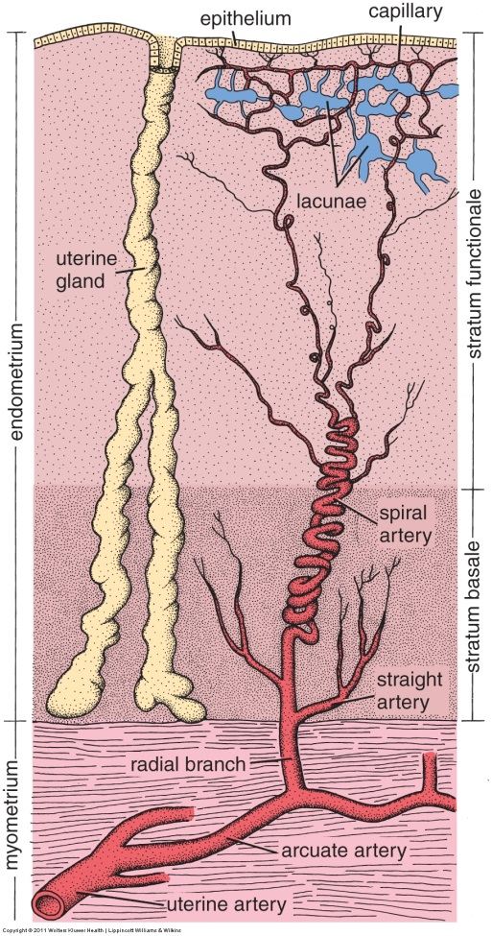
UTERUS
Uterine layers. Fig 23.15, Ross & Pawlina, 6th ed.
Wall thickness increases from fimbriae to uterus
Luminal diameter decreases from fimbriae to uterus
# folds decreases from fimbriae to uterus
Endometrium
Functionalis =
Compactum (surface region with pools of blood)
Spongiosum (glands)
Basalis = arcuate arteries give rise to spiral arteries; base of glands
Myometrium = 3 layers of sm muscle in swirls
Perimetrium = Serosa = s. squamous epithelium and

Glands under estrogen control:
Early proliferative:
endometrium = s. col + mitotic cells
Late proliferative:
endometrium= functionalis increases 2 fold
straight glands + mitotic cells

Glands after ovulation, estrogen + progesterone:
Early secretory:
endometrial glands = s. col, basal glycogen vacuoles
deep corkscrew glands
Late secretory:
Endometrial glands = s. col, apical glycogen vacuoles
Saw tooth glands

CHANGES IN UTERUS DURING MENSTRUAL CYCLE

