GI Glands lab notes

Acinus ducts other

Parotid: serous intercalated (s. cuboidal), long, many *fat striated (s. columnar) ct septae
excretory (st columnar to PSC)

Submandibular: serous/mucous intercalated (s.cuboidal)
*striated (s. columnar)
Excretory = stratified cuboidal to PSC

Sublingual: mucous intercalated
(serous demilunes) *NO striated ducts (or very few)

Myoepithelial cell
Salivon

Pancreas: serous acinus *NO striated ducts little c.t.
*centroacinus cells NO fat
Islets of Langerhans

Intracalated (s.cuboidal)
Interlobular duct (s.columnar)
Excretory duct (s.columnar + goblet) – 2 layers sm muscle

LIVER: Cords of hepatocytes = s. cuboidal epithelium
Blood sinuses (large bore capillaries) between hepatic cords
Central vein
Portal tracts = hepatic artery; portal vein; bile duct (s. cuboidal epithelium); lymphatic vessel
Excretory bile duct = s. columnar epithelium with microvilli
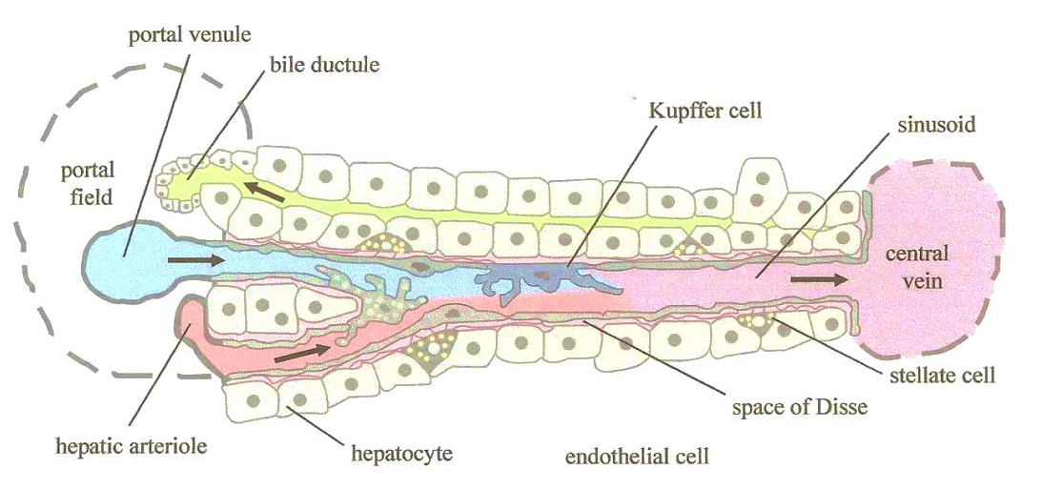
GALL BLADDER:
Mucosa- s. columnar epithelium; lamina propria
Muscularis- smooth muscle layer
Adventitia – dense irregular CT or fatty CT
Or Serosa- free side has a mesothelium

