MALE REPRODUCTIVE SYSTEM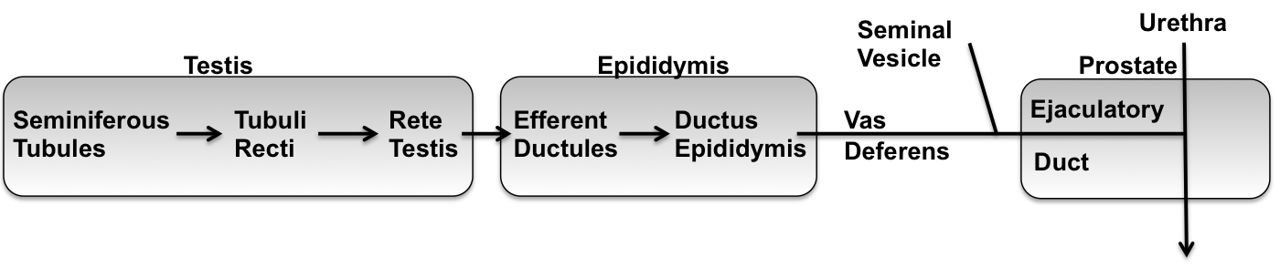
Epididymus
Efferent duct
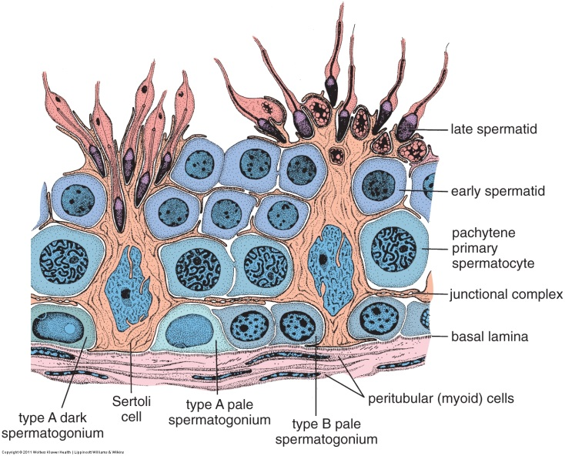
Serous cavity

Tunica vaginalis = sac- parietal and visceral layer

Seminiferous tubule

Rete testis - s. cuboidal with single cilium

vessels
vessels
Septum (c.t.)
t. albuginea (c.t.)
Vas deferens
TESTIS
Compact organ filled with tubules
Tunica albuginia = dense CT
CT septa divide organ into lobules
Each lobule has 1-4 seminiferous tubules
Seminiferous Tubules –stratified epithelium
1. Enclosed by a basal lamina and myeloid cells (contractile)
2. Sertoli cells = simple columnar epithelium surrounding developing sperm, pale, oval nucleus
3. Developing sperm:
A. Spermatogonia = next to BL = mitosis
Type A = homogeneous nucleus
Type B = heterochromatin
B. Spermatocytes = condensed chromosomes in meiosis
C. Spermatids = differentiation
Stages of spermatogenesis. Fig 22.6, Ross & Pawlina, 6th ed.
Early = small nuclei, acrosomal cap
Late = elongating, looking like sperm
D. Spermatozoa = free sperm in lumen
Leydig cells = between tubules, endocrine, vacuolated cytoplasm
EFFERENT DUCTS
Coiled tubules with irregular luminal surface (tall columnar and short cuboidal cells)
Simple columnar cells have cilia; simple cuboidal cells do not have cilia
Some smooth muscle surrounding tubules
EPIDIDYMIS
Coiled tubules with spermatozoa in lumens!
Head, body, tail (caput, corpus, cauda). Sperm stored in tail
Pseudo-stratified with tall (80-40 µm) columnar cells with stereocilia (25-10 µm) and small basal cells.
Smooth muscle surrounding tubules, 1 circular layer in caput (head), 3 layers (L-C-L) in cauda (tail)
VAS DEFERENS
3 layers of smooth muscle (L-C-L), very thick relative to lumen
Pseudo-stratified (many basal cells) columnar epithelium with stereocilia (may be poorly preserved)
Distal portion wider lumen = ampulla
Highly folded mucosa (secretory, no stereocilia), glandular diverticula
Muscle thinner, lose longitudinal layers in ejaculatory ducts
Look-alikes: ureter (proximal); oviduct or gall bladder (ampulla)

SEMINAL VESICLE
Sacculated, contorted tube = looks like multiple lumens (all connected)
Highly folded/involuted epithelium
Pseudo-stratified columnar epithelium, often looks simple
2 layers of smooth muscle (inner circular, outer longitudinal)
Nerves or ganglia
Look-alikes: oviduct or gall bladder
PROSTATE
Compact organ
Fibro-muscular stroma = CT and sm muscle densely interwoven, can be difficult to distinguish
Tubulo-alveolar glands
Pseudo-stratified columnar
Colloid = secretion in lumens; Lamellar concretions in older male (if present)
Ducts not apparent in sections
Penetrated by ejaculatory ducts & urethra
Look-alikes: breast (lactating); thyroid
PENIS
Corpus spongiosum, corpora cavernosa, tunica albuginea (c.t.) surrounds urethra (transitional)
Smooth muscle bundles surround vascular spaces (c. cavernosa, c.spongiosum)
Helicine (spiral) arteries with longitudinal sm muscle in tunica intima, and tunica adventia.

Corpus cavernosum penis
(blood vessels)
fibroelastic c.t., s. musc

Corpus spongiosum =
surrounds urethra

