Kidney Lab Notes
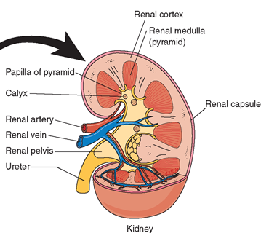
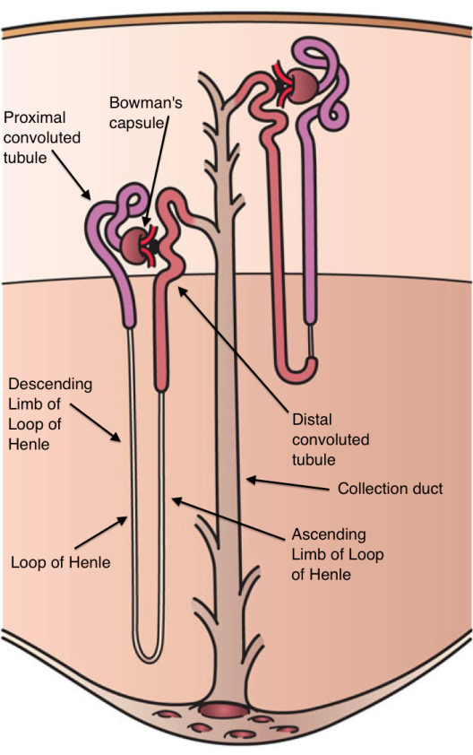

Kidney:
Parenchyma divided into cortex and medulla
CT capsule; NO mesothelium
Hilus = ureter exits; renal artery enters; renal vein exits

Parenchyma = Nephron = functional unit = renal corpuscle + renal tubule
Renal corpuscle = glomerulus + Bowman’s capsule
Medullary ray = collecting duct (straight duct) in cortex

Cortex contains:
Renal corpuscle: glomerulus surrounded by Bowman’s capsule
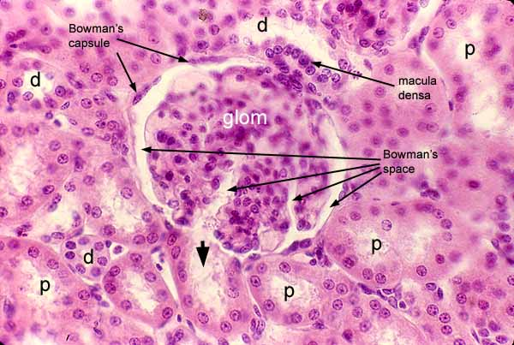
Proximal Convoluted Tubule (P):
Most numerous profiles Microvilli (brush border) Basal striations “s. cuboidal” in XS = occluded
Darkly stained

Distal Convoluted Tubule: fewer in number
s. cuboidal
NO brush border
Smaller in diameter; lumen is more open
More nuclei per XS area
Paler staining with basal striations
Medulla contains:
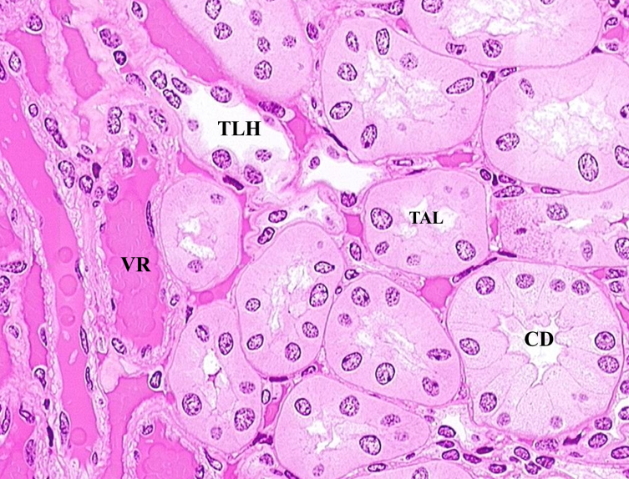
Loops of Henle (TLH) = s. squamous epithelium
Vasa recta (VR) = blood capillary –s. squamous endothelium
Thick ascending loop of Henle (TAL)- s.cuboidal
But not well defined cells; pale staining

Collecting ducts (CD) = s. cuboidal to s. columnar epithelium, pale staining with well-defined cell boundaries

JGA = juxtaglomerular apparatus in TAL has:
1. Afferent arteriole = JG cell, secretes renin
2. Macula densa of thick ascending loop of
Henle (TAL) = s. columnar (see image above)

Note: portal system has first capillary bed (glomerulus) connected to second capillary (peritubular capillary in cortex) or (vasa recta in medulla).

URETER: **Star shaped lumen, small lumen with thick wall
Mucosa: transitional epithelium, lamina propria = fibrous c.t.
Muscularis: 2 layers sm muscle inner longitudinal
outer circular
3rd near the bladder = outer, long
Adventitia: c.t.

BLADDER: ** Large lumen with relatively “thin” wall
Mucosa: transitional epithelium, Lamina propria = fibrous c.t
Muscularis: 3 layers sm muscle Inner longitudinal
Mid circular
Outer longitudinal
Serosa: mesothelium maybe present, if not = adventitia

