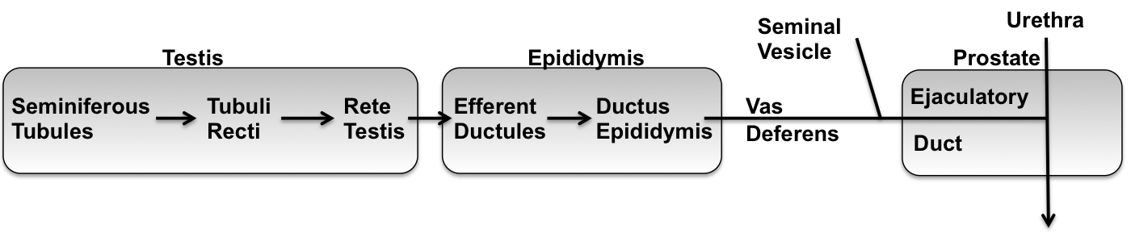
Testis (no look-alikes)
- Tunica Albuginia = Dense CT covering
  - Tunica vaginalis (if present), Parietal and visceral layers, outside TA
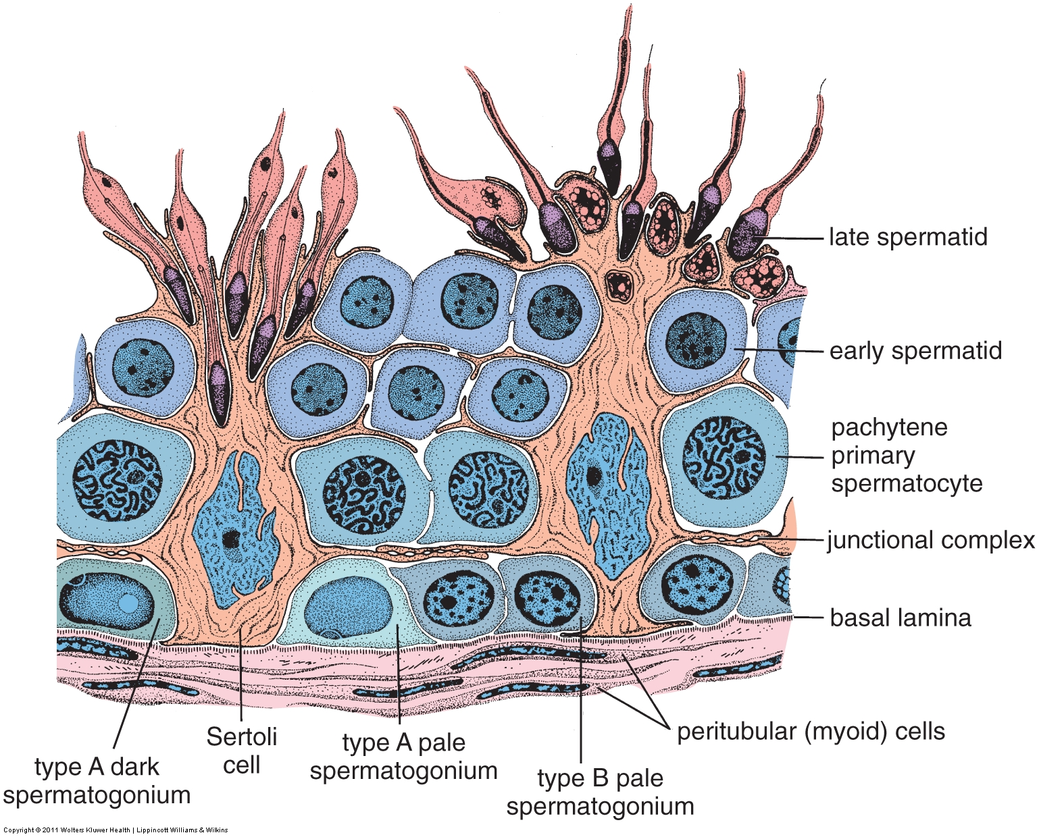
  - Cremaster muscle (if present), outside TV
- Compact organ full of tubules (xs and ls)
- Seminiferous Tubules full of developing sperm
  - Spermatogonia = on BL = mitosis
    - Type A = homogeneous nucleus
    - Type B = heterochromatin
  - Spermatocytes = above BL = meiosis
  - Spermatids = differentiation
    - Early = small nuclei, acrosomal cap
    - Late = elongating, looking like sperm
  - Spermatozoa = free sperm = in lumen
  - Sertoli Cells = pale, oval nucleus with nucleous = support cells
Stages of spermatogenesis. Fig 22.6, Ross & Pawlina, 6th ed.
- Leydig cells = between tubules = endocrine, vacuolated
- Myoid cells = long narrow cells surrounding tubules = contractile
- Tubuli Recti = only Sertoli cells, TR are short = hard to find, look near rete.
- Rete Testis = simple cuboidal, venous sinuses
- Pampiniform Plexus = countercurrent heat exchange for blood, in mediastinum testis
Epididymis (no look-alikes)
Efferent Ductules
- Coiled tubules with irregular luminal surface (tall and short cells)
- Pseudo-stratified with cilia (needed to propel immature spermatozoa)
- Some smooth muscle surrounding tubules
Ductus Epididymis
- Coiled tubules with spermatozoa in lumens!
- Head, body, tail (caput, corpus, cauda). Sperm stored in tail
- Pseudo-stratified with tall (80-40 µm) columnar cells with stereocilia (25-10 µm) and small basal cells.
- Halo cells = lymphocytes in epithelium
- Smooth muscle surrounding tubules, 1 circular layer in caput, 3 layers (L-C-L) in cauda
Vas Deferens (Ductus Deferens)
- 3 layers of smooth muscle (L-C-L), very thick relative to lumen
- Pseudo-stratified (many basal cells) columnar epithelium with stereocilia (may be poorly preserved)
- Distal portion wider lumen = ampulla
  - Highly folded mucosa (secretory, no stereocilia), glandular diverticula
  - Muscle thinner, lose longitudinal layers in ejaculatory ducts
- Look-alikes: ureter (proximal); oviduct or gall bladder (ampulla)

Seminal Vesicle
- Sacculated, contorted tube = looks like multiple lumens (all connected)
- Highly folded/involuted epithelium
- Pseudo-stratified columnar epithelium, often looks simple
- 2 layers of smooth muscle (inner circular, outer longitudinal)
- Nerves or ganglia
- Look-alikes: oviduct or gall bladder
Prostate
- Compact organ
- Fibro-muscular stroma = CT and SmM densely interwoven, can be difficult to distinguish
- Tubulo-alveolar glands
  - Pseudo-stratified columnar
  - Lamellar concretions (if present)
  - Ducts only see in certain sections
- Penetrated by ejaculatory ducts & urethra
- Can have lots of nerves/ganglia
- Look-alikes: breast (lactating)
Penis
- Corpus spongiosum, corpora cavernosa, tunica albuginea
- Smooth muscle bundles surround vascular spaces = subendothelial cushions
- Helicine arteries with longitudinal SmM in T. intima, and T. adventia.

