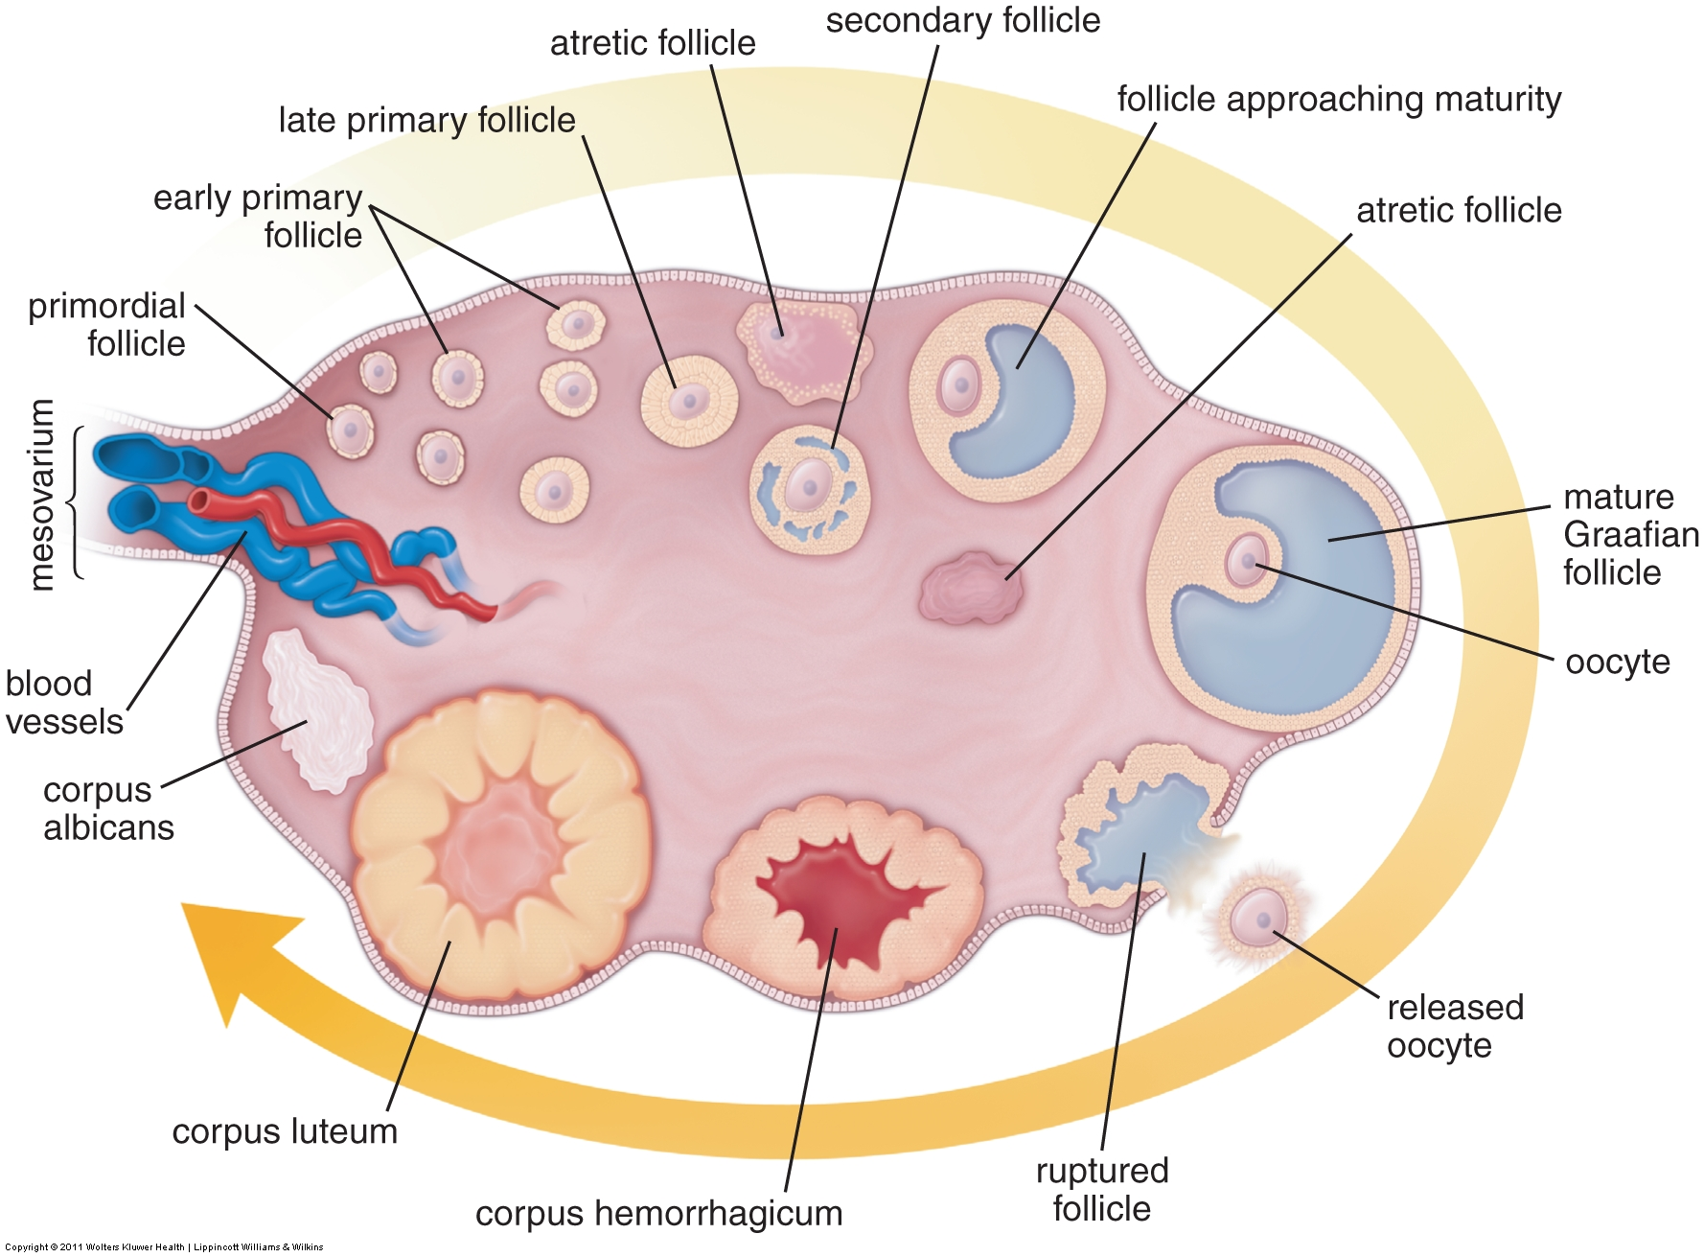
Ovary (no look-alikes)
Stages of ovarian follicles. Fig 23.2, Ross & Pawlina, 6th ed.
- Ovarian surface epithelium = cuboidal
- Tunica Albuginia = Dense CT covering
- Cortex/Medulla organization
  - Medulla = loose CT + blood vessels
  - Cortex = cellular CT + Sm Muscle + follicles
- Ovarian Follicles with developing ova
- Primordial
- Ova ~30 µm, may see Balbiani bodies
- Simple squamous follicle cells
- Primary = growing
- Cuboidal follicle cells
- Zona pelucida develops
- Early→Late = follicle: simple→stratified
- Stratified = stratum granulosum
- Theca folliculi develops
- Secondary (Antral)
- Ova ~125 µm
- Developing antra, cumulus oophorus and corona radiata
- Theca folliculi: interna (cuboidal, steroid secreting), externa (CT + smooth muscle)
- Mature (Graffian): only 1/cycle, single antrum, takes up whole cortex (~10 mm)
- Atretic follicles: at any stage. (can be difficult to distinguish from fixation artifact)
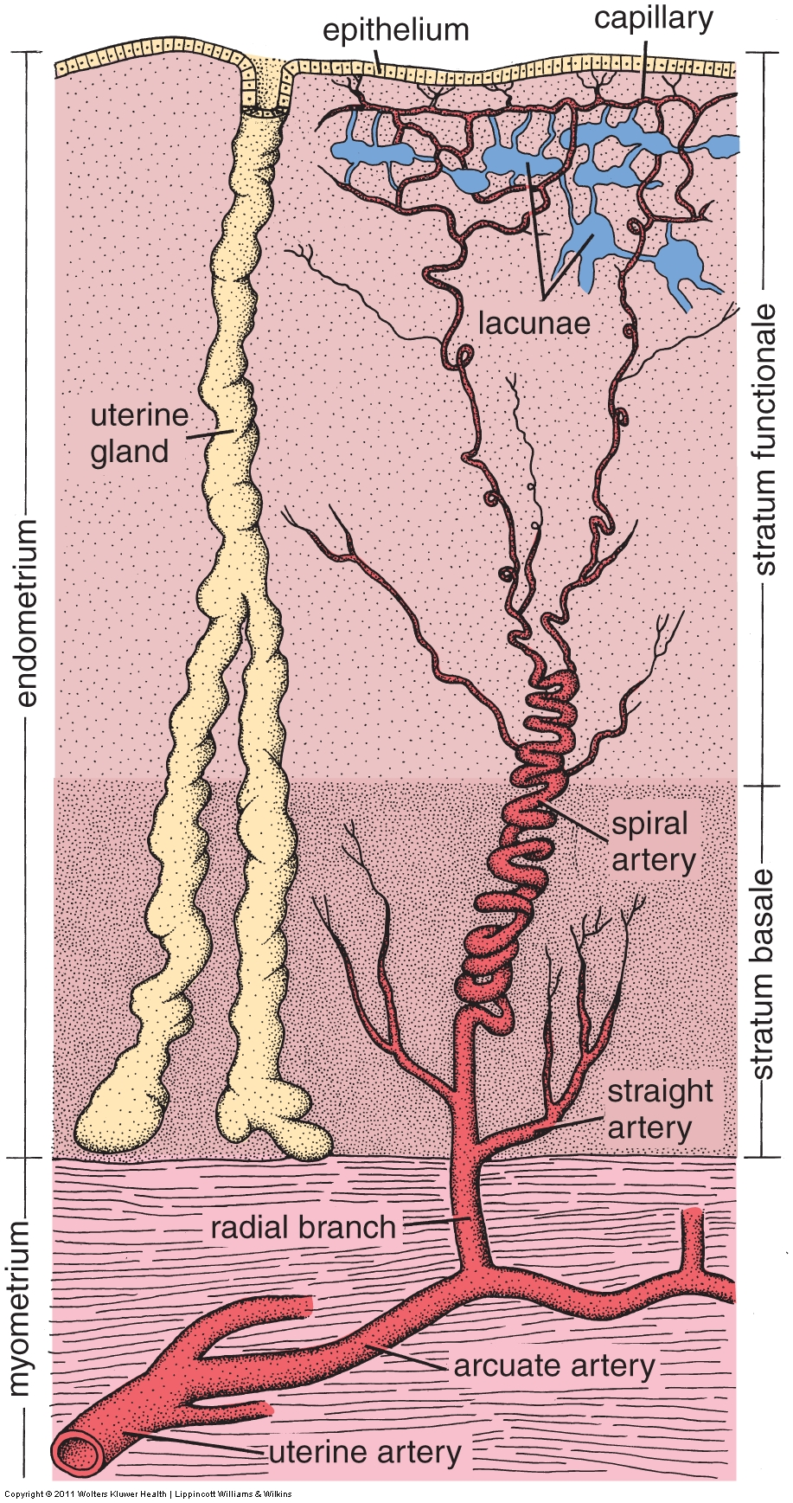
- Corpus Luteum = yellow body
Uterine layers. Fig 23.15, Ross & Pawlina, 6th ed.
  - Granulosa luteal cells = secretory
  - Theca luteal cells (T. interna) – bring in BVs
- Corpus Albicans = scar tissue
Oviduct = Fallopian Tube (look-alikes: vas deferens, ureter)
- Infundibulum→Ampulla→Isthmus→Intramural
- Thin wall, big lumen → Thick wall, small lumen
- Layering
- Mucosa – Highly folded, simple columnar, ciliated cells, peg cells
(compare to urothelium in ureter or stereocilia in vas)
- Muscularis: thick inner circular, thin outer longitudinal
(compare to ureter, reverse order, or vas, three-layer)
- Serosa – Hard to see, but compare to adventitia of ureter & vas.
Uterus (no look-alikes)
- Layers: peri- (serosa), myo- (muscle), endometrium (glands)
- Endometrium: Tubular glands, spiral arteries, highly cellular CT
- Stratum basale/functionale, functionale shed during menstruation
- Epithelium: Simple columnar, ciliated cells, peg cells.
- Regions: Fundus, corpus, cervix
- Cervix: branched glands, mucus-secreting, Nabothian cysts
Vagina (look-alikes: esophagus, anus)
- Mucosa
  - Stratified squamous epithelium, non-keratinized, pale due to glycogen
  - Thick lamina propria, 2 regions: cellular CT & elastic, vascular CT (submucosa)
- Muscularis: 2 indistinct layers, inner circular, outer longitudinal
- Adventitia: elastic CT, fatty CT, large blood vessels, parasympathetic ganglia
- See Extra Slides 250 #1 & 2 for good slides of the vagina.
- May see Bartholin’s or Skene’s glands (but no submucosal glands)
- Look-alikes:
  - Compare muscularis mucosae, submucosal glands and thick muscularis externa in esophagus
  - Compare vascular plexus (erectile tissue) in vagina
  - Compare apocrine glands in anus
Mammary (look-alikes: prostate, thyroid)
- Lobulated, tubulo-aveolar glands, with myoepithelial cells
- Ducts with stratified cuboidal epithelium
- Some interlobular adipose

Vocabulary:
- Uterus: Endometrium, myometrium, os, cervix, corpus, fundus
- Oviduct/Fallopian tube: Fimbrae, infundibulum, ampulla, isthmus, intramural
- Ovary: germinal epithelium, tunica albuginia, cortex, medulla, follicles
- Follicles: primordial, primary, secondary, graafian, atretic
- Graafian follicle: theca externa, theca interna, antrum, liquor folliculi, granulosa cells, cumulus oophorus, corona radiata, zona pelucida, oocyte
- Corpus luteum: granulosa lutein cells, theca lutein cells, corpus albicans

Some Review Slides for Normal Body:
Some descriptions (not necessarily complete) follow, but font is set to white. Change font color when you’re ready to see answers.
- http://141.214.65.171/UCSF%20Histology/UCSF224_40X.svs/view.apml?
I see a big tube (5-10 mm diameter) in cross section. It has GI layering with stratified squamous epi, thick Muscularis mucosae, mucous glands in submucosa (3:00), all smooth muscle in Muscularis externa, and a hint of a serosa in parts (eg near 10:00). This is all consistent with lower third of the esophagus, below diaphragm. A beautiful slide. Note well preserved Auerbach’s plexi between layers of M Ext. (eg near 11:00) and easy to find Meissner’s plexi in Submucosa (eg near 9:00). Note also stratified cuboidal duct penetrating the epithelium near 7:00, presumably from a mucous gland which is out of the plane of section.
- http://141.214.65.171/UCSF%20Histology/UCSF027_20X.svs/view.apml?
I see a solid organ with thick CT capsule and a serosa, no cortex/medulla, parenchyma = lymphocytes organized into lymph nodules scattered throughout organ, with central veins (actually in the center, too!) associated with each nodule. This is the spleen.
- http://141.214.65.171/UCSF%20Histology/UCSF248_40X.svs/view.apml?
I see a tube with GI layering and villi. Epithelium = tall simple columnar cells with brush border (= extremely uniform, dense microvilli) and occasional goblet cells (stained bright red in this slide, an unusual stain). Glands at bottom of epithelium show Paneth cells, which have white secretion granules in this slide (not red granules as we usually see for Paneth cells, but from the goblet cells we already know this is an usual stain, so it makes sense that the Paneth cells stain a different color than the goblet cells). No submucosal glands nor Peyer’s patches = jejunum (or ileum away from Peyer’s patches). Each of the layers on this slide is very short, suggesting this came from a small animal, like a mouse. Because of this brevity in the layering you might be excused for thinking this was gall bladder at first glance (I did), but the regularity of the villi, the glands at the base of the villi, the goblet cells, and the Muscularis mucosae all argue against the gall bladder, which should have none of those. And obviously, looking more carefully, you can see all 4 layers of the GI layering.
- http://141.214.65.171/UCSF%20Histology/UCSF269_40X.svs/view.apml?
Note the simple (tall) columnar epithelium, no goblet cells. Mucosa is folded, but not into regular villi or glands. Below epithelium is a loose (cellular) connective tissue with lots of lymphocytes. Below that is a Muscularis, in which the smooth muscle show cork-screw nuclei. There is a serosa across the top of the organ, but the bottom and sides show an adventitia, with the organ embedded in liver. This is gall bladder. The liver shows cords of very uniform cuboidal cells (hepatocytes). Although the lobular structure is not well presented in this slide, you can find central veins and some portal tracts. Venous sinusoids between the cords, some with Kupfer cells, are obvious and can be seen emptying into central veins in some places. A sharp eye can distinguish bile canaliculi in some places (see far right side), but these are somewhat ambiguous in this slide.
- http://141.214.65.171/UCSF%20Histology/UCSF329_40X.svs/view.apml?
On top, a solid organ full of tubules, with a cortex and medulla, and lots of round glomeruli in the cortex. Must be kidney. Note this beautiful trichrome stain shows collagen as blue, and nuclei as red/pink. RBCs are variably orange/yellow or colorless, and. plasma is grey/blue while lysed blood in the vasa recta is bright red. Note the proximal and distal convoluted tubules; what color is each? How can you distinguish collecting ducts and the thin Loops of Henle?
The organ below appears to have a highly folded lumen, and is therefore a hollow organ. The wall of the organ is made of four layers, an outermost adventitia, a gray layer which shows smooth muscle in cross and longitudinal section, a middle blue layer (mostly connective tissue, which typically stains blue in trichrome stains), and an innermost mucosa made up of transitional epithelium = urothelium. The transitional epithelium means we must be in the urinary system, so this is either the ureter, bladder or urethra. Since the organ is by itself, it’s probably not urethra, which is normally embedded in tissue. It’s too small to be the bladder, which would have a larger lumen. That leaves the ureter, with this being a longitudinal section. For confirmation, I would expect the muscularis to be two-layered, with the inner layer longitudinal and the outer layer circumferential. The muscularis is somewhat disorganized, but at least some areas look to show the expected orientation (see lower right side, about ¼ of the way from the end). Potentially confusing, there appears to be a number of RBCs n the lumen and even shed tubules from the kidney (see lumen at left side), but we can conclude that these must be artifacts or pathology of some sort.
- http://141.214.65.171/UCSF%20Histology/UCSF378_40X.svs/view.apml?
A tube of some sort, with a highly folded mucosa. Inside the lumen is various detritus, but a sharp eye can spot dark red triangles some of which have tails, which must be sperm, which must mean we’re in the male repro! The sacculated lumen suggests seminal vesicle. The columnar to low columnar epithelium is not helpful and insists on appearing simple, despite the expectation that it be pseudostratified. Can’t see any apical processes like stereocillia. This slide is labeled seminal vesicle; however, the Muscularis gives me pause, as it seems to be three layers (see area around 9:00), inner and outer longitudinal, and middle circumferential. This makes me suspect this slide might be the ampulla of the vas deferens, not the seminal vesicle.
- http://141.214.65.171/UCSF%20Histology/UCSF420_40X.svs/view.apml?
Weird looking, but this can only be an ovary, with a massive corpus lutuem (hemorrhagicum) on the left, and a giant empty follicle on the right. In between is a blue corpus albicans. There are many circular profiles visible at a medium magnification (10x), which I initially assumed were follicles. However, closer inspection proves most of them to be blood vessels, often with transparent RBCs in them, ~5-6 µm in diameter. Proper follicles containing ova are difficult to find. I could wish for a cuboidal epithelium (germinal epithelium) covering the organ as a key identifying feature, but since I do not see any, I assume it was torn off in processing, leaving us with the tunica albuginia, which I can see.
- http://141.214.65.171/UCSF%20Histology/UCSF405_40X.svs/view.apml?
I see cut surfaces at the left and bottom, and natural surfaces at the right and top. This is a solid chunk of something with whorls of (blue) elastic connective tissue and (gray) smooth muscle. The stratified squamous epithelium on the right side changes to a simple columnar epithelium about ½-way across the top natural surface. The columnar epithelium shows branched invaginations, which are glands. The surface of the columnar epithelium looks fairly weird with lots of surface blebbing, especially in the glands, but with a careful examination you can find some areas that show ciliated cells (http://tinyurl.com/n36v8jq). Smooth muscle, elastic connective tissue, branched glands, columnar epithelium with cilia transitioning to stratified squamous epithelium: this must be the cervix. I also see large cyst-like lumens filled with blue fluid at the top, middle of the organ, which must be Nabothian cysts.
- http://141.214.65.171/UCSF%20Histology/UCSF375_40X.svs/view.apml?
This appears to be a discrete structure with natural edges all around. Although difficult to identify everywhere, there appears to be a serosa surrounding the structure, under which there is (blue) dense irregular connective tissue. There are regions of unilocular adipose, many large blood vessels (arteries, veins, and lymphatics) and nerves. At the left is a tube with a lumen ~ 0.5 mm in diameter, lined by a pseudostratified epithelium with stereocilia seen in some places, surface blebbing in others. Inside the lumen are sperm! Outside the epithelium there is a (blue) lamina propropria, followed by a very thick muscularis. The muscularis is three-layered, inner longitudinal, middle circumferential (the thickest layer) and outer longitudinal. The tube must be the ductus deferens. The entire structure is the spermatic cord.
- http://141.214.65.171/UCSF%20Histology/UCSF401_40X.svs/view.apml?
The top natural surface has stratified squamous, keratinized epithelium (= skin!), which is quite wrinkly, while the whole structure has a rounded, nipple-like appearance. In the deep dermis there are many fascicles of smooth muscle. At lowest magnification I can see a glandular structure at the bottom right, and a large lumen northwest of that (and another farther NE). The glandular structure shows tubulo-aveolar glands with simple cuboidal epithelium. There is a hint of myoepithelial cells, seen as thin brownish bands surrounding many of the tubules. The large lumen is lined by stratified cuboidal epithelium and is filled with a uniform staining colloid. The gland and lumen are a bit of breast tissue, and the whole structure must be the nipple. The smooth muscle in the dermis is also consistent with our diagnosis.
- http://141.214.65.171/UCSF%20Histology/UCSF261_40X.svs/view.apml?
This is a layered structure, so it is part of a tube. It appears to have GI layering, although it is difficult to distinguish the Muscularis mucosae due to all the lymphocytes in the mucosa. However, I can see a clear serosa on the top, with a well-defined, 2-layered Muscularis externa below it. I can see lots of nerve plexuses, some of them in the classic position between the two layers (Aurbach’s plexus) but many of them within the layers of the M. externa, which is less usual. But the muscualaris externa really makes me think GI layering. Below that is a layer of dense irregular connective tissue, the Submucosa, also consistent with GI. What is difficult to distinguish is the Muscularis mucosae, because it appears to be invaded by lots of lymphocytes, but I think I can see wisps of smooth muscle that I can tentatively identify as M. mucosae. The lamina propria mucosae is chock-a-block full of lymph nodules, diffuse lymphocytes, and loads of eosinophils (note the bi-lobed nuclei, so not mast cells). The epithelium is simple columnar cells with microvilli and lots of goblet cells. The structure of the mucosa is a little strange, fairly smooth in most places, with a few regions where the epithelium invaginates into crypt-like structures. Nothing that looks like villi, so this is more like colon, less like small intestine, but not really like true colon which would have lots of parallel crypts. The slightly strange, but somewhat colon-like mucosa, plus all the lymph nodules leads me to conclude this is appendix.
- http://141.214.65.171/UCSF%20Histology/UCSF234_40X.svs/view.apml?
This is a layered structure = tube. At first glance it seems to have GI layering (but will confirm). Top = epithelium (lumen); bottom = outside. Can’t see a serosa, but the sharply-defined outer layer at the bottom suggests a serosa that has been lost, instead of an adventitia. The Muscularis externa does NOT show the classic 2-layers I usually see in the intestines, but apoears to be made of more layers (maybe three ), all of them more or less oblique. The Submucosa shows connective tissue (blue), some unilocular fat, and a number of blood vessels. There is also a lot of white space, which is probably artifact from the processing. There is a fairly well defined Muscularis mucosae, which shows layers of both cross- and longitudinally oriented smooth muscle. The lamina propria is typical loose (cellular) connective tissue. The M. externa already had me thinking stomach, but the mucosa absolutely confirms it: 1. At the surface, there is a single cell type, all with pale foamy appearance = mucus surface cells. 2. The mucosa is arranged in wide-bored pits leading to coiled tubular glands. 2. In the glands I can see two cell types: pale, triangular cells like fried eggs = parietal cells, and darker, more or less columnar cells = chief cells. Mucous neck cells are not really apparent here, but if I wanted to look for them I’d look in the neck region of the glands for cells that were clearly not parietal nor chief cells, and which looked somewhat like mucous surface cells. I see some cells that I can hand-wave and call mucous neck cells, but nothing really convincing. No doubt, this is stomach.
- http://141.214.65.171/UCSF%20Histology/UCSF294_40X.svs/view.apml?
Three slices from the same piece of tissue. It’s a solid organ, with cells arranged in ascini. The cells of the ascini are two-toned, purplish at the basal end, and paler at the apex. The organ is lobulated, and in some of the lobules I can identify larger ducts with simple cuboidal epithelium, usually next to blood vessels. Finer details of the duct system are hard to distinguish because the slide is not very well preserved, but I think I can see some intercalated ducts, with more squamous to low cuboidal epithelium, leading from the ascini. I cannot identify centroacinar cells with any confidence. Islets of Langerhans can be easily spotted as nests of cells quite distinct from the ascinar cells. The islet cells are bluish, and the islets are highly vascularized. This must be pancreas.
- http://141.214.65.171/UCSF%20Histology/UCSF305_40X.svs/view.apml?
At lowest mag I can spot that C-shaped piece of hyaline cartilage. This must be trachea. Data dump from there. Epithelium should be pseudostratified columnar epithelium with cilia and goblet cells. Confirm? Check! Sub-mucosa should have mucous glands, check. Should see bands of smooth muscle across the opening of the C. The complete C is not seen in this section, but you do see the expected smooth muscle on the left side. Check, check, check. Trachea!
- http://141.214.65.171/UCSF%20Histology/UCSF425_40X.svs/view.apml?
Fruitcake = ovary! A solid organ full of follicles. Follicles contain giant cells (~100 µm) = oocytes in various stages of development. Describe them. Cortext/medulla organization is not apparent (follicles throughout = all cortex). No corpus luteum to be seen, but plenty of regions of corpus albicans. Epithelium on the outside of the organ is not the usual squamous serosa, but instead tends more towards cuboidal (= “germinal” epithelium). Stroma = mix of CT and smooth muscle.

