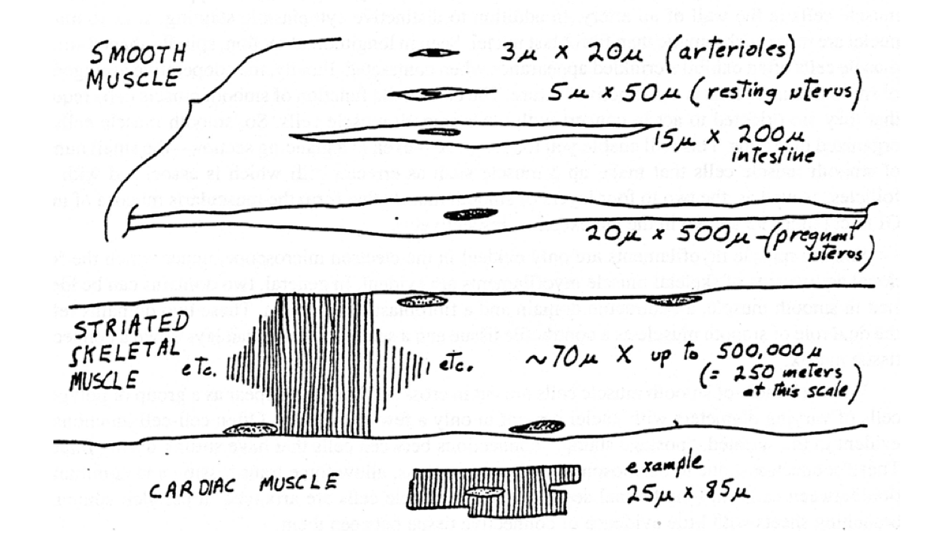
Cardiac Muscle (tissue)
- Key Features:
- Look a likes:
Heart (organ)
- Layers: Note different definitions!
  - Endocardium
  - Myocardium
  - Epicardium
  - Pericardium
- Key Features.
- Purkinje fibers

Blood Vessels

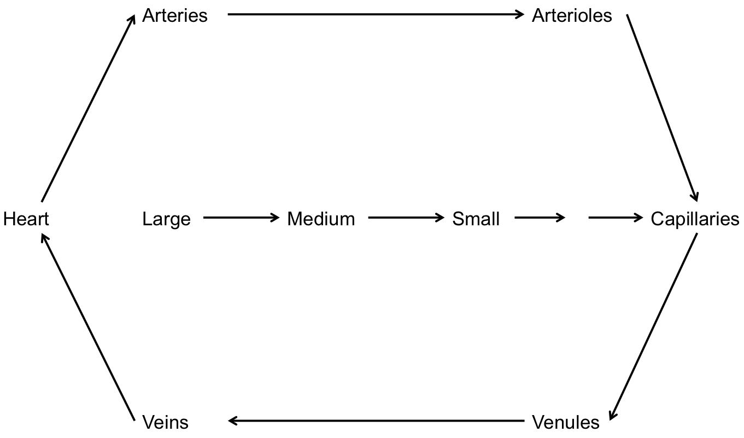

Layers:
- Tunica Intima
- Media
- Adventitia

Lymph Vessels

