Lymphatic Unknowns
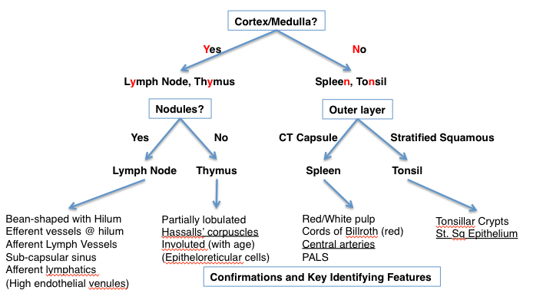

http://141.214.65.171/UCSF%20Histology/UCSF027_20X.svs/view.apml?

http://141.214.65.171/UCSF%20Histology/UCSF019_40X.svs/view.apml?

http://141.214.65.171/UCSF%20Histology/UCSF037_20X.svs/view.apml?

http://141.214.65.171/UCSF%20Histology/UCSF033_40X.svs/view.apml?

http://141.214.65.171/UIowa_Virtual_Slides/b/b13.svs/view.apml?

