Lab 4 Quiz

1. Identify the 3 large lumens, giving the key identifying features for each.
http://141.214.65.171/Drexel_Virtual_Slides/Respiratory/HU72_40x.svs/view.apml?X=0.0557861410717117&Y=-0.0340692845458744&zoom=9.88467838514151
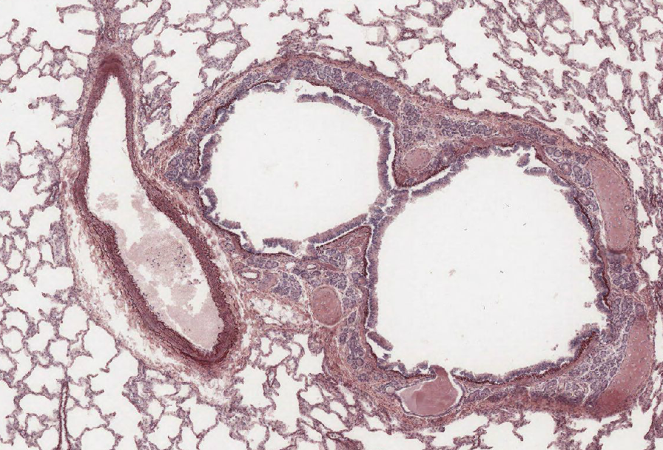

2. Identify the organ and describe the layering. Note especially any unusual or unexpected features.

http://141.214.65.171/UCSF%20Histology/UCSF183_40X.svs/view.apml?
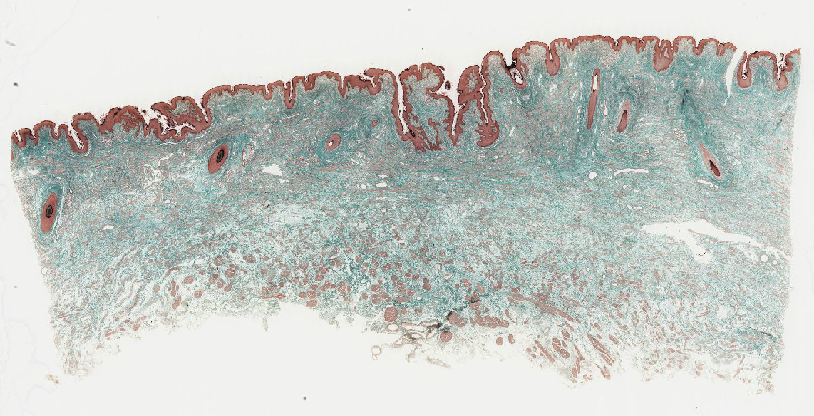

3. Identify the organ, identify the likely region of the organ, and note any key features.
http://141.214.65.171/UCSF%20Histology/UCSF102_40X.svs/view.apml?
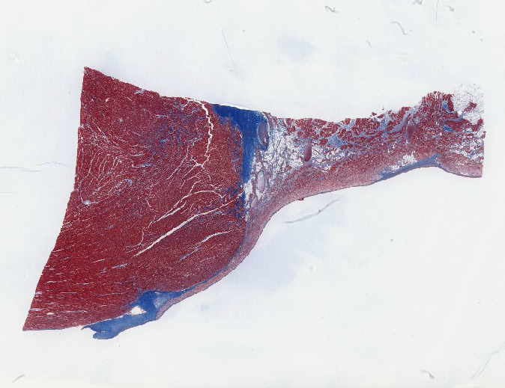

4. Identify the organ. Describe the outermost layer and hypothesize what region of the organ the slide comes from.
http://141.214.65.171/UCSF%20Histology/UCSF309_40X.svs/view.apml?
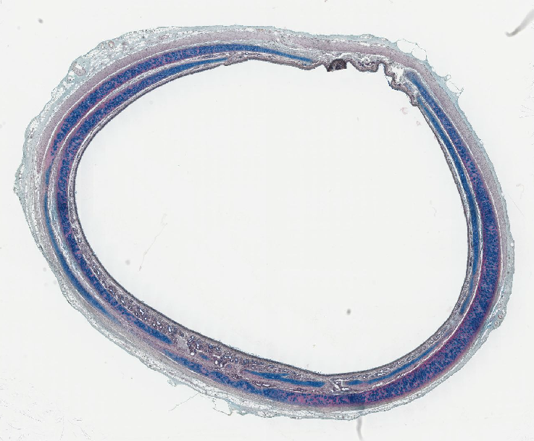

5. Identify the lumen marked with an asterisk.
http://141.214.65.171/LSUslides/A-72.svs/view.apml?X=0.315665435468521&Y=-0.0392790713938612&zoom=15.552
