Salivary Glands
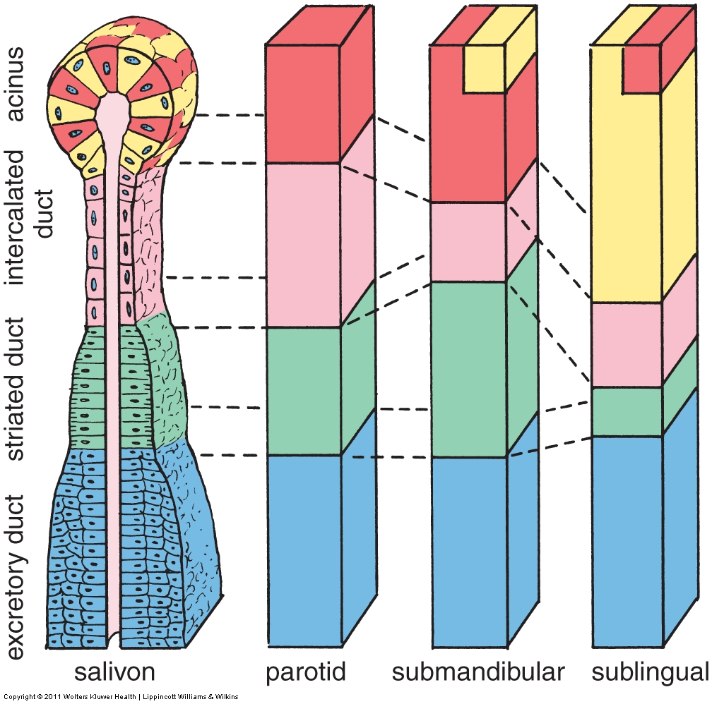
Solid organ, lobulated by CT septa
- Surrounded by adventitia
- Parenchyma = epithelial cells arranged in acini
- Myoepithelial cells surround acini
- Ducts low cuboidal to columnar to stratified
- Intercalated ducts striated ducts  excretory ducts
- Parotid = Protein = serous acini
  - Fatty
  - Large nerves (facial)
- Submandibular = mixed serous and mucous acini
- Sublingual = Slime = mucous,
  - tubulo-acinar arrangement
- Look-a-likes: Parotid-vs-Pancreas
  - Striated ducts & stratified excretory ducts
  - (Fatty, large nerves, myoepithelial cells)
  - No Islets of Langerhans

Pancreas
- Solid organ, lobulated by CT septa
- Parenchyma = epithelial cells arranged in acini, all serous, no mucous acini.
- Two-toned acinar cells, blue basal, red towards lumen, with secretory granules
- Ducts simple squamous to cuboidal to columnar
- Centroacinar cells  intercalated ducts  intralobar collecting ducts  pancreatic duct  ampulla of Vater
- Islets of Langerhans = group of lighter staining cells, highly vascularized (endocrine)
- Look-a-likes: Pancreas-vs-Parotid
  - Islets of Langerhans,
  - Centro-acinar cells, simple columnar excretory ducts
  - No striated ducts, no myoepithelial cells
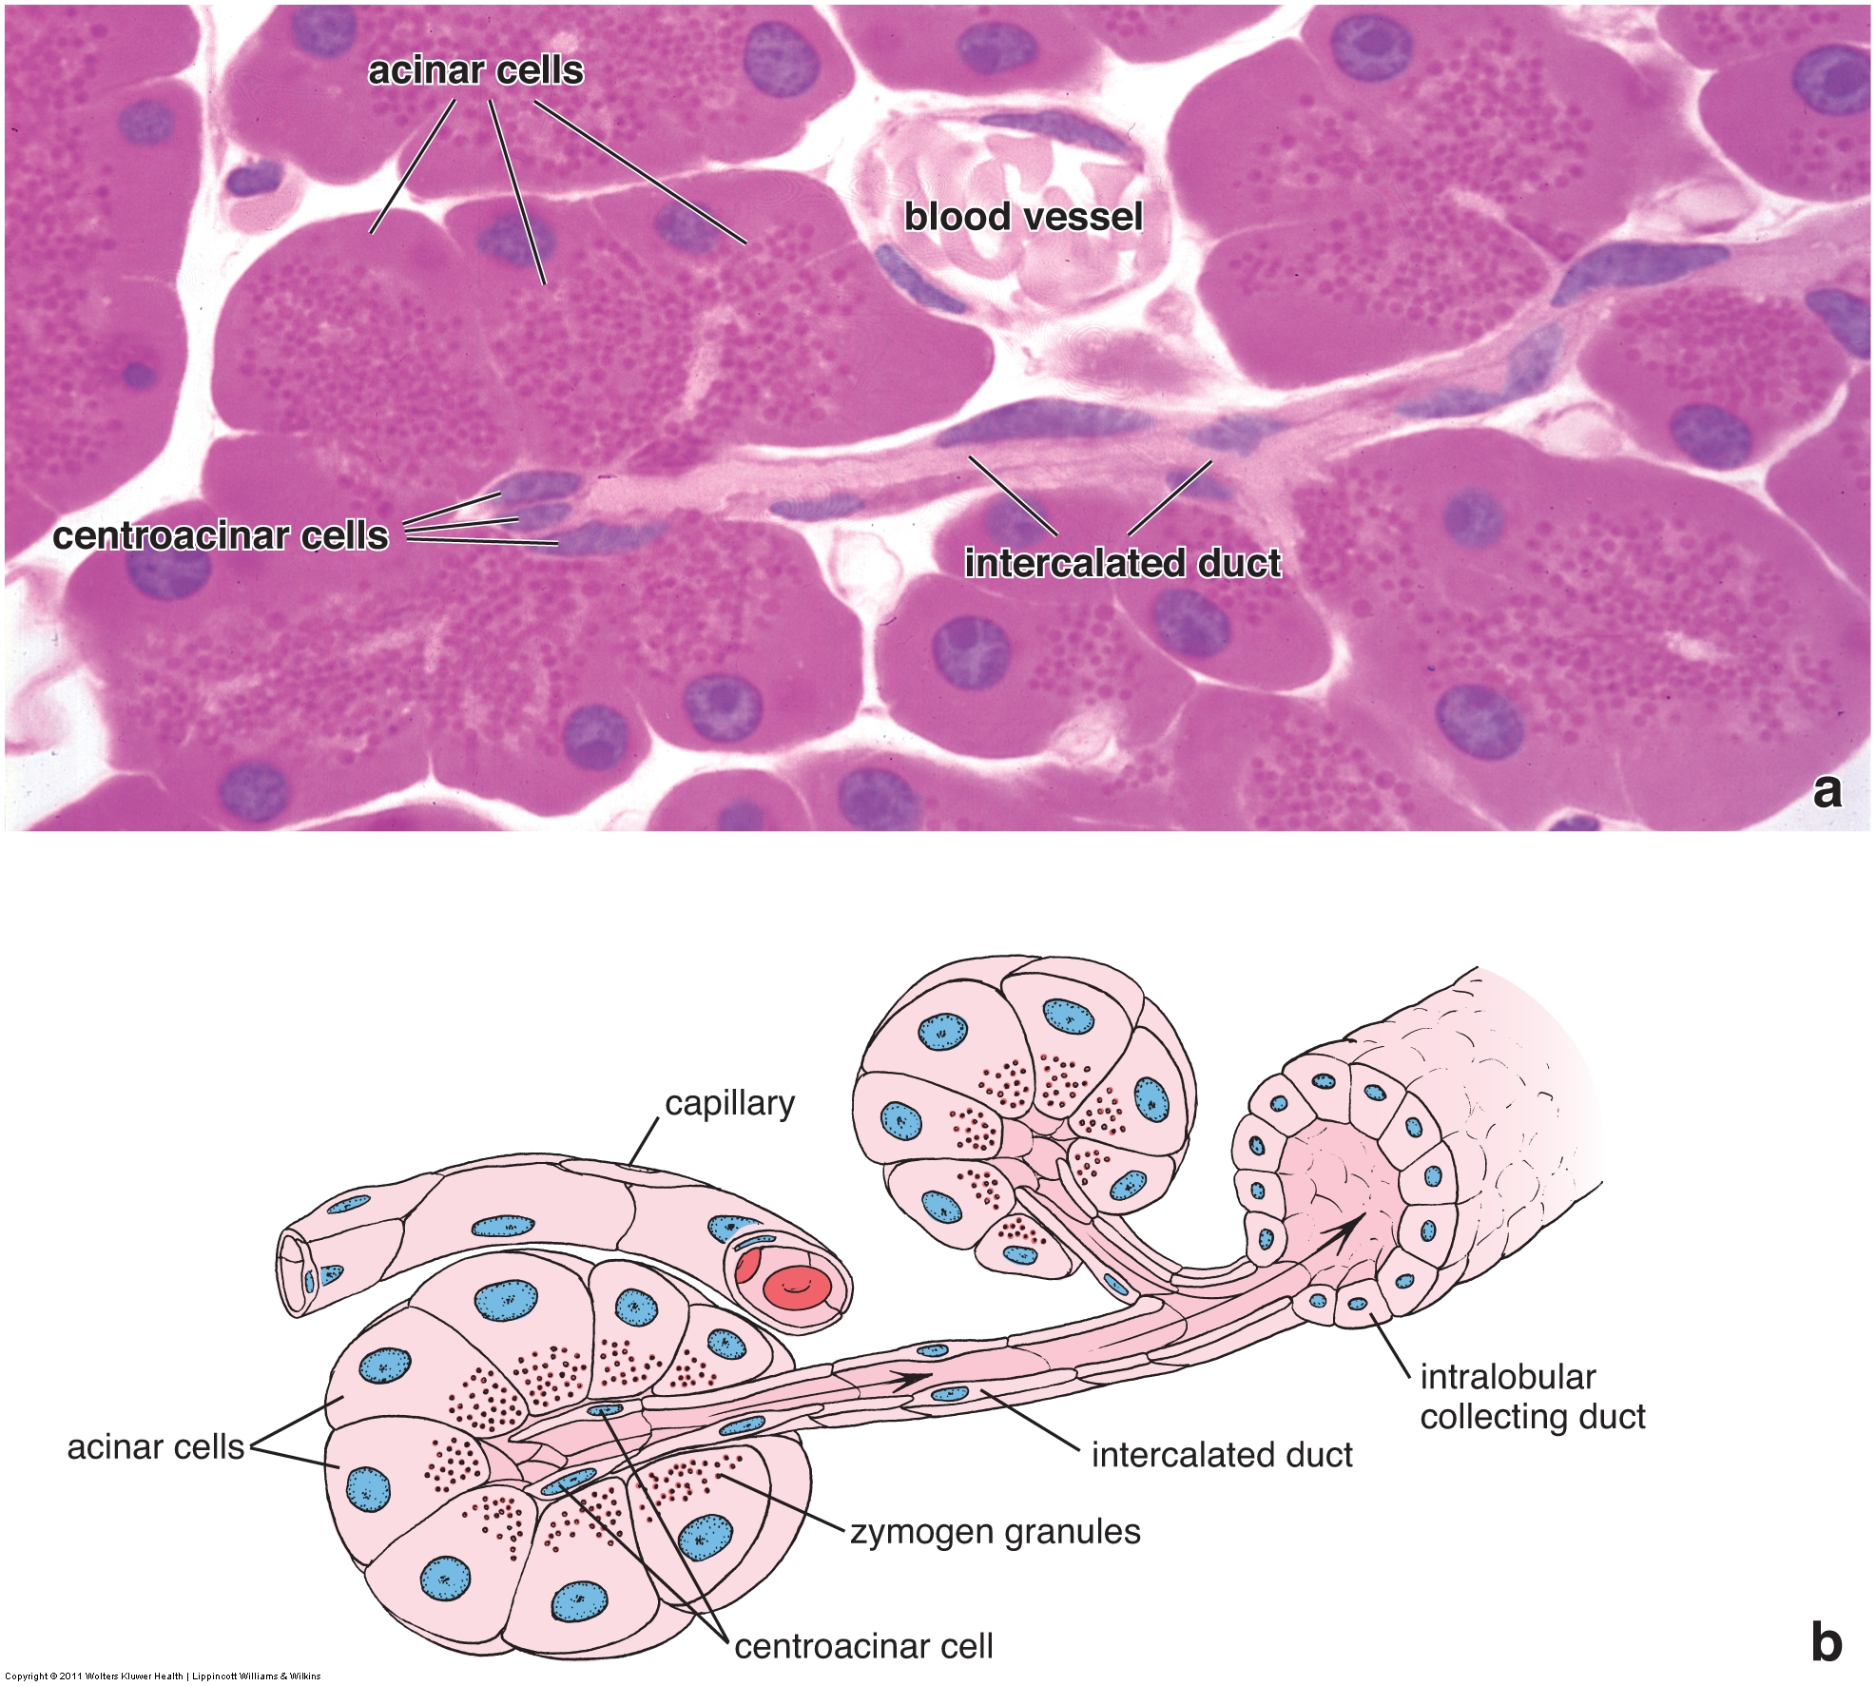
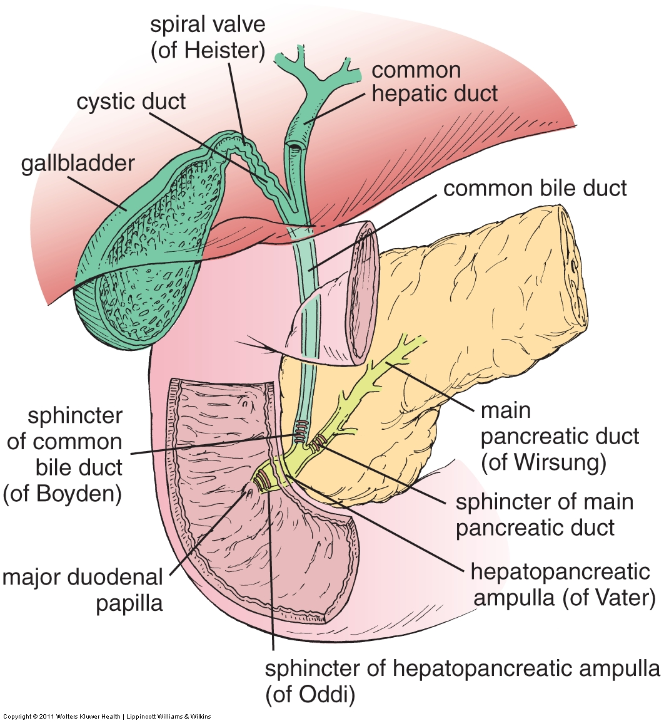
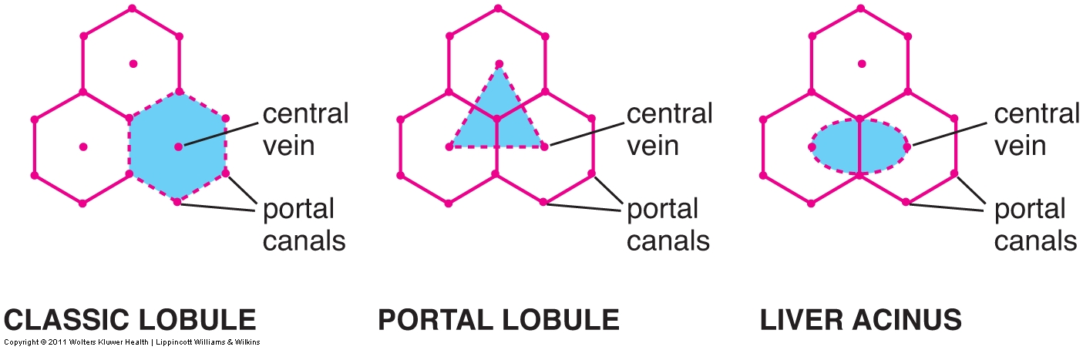
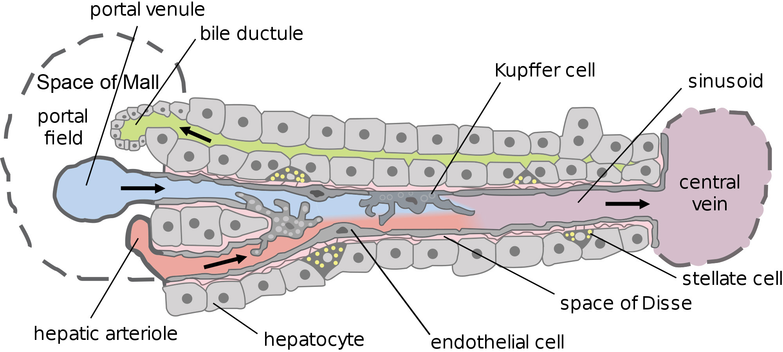
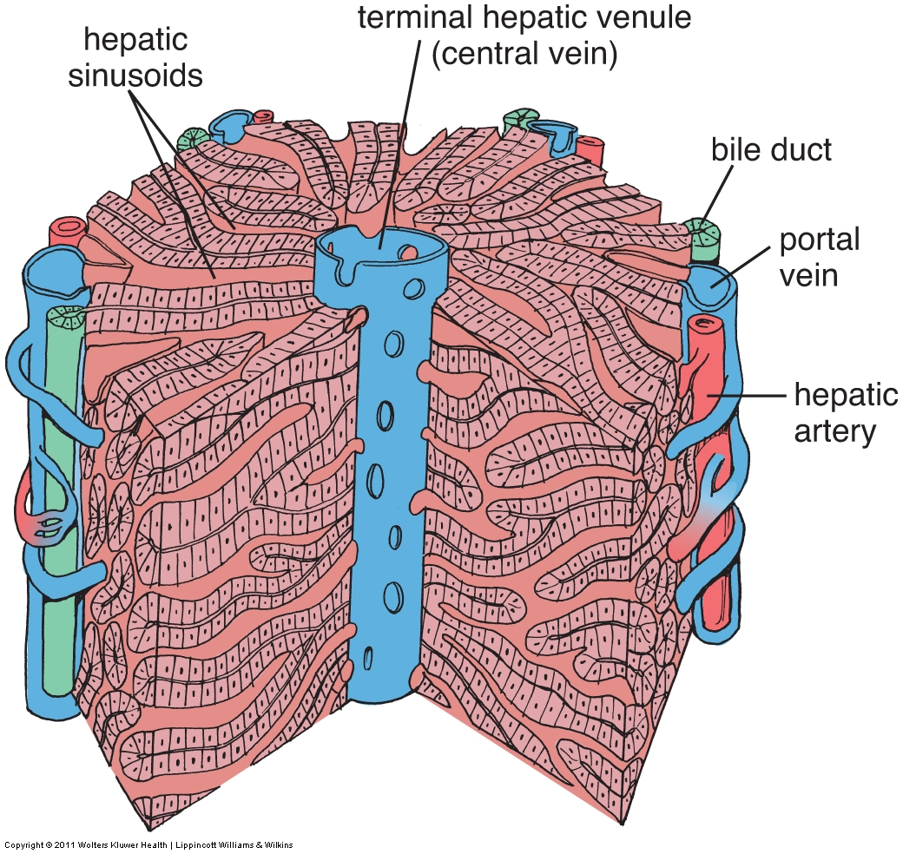
Liver
- Solid organ, very homogenous
- Thin CT capsule covered by serosa
- Parenchyma = cords of cuboidal cells (hepatocytes) separated by hepatic (blood) sinusoids
- Stroma = wispy CT
- Classic lobules = hepatocytes radiating from central vein in middle, portal tracts around perimeter
- Portal tract = portal vein, hepatic artery, bile duct & lymphatics (not really a triad)
- Portal venous blood (75%) MIXES with hepatic arterial blood (25%) in the hepatic sinusoid, => [O₂] low
- Hepatic sinusoids
  - Defined by squamous endothelial cells, fenestrated & gaps between cells
  - Contain Kupffer cells (macrophages) to clean up senescent RBCs
- Bile canaliculi between hepatocytes connect to bile ducts
- Bile ducts = simple cuboidal (low)
- Space of Disse = space between hepatocytes and endothelial cells of sinusoids
  - Hepatocytes have microvilli => absorptive
  - Contains stellate (Ito) cells that store vitamin A, may become myofibroblasts => fibrosis.
- Peri-portal extracellular space = Space of Mall, contains blind lymphatic capillaries
- Counter-current flow: Blood towards central vein, bile & lymph towards portal tract
- Look-a-likes: none for liver
Gall Bladder
- Wildly folded mucosa = simple columnar epithelium with microvilli, covering loose CT lamina propria
- Muscularis externa, surrounded by adventitia (or serosa on part of it)
- Embedded in liver!
- No Muscularis mucosae, nor sub-mucosa
- Look-a-likes:
  - Gall bladder versus GI:
    - No GI layering, no Muscularis mucosae, no sub-mucosa, Muscularis externa not 2 clear layers
    - Folded mucosa, but no villi, no crypts. May see Rokatanski-Aschoff sinuses
  - Gall bladder versus urinary bladder: simple columnar epithelium versus transitional

